Integers: Practice test 3
Year 7 Maths · Test · Test 3
Name: ____________________ Date: ______________
Time: 45 minutes
Total: 40 marks
Show your working in the boxes. Then write each final answer on the answer sheet on the last page.

 Section A: No calculator
- Write an integer to represent each situation.
  - A submarine is 250 m below sea level. (1 mark)

  - The temperature in a classroom rose by 6 degrees. (1 mark)

- Look at the number line.
- 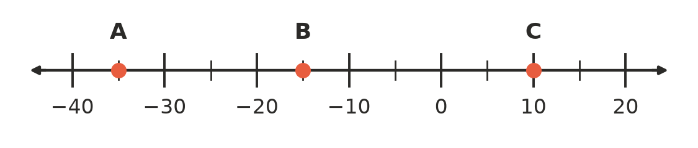
  - Which integer is at point A? (1 mark)

  - Which integer is at point B? (1 mark)

  - Which integer is at point C? (1 mark)

  - How many units is it from point B to point C? (1 mark)

- Write < or > in each box to make the statement true.
  - −12 □ −21 (1 mark)

  - −1 □ 1 (1 mark)

  - −100 □ −99 (1 mark)

- Answer each question.
  - Write −6, 2, −13, −1, 5 in ascending order, using < signs between them. (1 mark)

  - List all the integers that are greater than −4 and less than 2. (1 mark)

- Calculate each of these.
  - −8 + 13 (1 mark)

  - −9 + (−9) (1 mark)

  - 4 + (−17) (1 mark)

  - −23 + 16 (1 mark)

- Calculate each of these.
  - 6 − 14 (1 mark)

  - −11 − 5 (1 mark)

  - −3 − (−12) (1 mark)

  - 0 − (−7) (1 mark)

- The number line shows a calculation with two jumps. It starts at the red dot and finishes at the yellow dot. Write the calculation and its answer as a number sentence. (2 marks)
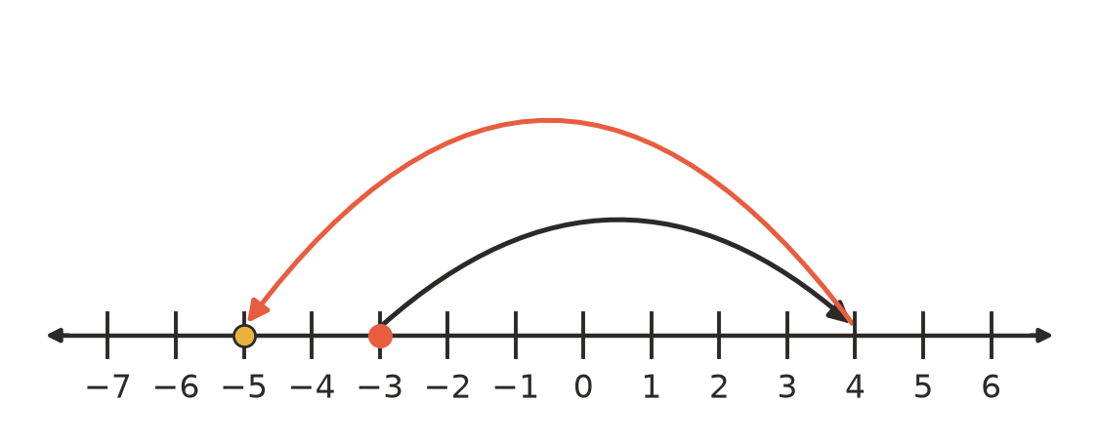

- Calculate each of these. Work from left to right.
  - −4 + 9 − 12 (1 mark)

  - 5 − (−3) + (−10) (1 mark)

- Noah says, “When you subtract, the answer is always smaller than the number you started with.” Is Noah correct? Explain, using an example. (2 marks)

- At 4 am on a frosty morning the temperature was −9 °C. It rose by 3 degrees every hour. At what time did the temperature first reach 0 °C? Show your working. (2 marks)

- Find the missing number in the box: □ − (−8) = −3 (1 mark)

 Section B: Calculator allowed
- Use a calculator to evaluate each of these.
  - −4518 + 2967 (1 mark)

  - 1384 − 2902 (1 mark)

  - −675 − (−3240) (1 mark)

- One winter’s day, the temperature at Mawson Station in Antarctica was −27 °C and the temperature in Darwin was 31 °C. What is the difference between these two temperatures? (2 marks)

- Josh’s bank account is overdrawn by $58, so his balance is −$58. Then he is paid $450, buys shoes for $129, pays an $87 phone bill and gets a $35 refund. What is his balance now? Show your working. (2 marks)

- In this magic square, every row, every column and both diagonals add to −6. Find the numbers that go in boxes x, y and z.
x | 0 | −1
2 | y | −6
−3 | −4 | z

  - x (1 mark)

  - y (1 mark)

  - z (1 mark)

- In a game, Ari’s score was −35. After two more rounds his score was 12. In the first of those rounds he gained 26 points. How many points did he gain or lose in the second round? Show your working. (2 marks)

 Answer sheet
Name: ____________________
Write your final answer for each question in the table.
Question | Answer | Marks | Question | Answer | Marks
1a |  | /1 | 6c |  | /1
1b |  | /1 | 6d |  | /1
2a |  | /1 | 7 |  | /2
2b |  | /1 | 8a |  | /1
2c |  | /1 | 8b |  | /1
2d |  | /1 | 9 |  | /2
3a |  | /1 | 10 |  | /2
3b |  | /1 | 11 |  | /1
3c |  | /1 | 12a |  | /1
4a |  | /1 | 12b |  | /1
4b |  | /1 | 12c |  | /1
5a |  | /1 | 13 |  | /2
5b |  | /1 | 14 |  | /2
5c |  | /1 | 15a |  | /1
5d |  | /1 | 15b |  | /1
6a |  | /1 | 15c |  | /1
6b |  | /1 | 16 |  | /2
 |  |  |  | Total | /40

