Integers: Practice test 2
Year 7 Maths · Test · Test 2
Name: ____________________ Date: ______________
Time: 45 minutes
Total: 40 marks
Show your working in the boxes. Then write each final answer on the answer sheet on the last page.

 Section A: No calculator
- Write an integer to represent each situation.
  - On a July morning in Canberra, the temperature was 5 degrees below zero. (1 mark)

  - Ella’s phone bill left her bank account $40 in debt. (1 mark)

- Look at the number line.
- 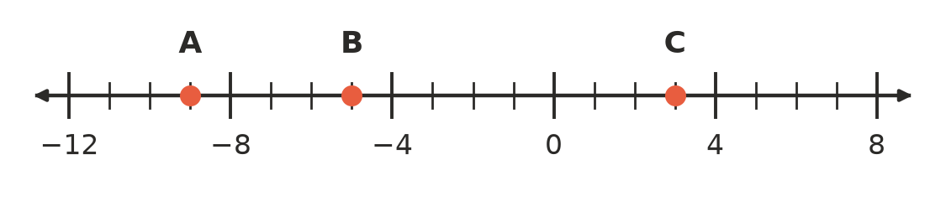
  - Which integer is at point A? (1 mark)

  - Which integer is at point B? (1 mark)

  - Which integer is at point C? (1 mark)

  - How many units apart are points A and C? (1 mark)

- Write true or false for each statement.
  - −10 > −1 (1 mark)

  - −2 > −20 (1 mark)

  - 0 < −5 (1 mark)

- Answer each question.
  - Write −3, 6, −15, 1, −8, 0 in descending order (largest to smallest). (1 mark)

  - Which integer is exactly halfway between −9 and 3 on a number line? (1 mark)

- Calculate each of these.
  - −9 + 4 (1 mark)

  - −5 + (−7) (1 mark)

  - 6 + (−13) (1 mark)

  - −15 + 15 (1 mark)

- Calculate each of these.
  - 3 − 11 (1 mark)

  - −7 − 8 (1 mark)

  - 2 − (−9) (1 mark)

  - −4 − (−10) (1 mark)

- The number line shows a calculation. It starts at the red dot and finishes at the yellow dot. Write the calculation and its answer as a number sentence. (1 mark)
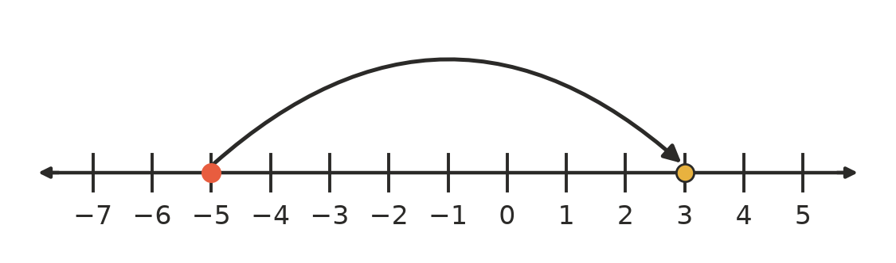

- A kookaburra sits on a branch 5 m above the surface of a creek. A fish swims 8 m below the surface. How far is the kookaburra above the fish? Show your working. (2 marks)

- Ava says that 6 − (−2) = 4. Explain the mistake Ava made, then give the correct answer. (2 marks)

- Find the missing number in each box.
  - □ + (−6) = −2 (1 mark)

  - 3 − □ = 8 (1 mark)

- Look at this pattern: 14, 9, 4, −1, …
  - Write the next two numbers in the pattern. (1 mark)

  - The pattern keeps going. What is the first number in the pattern that is less than −30? (1 mark)

 Section B: Calculator allowed
- Use a calculator to evaluate each of these.
  - −1563 + 879 (1 mark)

  - −2045 − 3768 (1 mark)

  - −912 − (−4630) (1 mark)

- A small business records its profit for each month. A loss is written as a negative number.
Month | January | February | March | April
Profit ($) | −1250 | 3480 | −645 | 2190

  - What was the total profit for the four months? (2 marks)

  - In which month did the business make its biggest loss? (1 mark)

- In an underground mine, a lift starts at −340 m (340 m below the surface). It rises 125 m, then goes down 410 m. What is the lift’s position now? Show your working. (2 marks)

- In this addition pyramid, each brick is the sum of the two bricks directly below it. Find the missing number in the bottom row. Show your working. (2 marks)
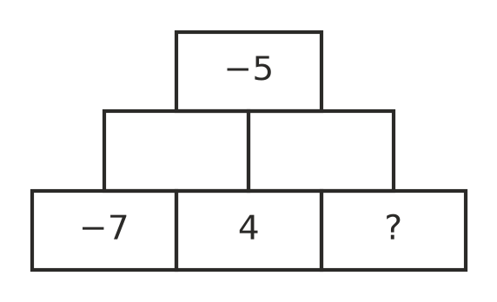

- Jake says, “When you add a negative integer and a positive integer, the answer is always negative.” Is Jake correct? Explain, using an example. (2 marks)

 Answer sheet
Name: ____________________
Write your final answer for each question in the table.
Question | Answer | Marks | Question | Answer | Marks
1a |  | /1 | 6c |  | /1
1b |  | /1 | 6d |  | /1
2a |  | /1 | 7 |  | /1
2b |  | /1 | 8 |  | /2
2c |  | /1 | 9 |  | /2
2d |  | /1 | 10a |  | /1
3a |  | /1 | 10b |  | /1
3b |  | /1 | 11a |  | /1
3c |  | /1 | 11b |  | /1
4a |  | /1 | 12a |  | /1
4b |  | /1 | 12b |  | /1
5a |  | /1 | 12c |  | /1
5b |  | /1 | 13a |  | /2
5c |  | /1 | 13b |  | /1
5d |  | /1 | 14 |  | /2
6a |  | /1 | 15 |  | /2
6b |  | /1 | 16 |  | /2
 |  |  |  | Total | /40

