Integers: Practice test 1
Year 7 Maths · Test · Test 1
Name: ____________________ Date: ______________
Time: 45 minutes
Total: 40 marks
Show your working in the boxes. Then write each final answer on the answer sheet on the last page.

 Section A: No calculator
- Write an integer to represent each situation.
  - A diver is 12 metres below the surface of the water. (1 mark)

  - Kai earned $35 mowing lawns. (1 mark)

- Look at the number line.
- 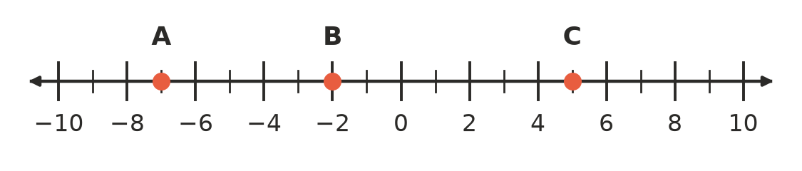
  - Which integer is at point A? (1 mark)

  - Which integer is at point B? (1 mark)

  - Which integer is at point C? (1 mark)

  - Which integer is 4 units to the left of point A? (1 mark)

- Write < or > in each box to make the statement true.
  - −6 □ 2 (1 mark)

  - −4 □ −9 (1 mark)

  - 0 □ −3 (1 mark)

- Order these integers.
  - Write 4, −7, 0, −2, 9, −11 in ascending order (smallest to largest). (1 mark)

  - Write −5, 3, −1, −8 in descending order, using > signs between them. (1 mark)

- Calculate each of these.
  - −3 + 8 (1 mark)

  - −6 + (−4) (1 mark)

  - 5 + (−9) (1 mark)

  - −12 + 7 (1 mark)

- Calculate each of these.
  - 4 − 10 (1 mark)

  - −3 − 6 (1 mark)

  - 7 − (−5) (1 mark)

  - −8 − (−2) (1 mark)

- The number line shows a calculation. It starts at the red dot and finishes at the yellow dot. Write the calculation and its answer as a number sentence. (1 mark)
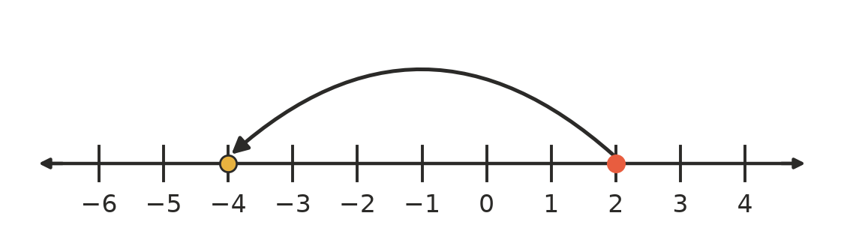

- At 5 am at Falls Creek the temperature was −6 °C. By 1 pm the temperature had risen by 10 degrees.
  - What was the temperature at 1 pm? (1 mark)

  - By 11 pm the temperature was −3 °C. By how many degrees did it fall between 1 pm and 11 pm? (1 mark)

- Liam says, “−8 is greater than −3, because 8 is greater than 3.” Is Liam correct? Explain your answer. (2 marks)

- Find the missing number in each box.
  - −5 + □ = 2 (1 mark)

  - □ − 9 = −4 (1 mark)

- A building has floors above and below the ground. The ground floor is floor 0. A lift starts at floor 2. It goes down 5 floors, then up 3 floors, then down 6 floors. Which floor does the lift finish on? Show your working. (2 marks)

 Section B: Calculator allowed
- Use a calculator to evaluate each of these.
  - −347 + 1285 (1 mark)

  - −2406 − 1879 (1 mark)

  - 568 − (−1347) (1 mark)

- Mia’s bank account is overdrawn by $145, so her balance is −$145. She deposits $320 and then pays a $212 phone bill from the account. What is her balance now? (2 marks)

- The pizza oven at a school fete is at 285 °C. The freezer in the canteen is at −22 °C. What is the difference between these two temperatures? (2 marks)

- A submarine is at −186 m (186 m below sea level). It rises 74 m, then dives 235 m.
  - What is the submarine’s position now? (1 mark)

  - How far must it now rise to reach −50 m? (1 mark)

- Two integers add to −3. When the smaller one is subtracted from the larger one, the answer is 11. Find the two integers. Show how you found them. (2 marks)

- Write the next two numbers in this pattern: −47, −29, −11, … (1 mark)

 Answer sheet
Name: ____________________
Write your final answer for each question in the table.
Question | Answer | Marks | Question | Answer | Marks
1a |  | /1 | 6d |  | /1
1b |  | /1 | 7 |  | /1
2a |  | /1 | 8a |  | /1
2b |  | /1 | 8b |  | /1
2c |  | /1 | 9 |  | /2
2d |  | /1 | 10a |  | /1
3a |  | /1 | 10b |  | /1
3b |  | /1 | 11 |  | /2
3c |  | /1 | 12a |  | /1
4a |  | /1 | 12b |  | /1
4b |  | /1 | 12c |  | /1
5a |  | /1 | 13 |  | /2
5b |  | /1 | 14 |  | /2
5c |  | /1 | 15a |  | /1
5d |  | /1 | 15b |  | /1
6a |  | /1 | 16 |  | /2
6b |  | /1 | 17 |  | /1
6c |  | /1
 |  |  |  | Total | /40

