3.03 Add and subtract integers
Year 7 Maths · Worksheet · Level 1 · Warm-up
Name: ____________________ Date: ______________
This worksheet practises adding and subtracting integers with jumps on a number line. Adding a positive number moves you right, and subtracting a positive number moves you left. Tip: adding a negative is the same as subtracting (6 + (−2) = 6 − 2), and subtracting a negative is the same as adding (3 − (−4) = 3 + 4).

 Understanding
- Each number line shows a jump. It starts at the black dot. Write the number sentence it shows, with the answer.
  - Jump A
  - 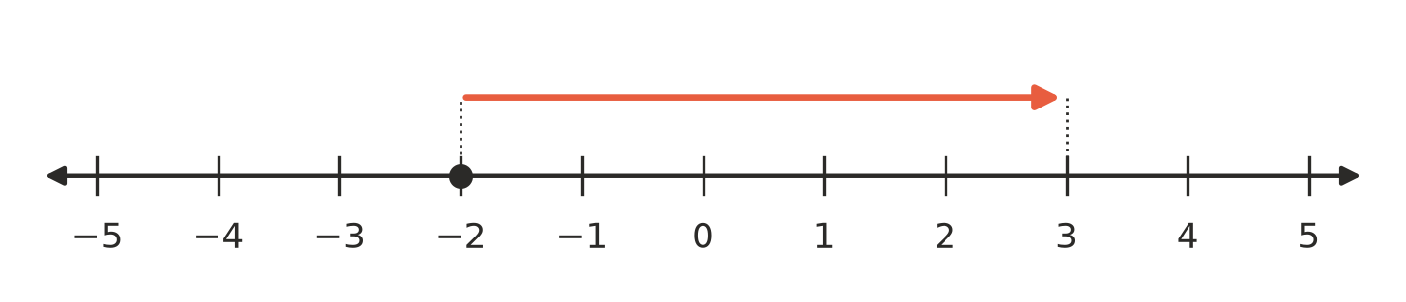
  - Number sentence: ______________
  - Jump B
  - 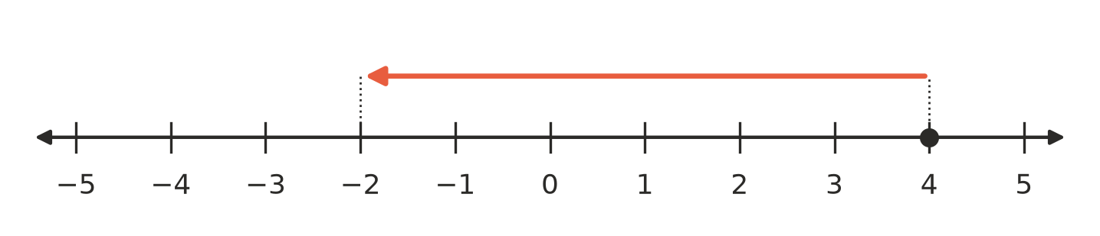
  - Number sentence: ______________
- Does each part of a calculation move you to the right or to the left on a number line? Write Right or Left in each empty box.
Part of the calculation | Right or left
+ 4
− 3
+ (−2)
− (−5)

- Rewrite each calculation using only one sign. The first one is done for you.
  - 6 + (−2) = 6 − 2
  - 3 − (−4) = ______________
  - −1 + (−5) = ______________
  - −7 − (−2) = ______________

 Fluency
- Use the number line to help you work these out.
- 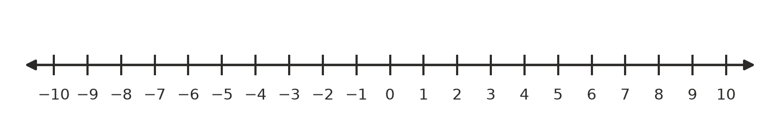
  - −3 + 5 = ______________
  - 2 − 6 = ______________
  - −4 − 3 = ______________
  - −8 + 8 = ______________
  - 1 − 9 = ______________
  - −6 + 2 = ______________
- Adding a negative: rewrite, then calculate.
  - 5 + (−3) = ______________
  - −2 + (−4) = ______________
  - 4 + (−7) = ______________
  - −1 + (−8) = ______________
- Subtracting a negative: rewrite, then calculate.
  - 3 − (−2) = ______________
  - −5 − (−1) = ______________
  - −6 − (−6) = ______________
  - 0 − (−7) = ______________

 Reasoning
- Is each statement true or false? Write True or False in each empty box.
Statement | True or false
−4 + 4 = 0
6 − (−1) = 5
−2 + (−3) = −5
Subtracting a negative number makes the answer bigger.
−3 − 2 = −1

- Mia worked out −5 + 3 and got −8. Explain her mistake, and write the correct answer.

 Problem solving
- At 5 am in Thredbo the temperature was −3 °C. By 11 am it had risen by 7 degrees. What was the temperature at 11 am? ______________
- Ben gets in a lift on floor 2 and goes down 5 floors. Which floor does he get out on? ______________
- Ruby has $15 in her bank account. She spends $20, so her balance goes below zero.
  - What is her balance now? ______________
  - Then she is paid $12 for babysitting. What is her balance now? ______________
- A snorkeller is 6 m below the surface of the water (−6 m). She swims up 4 m. Write her new position as an integer. ______________

