3.03 Add and subtract integers
Year 7 Maths · A5 question sheet · Level 3 · Challenge
This worksheet stretches your skills in adding and subtracting integers with bigger numbers, longer calculations, brackets and puzzles. Tip: work out anything in brackets first, then change any double signs, then work from left to right.

 Understanding
- The number line shows two jumps. The first jump starts at the black dot. Write the number sentence it shows, with the answer.
- 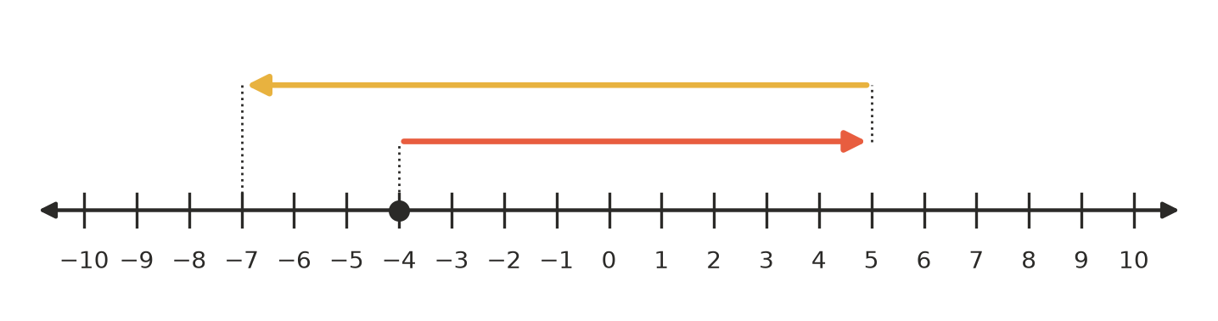
- Number sentence:
- Rewrite each calculation using only one sign, then calculate.
  - −14 − (−23) =
  - 27 + (−45) =
  - −36 + (−19) =
  - −8 − (+15) =
  - 0 − (−(−12)) =

 Fluency
- Calculate.
  - −48 + 75 =
  - 36 − 91 =
  - −64 − 29 =
  - −120 + (−85) =
  - 53 − (−47) =
  - −250 − (−175) =
- Calculate. Work from left to right.
  - −15 + 8 − 21 + 30 =
  - 12 − (−9) + (−30) − 4 =
  - −7 − 7 − (−7) + (−7) =
  - −100 + 37 − (−63) − 1 =
- Calculate. Work out the brackets first.
  - 8 − (3 − 10) =
  - (−6 + 2) − (5 − 11) =
  - −20 − (−4 − 9) =
  - (−15 − (−3)) + (7 − 19) =

 Reasoning
- Find the missing number in each statement.
  - −17 + □ = −42, so □ =
  - □ − (−13) = 6, so □ =
  - 24 − □ = 31, so □ =
  - −9 − □ = −9, so □ =
  - □ + (−38) = −11, so □ =
- Is each statement always true, sometimes true or never true? Write Always, Sometimes or Never in your book.
Statement
The sum of two negative integers is negative.
The sum of a positive integer and a negative integer is negative.
Subtracting a negative integer gives a larger answer than you started with.
For two integers a and b, a − b = b − a.
An integer plus its opposite equals 0.

- Ella says, “Two negatives make a positive, so −5 + (−3) = 8.” Explain what is wrong with Ella’s thinking, and write the correct answer.

 Problem solving
- In this magic square, every row, every column and both diagonals add up to the same total. Each integer from −4 to 4 is used exactly once. Complete the square, and write the magic total.
- 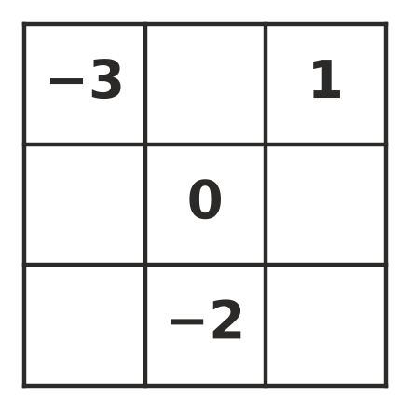
- Magic total:
- A weather station at Thredbo recorded the temperature at 6 am as −8 °C. The table shows how the temperature changed after that.
Time | 6 am to 9 am | 9 am to noon | noon to 6 pm | 6 pm to midnight
Change (°C) | rose 5 | rose 7 | fell 4 | fell 9

  - What was the temperature at midnight?
  - What was the highest temperature recorded at these times, and when was it?
  - What is the difference between the highest and the lowest of the five recorded temperatures?
- A submarine is at −250 m. It rises 85 m, dives 140 m, then rises 190 m.
  - Where is the submarine now?
  - What was the deepest point of its journey?
- Two integers have a sum of −3. When the smaller one is subtracted from the larger one, the answer is 11. What are the two integers? Show your working.
- A Year 7 canteen stall keeps track of its profit (+) and loss (−) each day. Over five days it made a total profit of $5. The results for the first four days were: +$48, −$25, +$31, −$72. What was the result on day 5? Show your working.

