3.03 Add and subtract integers
Year 7 Maths · A5 question sheet · Level 2 · Core
This worksheet practises adding and subtracting integers, including adding and subtracting negatives. Tip: first change any double signs. Adding a negative means subtract (+ (−) becomes −), and subtracting a negative means add (− (−) becomes +). Then use a number line in your head.

 Understanding
- Each number line shows a jump. It starts at the black dot. Write the number sentence it shows, with the answer.
  - Jump A
  - 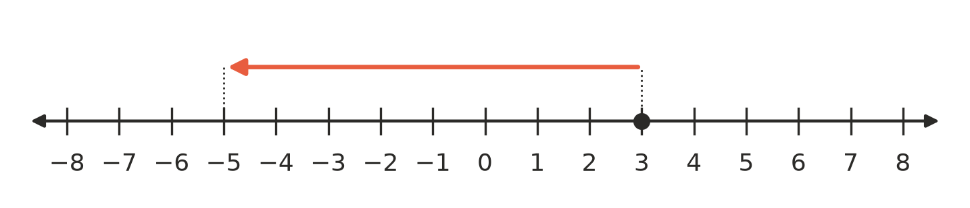
  - Number sentence:
  - Jump B
  - 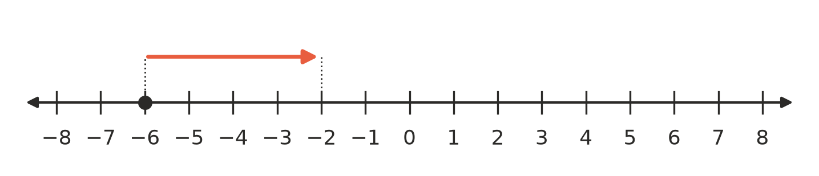
  - Number sentence:
- Rewrite each calculation using only one sign, then calculate.
  - 7 + (−10) =
  - −4 − (−9) =
  - −2 + (−11) =
  - 8 − (−5) =
- Complete each sentence.
  - Adding −8 is the same as ______________ 8.
  - Subtracting −3 is the same as ______________ 3.
  - Subtracting 5 is the same as adding

 Fluency
- Calculate.
  - −7 + 12 =
  - 4 − 15 =
  - −9 − 6 =
  - −13 + 8 =
  - −20 + 20 =
  - 0 − 14 =
- Calculate.
  - 9 + (−14) =
  - −6 + (−9) =
  - −15 + (−5) =
  - 12 + (−12) =
- Calculate.
  - 8 − (−7) =
  - −10 − (−4) =
  - −3 − (−12) =
  - −18 − (−18) =
- Work from left to right.
  - −4 + 9 − 7 =
  - 6 − 10 + (−3) =
  - −5 − (−8) + (−6) =
  - −12 + 5 − (−2) =

 Reasoning
- Find the missing number in each statement.
  - −3 + □ = 4, so □ =
  - □ − 6 = −10, so □ =
  - 5 + □ = −2, so □ =
  - −8 − □ = −3, so □ =
- Copy and continue the pattern to show why 5 − (−3) = 8.
- 5 − 3 = 2, 5 − 2 = 3, 5 − 1 = 4, 5 − 0 = 5, 5 − (−1) = ______________, 5 − (−2) = ______________, 5 − (−3) =
- What happens to the answer each time you subtract a number that is 1 smaller?
- Ben worked out −6 − (−2) and got −8. Explain his mistake, and write the correct answer.

 Problem solving
- One winter’s day at Perisher, the lowest temperature was −7 °C and the highest was 4 °C. How many degrees difference is there between the highest and lowest temperatures? Show your working.
- Liam’s bank balance is −$35. He is paid $60 for mowing lawns, then buys a game for $42. What is his balance now? Show your working.
- A scuba diver at the Great Barrier Reef is at −18 m. She rises 7 m to look at a turtle, then dives down 12 m to look at a reef shark. Where is she now? Show your working.
- In a trivia night, a team’s score starts at 4. In the next four rounds the team loses 6 points, gains 3 points, loses 5 points, then gains 2 points. What is the team’s final score? Show your working.

