3.02 Compare integers
Year 7 Maths · Worksheet · Level 1 · Warm-up
Name: ____________________ Date: ______________
This worksheet practises comparing and ordering integers. On a number line, the integer further to the right is always the larger one. Tip: the symbol < means “is less than” and > means “is greater than”. The open side of the symbol faces the larger number.

 Understanding
- Use the number line to help you. Write the larger integer in each pair.
- 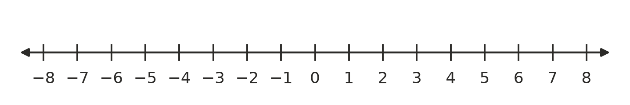
  - 3 or −5 ______________
  - −2 or −6 ______________
  - 0 or −1 ______________
  - −4 or −3 ______________
- Write < or > in each box to make a true statement.
  - 5 □ −2
  - −7 □ −3
  - 0 □ −4
  - −1 □ 1
  - −6 □ −8
  - −10 □ 2
- Write each statement using < or >.
  - −3 is less than 4 ______________
  - 0 is greater than −9 ______________
  - −8 is less than −5 ______________

 Fluency
- Write each list in order from smallest to largest.
  - 4, −2, 0, −5 ______________
  - −1, −7, 3, −4 ______________
  - 6, −6, 2, −3, 0 ______________
- Write each list in order from largest to smallest.
  - −3, 5, −8, 1 ______________
  - −2, −9, −5, −1 ______________
- Write the integer that is:
  - one more than −4 ______________
  - one less than −4 ______________
  - the larger of −12 and −15 ______________
  - the smallest of −3, −11 and 2 ______________

 Reasoning
- Is each statement true or false? Write True or False in each empty box.
Statement | True or false
−8 > −2
−1 is greater than −100.
0 is greater than every negative integer.
−5 < −5
A temperature of −3 °C is colder than −1 °C.

- Tom says, “−9 > −4, because 9 is bigger than 4.” Explain Tom’s mistake.

 Problem solving
- The table shows the temperature in six towns at 6 am on a winter morning.
Town | Temperature (°C)
Thredbo | −6
Canberra | −2
Orange | 0
Ballarat | 3
Hobart | 4
Cooma | −3

  - Which town was the coldest? ______________
  - Which town was the warmest? ______________
  - Write the towns in order from coldest to warmest.

  - Which towns were colder than −1 °C? ______________
- At the beach, a turtle is swimming at −8 m, a shark is at −20 m and a dolphin is at −3 m (0 m is the surface of the water).
  - Which animal is the deepest? ______________
  - Which animal is closest to the surface? ______________
- I am an integer. I am greater than −5 but less than −2, and I am not −3. What am I? ______________
- A car park has levels −1, −2 and −3 below the ground floor. Is level −3 higher or lower than level −1? Explain how you know.

