3.02 Compare integers
Year 7 Maths · A5 question sheet · Level 1 · Warm-up
This worksheet practises comparing and ordering integers. On a number line, the integer further to the right is always the larger one. Tip: the symbol < means “is less than” and > means “is greater than”. The open side of the symbol faces the larger number.

 Understanding
- Use the number line to help you. Write the larger integer in each pair.
- 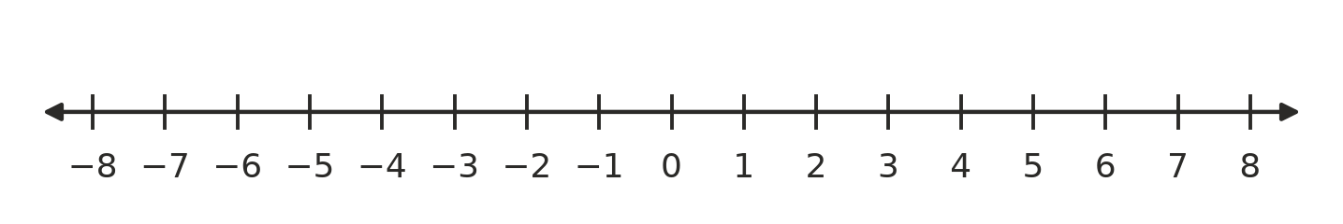
  - 3 or −5
  - −2 or −6
  - 0 or −1
  - −4 or −3
- Write < or > in your book to make a true statement.
  - 5 □ −2
  - −7 □ −3
  - 0 □ −4
  - −1 □ 1
  - −6 □ −8
  - −10 □ 2
- Write each statement using < or >.
  - −3 is less than 4
  - 0 is greater than −9
  - −8 is less than −5

 Fluency
- Write each list in order from smallest to largest.
  - 4, −2, 0, −5
  - −1, −7, 3, −4
  - 6, −6, 2, −3, 0
- Write each list in order from largest to smallest.
  - −3, 5, −8, 1
  - −2, −9, −5, −1
- Write the integer that is:
  - one more than −4
  - one less than −4
  - the larger of −12 and −15
  - the smallest of −3, −11 and 2

 Reasoning
- Is each statement true or false? Write True or False in your book.
Statement
−8 > −2
−1 is greater than −100.
0 is greater than every negative integer.
−5 < −5
A temperature of −3 °C is colder than −1 °C.

- Tom says, “−9 > −4, because 9 is bigger than 4.” Explain Tom’s mistake.

 Problem solving
- The table shows the temperature in six towns at 6 am on a winter morning.
Town | Temperature (°C)
Thredbo | −6
Canberra | −2
Orange | 0
Ballarat | 3
Hobart | 4
Cooma | −3

  - Which town was the coldest?
  - Which town was the warmest?
  - Write the towns in order from coldest to warmest.
  - Which towns were colder than −1 °C?
- At the beach, a turtle is swimming at −8 m, a shark is at −20 m and a dolphin is at −3 m (0 m is the surface of the water).
  - Which animal is the deepest?
  - Which animal is closest to the surface?
- I am an integer. I am greater than −5 but less than −2, and I am not −3. What am I?
- A car park has levels −1, −2 and −3 below the ground floor. Is level −3 higher or lower than level −1? Explain how you know.

