3.01 Integers and the number line
Year 7 Maths · Worksheet · Level 3 · Challenge
Name: ____________________ Date: ______________
This worksheet stretches your understanding of integers, opposites and number lines with bigger numbers, patterns and puzzles. Tip: the opposite of a number can be written with a minus sign in front, so the opposite of −5 is written −(−5), which equals 5.

 Understanding
- Write an integer for each situation.
  - the opposite of a fall of 18 m ______________
  - a debt of $1250 ______________
  - a temperature in Antarctica of 62 degrees below zero ______________
  - finishing a race 3 laps behind the leader ______________
  - the opposite of a loss of 0 points ______________
- Write each number as a single integer.
  - −(−14) = ______________
  - −(−(−3)) = ______________
  - −(0) = ______________
  - −(−(−(−8))) = ______________
- Is each number an integer? Write Yes or No in each empty box.
Number | Integer?
−12
3.5
0
$−\frac{8}{2}$
1 000 000
$\frac{1}{3}$
−0.2
$\sqrt{25}$

 Fluency
- Write the integer at each letter on the number line.
- 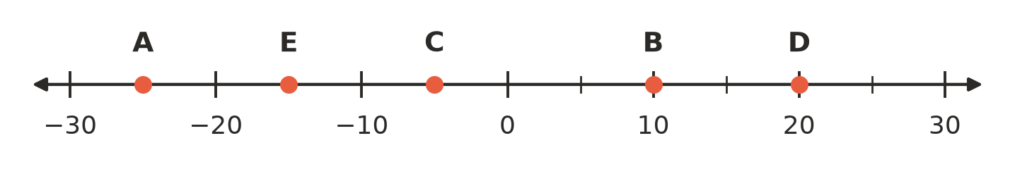
  - A = ______________
  - B = ______________
  - C = ______________
  - D = ______________
  - E = ______________
- Draw a dot on the number line for each integer, and write its letter above the dot: P = −14, Q = 6, R = −3, S = 17, T = −19.
- 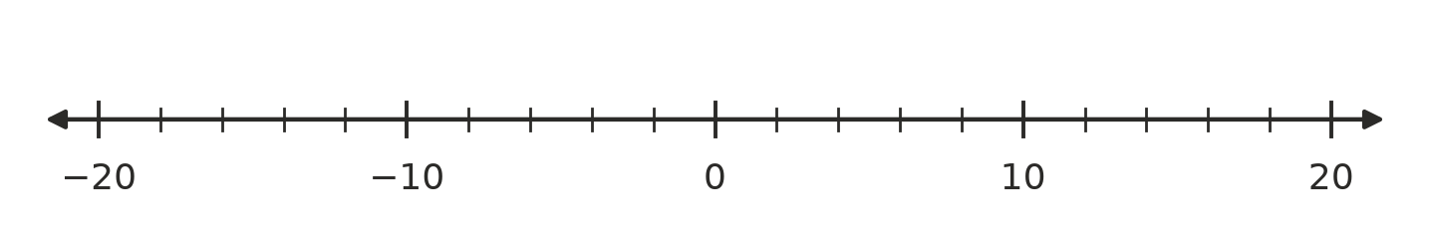
- Integer patterns.
  - Write the next three integers: 14, 9, 4, ______________, ______________, ______________
  - Write the next three integers: −50, −38, −26, ______________, ______________, ______________
  - The pattern 7, 4, 1, … keeps going. What is the 10th integer in the pattern? ______________
  - The pattern −2, −5, −8, … keeps going. Which term in the pattern is −29? (For example, −8 is the 3rd term.) ______________
- Answer each question.
  - Which integer is exactly halfway between −23 and 9? ______________
  - How many units apart are −46 and 27 on the number line? ______________
  - Which two integers are 9 units away from −4? ______________
  - How many integers are there from −35 to 18, counting both −35 and 18? ______________

 Reasoning
- Is each statement true or false? Write True or False in each empty box.
Statement | True or false
Between any two different integers there is always another integer.
Every integer is either positive or negative.
The opposite of a negative integer is always positive.
There are exactly 21 integers from −10 to 10, counting −10 and 10.
−(−(−6)) is a positive integer.

- Ari says, “The integer exactly halfway between any integer and its opposite is always 0.” Is Ari right? Explain why.

- Explain why there is no smallest integer.

 Problem solving
- A hotel has floors numbered from −6 (the lowest car park) up to 20. A lift starts on floor 7. It goes down 11 floors, then up 4 floors, then down 6 floors.
  - Which floor does the lift finish on? ______________
  - What was the lowest floor the lift reached? ______________
  - How many floors does the hotel have altogether, including the ground floor (0)? ______________
- Find each mystery integer.
  - An integer and its opposite are 38 units apart. What is the positive one? ______________
  - I am 6 units to the left of my own opposite. What am I? ______________
  - I am 10 units from −3, and I am positive. What am I? ______________
- At Thredbo one winter’s day, the temperature at 6 am was 7 degrees below zero. It rose 12 degrees by 2 pm, then fell 9 degrees by midnight.
  - Write the 6 am temperature as an integer. ______________
  - What was the temperature at 2 pm? ______________
  - What was the temperature at midnight? ______________

