3.01 Integers and the number line
Year 7 Maths · Worksheet · Level 1 · Warm-up
Name: ____________________ Date: ______________
Integers are the whole numbers and their opposites: …, −3, −2, −1, 0, 1, 2, 3, … Numbers to the left of 0 on a number line are negative, and numbers to the right are positive. Zero is neither. Tip: always write the minus sign in front of a negative number, like −5.

 Understanding
- Is each integer positive, negative or neither? Write your answer in each empty box.
Integer | Positive, negative or neither
8
−3
0
−15
42
−1

- Write an integer for each situation. Use a minus sign for the negative ones.
  - 6 degrees below zero ______________
  - a gain of 4 kg ______________
  - 20 m below sea level ______________
  - putting $50 into a bank account ______________
  - losing 3 points in a game ______________
  - 2 floors below the ground floor ______________
- The opposite of an integer is the same distance from 0, but on the other side. Write the opposite of each integer.
  - 7 ______________
  - −4 ______________
  - −12 ______________
  - 0 ______________

 Fluency
- Write the integer at each letter on the number line.
- 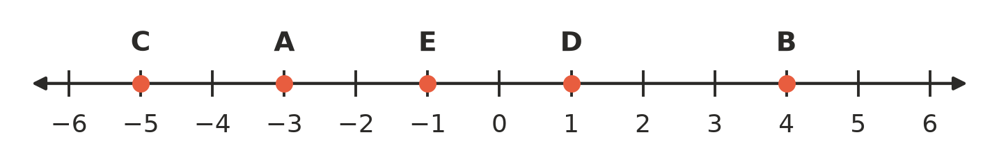
  - A = ______________
  - B = ______________
  - C = ______________
  - D = ______________
  - E = ______________
- Draw a dot on the number line for each integer, and write its letter above the dot: P = −7, Q = 3, R = −2, S = 6.
- 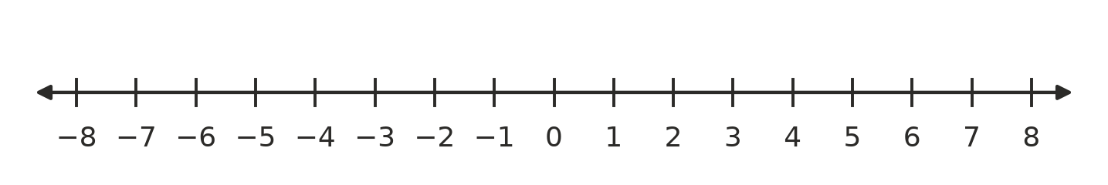
- Write the next three integers in each pattern.
  - 3, 2, 1, ______________, ______________, ______________
  - −10, −8, −6, ______________, ______________, ______________
  - 5, 3, 1, ______________, ______________, ______________
  - −1, −2, −3, ______________, ______________, ______________
- Use the number line in Question 5 to help you.
  - List all the integers that are between −4 and 3. ______________
  - How many integers are between −5 and 5? (Do not count −5 and 5.) ______________

 Reasoning
- Is each statement true or false? Write True or False in each empty box.
Statement | True or false
−5 is an integer.
0 is a positive integer.
The opposite of −9 is 9.
Every negative integer is to the left of 0 on the number line.
7.5 is an integer.

- Sam says, “−6 and 6 are the same distance from 0.” Is Sam right? Explain how you know.

 Problem solving
- Jo stands on 0 on a number line. She walks 4 steps to the left, then 7 steps to the right. Which integer is she standing on now? ______________
- Find each mystery integer.
  - I am 3 steps to the left of 1 on the number line. ______________
  - I am the opposite of 5. ______________
  - I am negative, and I am 8 steps away from 0. ______________
- The lowest point in Australia is in Kati Thanda–Lake Eyre, about 15 m below sea level. The highest point is the top of Mount Kosciuszko, about 2228 m above sea level. Write each height as an integer.
  - Kati Thanda–Lake Eyre ______________
  - Mount Kosciuszko ______________

