3.01 Integers and the number line
Year 7 Maths · A5 question sheet · Level 3 · Challenge
This worksheet stretches your understanding of integers, opposites and number lines with bigger numbers, patterns and puzzles. Tip: the opposite of a number can be written with a minus sign in front, so the opposite of −5 is written −(−5), which equals 5.

 Understanding
- Write an integer for each situation.
  - the opposite of a fall of 18 m
  - a debt of $1250
  - a temperature in Antarctica of 62 degrees below zero
  - finishing a race 3 laps behind the leader
  - the opposite of a loss of 0 points
- Write each number as a single integer.
  - −(−14) =
  - −(−(−3)) =
  - −(0) =
  - −(−(−(−8))) =
- Is each number an integer? Write Yes or No in your book.
Number
−12
3.5
0
$−\frac{8}{2}$
1 000 000
$\frac{1}{3}$
−0.2
$\sqrt{25}$

 Fluency
- Write the integer at each letter on the number line.
- 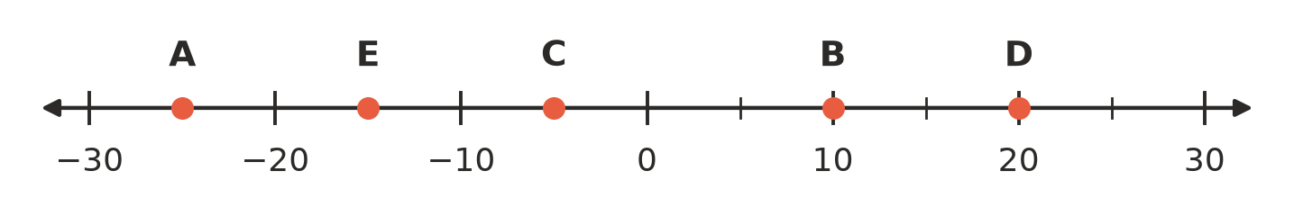
  - A =
  - B =
  - C =
  - D =
  - E =
- Draw a dot on a copy of the number line in your book for each integer, and write its letter above the dot: P = −14, Q = 6, R = −3, S = 17, T = −19.
- 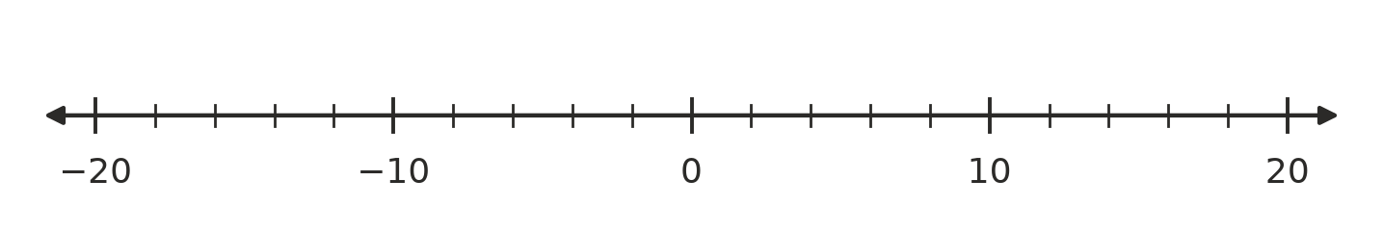
- Integer patterns.
  - Write the next three integers: 14, 9, 4, ______________, ______________,
  - Write the next three integers: −50, −38, −26, ______________, ______________,
  - The pattern 7, 4, 1, … keeps going. What is the 10th integer in the pattern?
  - The pattern −2, −5, −8, … keeps going. Which term in the pattern is −29? (For example, −8 is the 3rd term.)
- Answer each question.
  - Which integer is exactly halfway between −23 and 9?
  - How many units apart are −46 and 27 on the number line?
  - Which two integers are 9 units away from −4?
  - How many integers are there from −35 to 18, counting both −35 and 18?

 Reasoning
- Is each statement true or false? Write True or False in your book.
Statement
Between any two different integers there is always another integer.
Every integer is either positive or negative.
The opposite of a negative integer is always positive.
There are exactly 21 integers from −10 to 10, counting −10 and 10.
−(−(−6)) is a positive integer.

- Ari says, “The integer exactly halfway between any integer and its opposite is always 0.” Is Ari right? Explain why.
- Explain why there is no smallest integer.

 Problem solving
- A hotel has floors numbered from −6 (the lowest car park) up to 20. A lift starts on floor 7. It goes down 11 floors, then up 4 floors, then down 6 floors.
  - Which floor does the lift finish on?
  - What was the lowest floor the lift reached?
  - How many floors does the hotel have altogether, including the ground floor (0)?
- Find each mystery integer.
  - An integer and its opposite are 38 units apart. What is the positive one?
  - I am 6 units to the left of my own opposite. What am I?
  - I am 10 units from −3, and I am positive. What am I?
- At Thredbo one winter’s day, the temperature at 6 am was 7 degrees below zero. It rose 12 degrees by 2 pm, then fell 9 degrees by midnight.
  - Write the 6 am temperature as an integer.
  - What was the temperature at 2 pm?
  - What was the temperature at midnight?

