3.01 Integers and the number line
Year 7 Maths · A5 question sheet · Level 2 · Core
This worksheet practises writing integers for real situations, finding opposites, and reading and marking integers on number lines. Tip: on a number line, count the gap between two labelled marks first, so you know how much each small step is worth.

 Understanding
- Write an integer for each situation.
  - a temperature of 9 °C below zero
  - a profit of $250
  - 35 m below sea level
  - 4 seconds before a rocket lifts off
  - taking $80 out of a bank account
  - no gain and no loss
- Write the opposite of each integer.
  - 15
  - −28
  - 0
  - the opposite of the opposite of −11
- Describe the opposite of each situation in words.
  - going up 3 floors in a lift
  - a gain of 12 points
  - 40 m below sea level

 Fluency
- Write the integer at each letter on the number line.
- 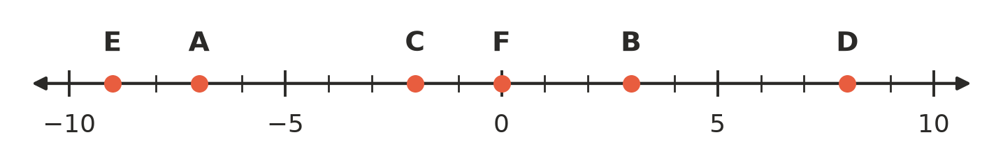
  - A =
  - B =
  - C =
  - D =
  - E =
  - F =
- Draw a dot on a copy of the number line in your book for each integer, and write its letter above the dot: P = −9, Q = 4, R = −4, S = 10, T = −1.
- 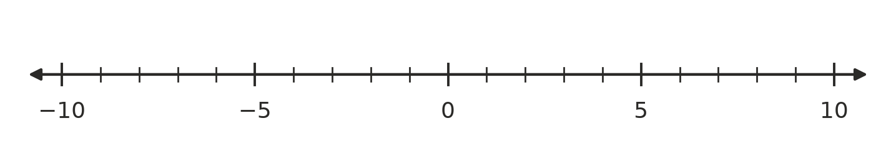
- Write the temperature shown on each thermometer, in °C.
- 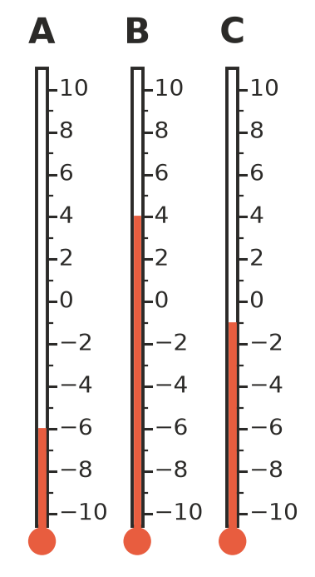
  - A =
  - B =
  - C =
- Write the next three integers in each pattern.
  - 8, 5, 2, ______________, ______________,
  - −20, −15, −10, ______________, ______________,
  - 6, 2, −2, ______________, ______________,
  - −3, −6, −9, ______________, ______________,
- Answer each question. A quick sketch of a number line may help.
  - List the integers that are greater than −6 and less than −1.
  - How many integers are between −8 and 8? (Do not count −8 and 8.)
  - Which integer is exactly halfway between −6 and 2?
  - Which integer is exactly halfway between −11 and −3?

 Reasoning
- Is each statement true or false? Write True or False in your book.
Statement
The opposite of 0 is 0.
−1 is the largest negative integer.
There is a smallest negative integer.
Every integer has an opposite.
−3.5 is an integer.

- Zoe says, “−7 is 7 units from 0, so −7 and 7 are really the same number.” Explain what Zoe has right and what she has wrong.

 Problem solving
- An office building has floors numbered from −4 (the lowest car park) up to 12. The ground floor is 0.
  - How many floors does the building have altogether?
  - A lift goes from floor 5 down to floor −3. How many floors does it go down?
- Find each mystery integer.
  - I am 4 to the left of −5 on the number line.
  - My opposite is 11.
  - I am halfway between −14 and 0.
  - I am negative, and I am the same distance from 0 as 13 is.
- At Perisher at 6 am, the temperature was 5 degrees below zero. By midday it was 8 degrees warmer.
  - Write the 6 am temperature as an integer.
  - Use a number line to find the temperature at midday.
- Start at −3 on a number line. Move 8 to the right, then 12 to the left. Where do you finish?

