Fractions: Practice test 1
Year 7 Maths · Test · Test 1
Name: ____________________ Date: ______________
Time: 45 minutes
Total: 40 marks
Show your working in the boxes. Then write each final answer on the answer sheet on the last page. Give every answer in simplest form, and write answers greater than 1 as mixed numbers.

 Section A: No calculator
- What fraction of each shape is shaded?
- 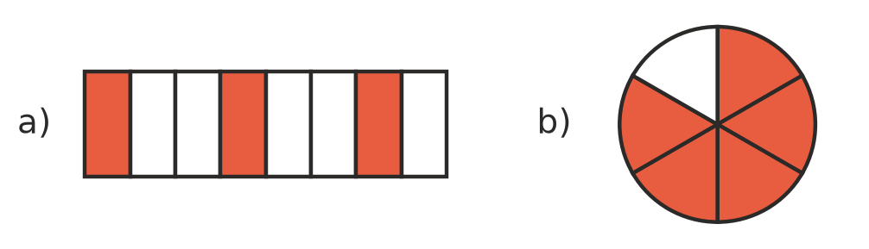
  - the rectangle (1 mark)

  - the circle (1 mark)

- Write <, > or = in each box to make the statement true.
  - $\frac{4}{9}$ □ $\frac{4}{7}$ (1 mark)

  - $2\frac{3}{5}$ □ $\frac{13}{5}$ (1 mark)

- Write these fractions in ascending order (smallest to largest): $\frac{5}{6}$, $\frac{2}{3}$, $\frac{3}{4}$, $\frac{7}{12}$ (2 marks)

- Write the fraction shown by each point on the number line.
- 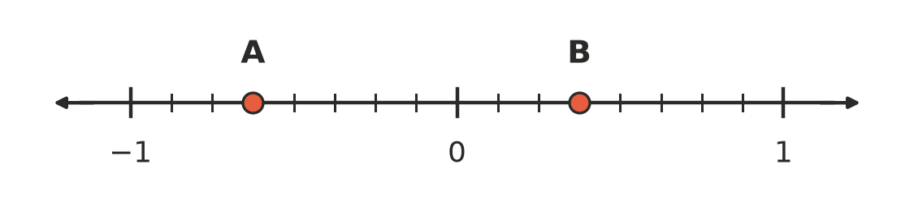
  - point A (1 mark)

  - point B (1 mark)

- Write these numbers in ascending order: $−\frac{2}{3}$, $\frac{1}{6}$, $−\frac{5}{6}$, $−\frac{1}{2}$ (2 marks)

- Equivalent fractions.
  - Find the missing number: $\frac{3}{5}$ = $\frac{□}{40}$ (1 mark)

  - Write $\frac{18}{24}$ in simplest form. (1 mark)

  - Write $\frac{23}{6}$ as a mixed number. (1 mark)

- Calculate each of these.
  - $\frac{3}{8}$ + $\frac{1}{4}$ (1 mark)

  - $\frac{5}{6}$ − $\frac{2}{9}$ (1 mark)

  - $2\frac{1}{3}$ + $1\frac{3}{4}$ (2 marks)

  - $4\frac{1}{5}$ − $2\frac{1}{2}$ (2 marks)

- A school canteen orders 64 pies for a footy carnival. $\frac{3}{8}$ of the pies are vegetable pies. How many vegetable pies are there? (1 mark)

- Calculate each of these.
  - $\frac{4}{9}$ × $\frac{3}{10}$ (1 mark)

  - $1\frac{1}{2}$ × $2\frac{2}{3}$ (2 marks)

- Calculate each of these.
  - $\frac{5}{6}$ ÷ $\frac{2}{3}$ (1 mark)

  - 6 ÷ $\frac{3}{4}$ (1 mark)

- Calculate $\frac{1}{2}$ + $\frac{3}{4}$ × $\frac{2}{3}$. (2 marks)

- Liam says that $\frac{2}{3}$ + $\frac{1}{4}$ = $\frac{3}{7}$. Explain the mistake Liam made, then find the correct answer. (2 marks)

 Section B: Calculator allowed
- There are 140 campers at a church camp. On Saturday afternoon, $\frac{2}{5}$ of them go canoeing, $\frac{1}{4}$ of them do archery and the rest go bushwalking.
  - What fraction of the campers go bushwalking? (1 mark)

  - How many campers go bushwalking? (1 mark)

- A jug holds $2\frac{1}{4}$ litres of cordial. Each cup holds $\frac{3}{16}$ of a litre. How many cups can be filled from the jug? (2 marks)

- Find the fraction that is exactly halfway between $\frac{2}{5}$ and $\frac{3}{4}$. Show how you found it. (2 marks)

- A family is driving 360 km to the beach. On the first day they drive $\frac{5}{12}$ of the distance. On the second day they drive $\frac{3}{7}$ of the distance that is left. How far do they still have to drive? (3 marks)

- Calculate ($3\frac{1}{2}$ − $1\frac{4}{5}$) ÷ $2\frac{5}{6}$. (2 marks)

 Answer sheet
Name: ____________________
Write your final answer for each question in the table.
Question | Answer | Marks | Question | Answer | Marks
1a |  | /1 | 7d |  | /2
1b |  | /1 | 8 |  | /1
2a |  | /1 | 9a |  | /1
2b |  | /1 | 9b |  | /2
3 |  | /2 | 10a |  | /1
4a |  | /1 | 10b |  | /1
4b |  | /1 | 11 |  | /2
5 |  | /2 | 12 |  | /2
6a |  | /1 | 13a |  | /1
6b |  | /1 | 13b |  | /1
6c |  | /1 | 14 |  | /2
7a |  | /1 | 15 |  | /2
7b |  | /1 | 16 |  | /3
7c |  | /2 | 17 |  | /2
 |  |  |  | Total | /40

