4.07 Divide fractions
Year 7 Maths · A5 question sheet · Level 2 · Core
This worksheet practises dividing fractions, whole numbers and mixed numbers. Tip: change mixed numbers to improper fractions first, then multiply by the reciprocal of the second number. You can check a division by multiplying back.

 Understanding
- The number line shows jumps of $\frac{3}{4}$ from 0 to 3.
- 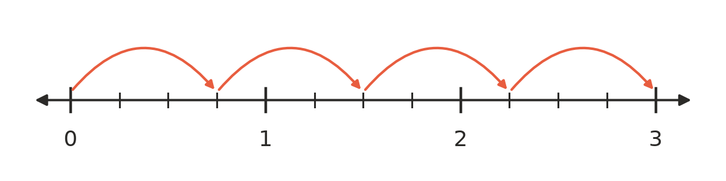
  - How many jumps of $\frac{3}{4}$ fit into 3?
  - Write a division that matches the number line.
- Write the reciprocal of each number.
  - $\frac{5}{9}$
  - $1\frac{2}{3}$
  - $\frac{1}{12}$
  - 8
- Without calculating, is each answer bigger than 10, smaller than 10 or equal to 10?
  - 10 ÷ $\frac{2}{5}$
  - 10 ÷ $\frac{5}{2}$
  - 10 ÷ $\frac{4}{4}$

 Fluency
- Calculate. Give each answer in simplest form, and write improper fractions as mixed numbers.
  - $\frac{4}{5}÷\frac{2}{3}$ =
  - $\frac{3}{8}÷\frac{9}{10}$ =
  - $\frac{7}{12}÷\frac{7}{18}$ =
  - $\frac{5}{6}÷\frac{10}{9}$ =
  - $\frac{8}{15}÷\frac{4}{5}$ =
  - $\frac{11}{12}÷\frac{1}{4}$ =
- Calculate.
  - 12 ÷ $\frac{3}{4}$ =
  - $\frac{2}{3}$ ÷ 6 =
  - 15 ÷ $\frac{5}{8}$ =
  - $\frac{9}{10}$ ÷ 3 =
- Calculate. Give each answer as a whole number or mixed number in simplest form.
  - $2\frac{1}{2}÷\frac{1}{4}$ =
  - $3\frac{3}{4}÷1\frac{1}{4}$ =
  - $4\frac{1}{2}÷\frac{2}{3}$ =
  - $5\frac{1}{3}÷2\frac{2}{3}$ =

 Reasoning
- Ella worked out $\frac{5}{6}÷\frac{2}{3}=1\frac{1}{4}$. Show how to check her answer using multiplication.
- Explain why dividing by $\frac{1}{2}$ gives the same answer as multiplying by 2.

 Problem solving
- In woodwork, a plank $4\frac{1}{2}$ m long is cut into pieces that are each $\frac{3}{4}$ m long. How many pieces can be cut?
- A farm cafe has 12 litres of milk. Each milkshake uses $\frac{3}{8}$ of a litre. How many milkshakes can be made?
- On a road trip, $\frac{3}{4}$ of a tank of fuel lasts $4\frac{1}{2}$ hours of driving. How many hours of driving does a full tank last?
- For a fundraiser, 15 kg of jellybeans are packed into bags that each hold $\frac{3}{10}$ of a kilogram.
  - How many bags can be filled?
  - Each bag sells for $4. How much money is raised if every bag is sold?
- A rectangle has an area of $5\frac{1}{4}$ m² and a width of $1\frac{1}{2}$ m. How long is it?

