4.06 Multiply fractions
Year 7 Maths · A5 question sheet · Level 3 · Challenge
This worksheet stretches your skills with bigger numbers, several fractions at once, powers and multi-step problems. Tip: when there are three fractions, cancel every factor you can across the whole calculation before you multiply.

 Understanding
- Look at the area model. The yellow columns show one fraction and the red striped rows show another.
- 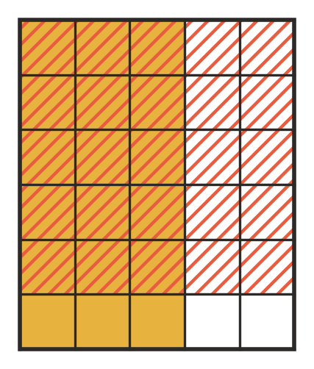
  - Write the multiplication that the area model shows.
  - What is the answer in simplest form?
- Without calculating, write these in order from smallest to largest. Explain your thinking.
- $\frac{5}{6}×\frac{7}{8}$ $\frac{5}{6}$ $\frac{5}{6}×\frac{9}{8}$

 Fluency
- Calculate. Cancel first, and give each answer in simplest form.
  - $\frac{14}{15}×\frac{25}{28}$ =
  - $\frac{16}{45}×\frac{27}{40}$ =
  - $\frac{3}{4}×\frac{8}{9}×\frac{3}{10}$ =
  - $\frac{5}{12}×\frac{18}{25}×\frac{10}{21}$ =
- Calculate. Give each answer as a whole number or mixed number in simplest form.
  - $3\frac{3}{4}×2\frac{2}{5}$ =
  - $4\frac{1}{6}×\frac{3}{10}$ =
  - $2\frac{1}{3}×1\frac{2}{7}×1\frac{1}{9}$ =
  - $5\frac{1}{4}×2\frac{2}{3}$ =
- Calculate.
  - ${\left(\frac{3}{4}\right)}^{3}$ =
  - ${\left(2\frac{1}{2}\right)}^{2}$ =
  - ${\left(\frac{1}{2}\right)}^{2}×{\left(\frac{2}{3}\right)}^{2}$ =
- Find the missing fraction.
  - $\frac{3}{5}$ × □ = $\frac{9}{20}$
  - □ × $\frac{2}{3}$ = $\frac{8}{15}$
  - $1\frac{1}{2}$ × □ = 1

 Reasoning
- Explain why $\frac{3}{7}×\frac{7}{3}=1$. What do you notice about the two fractions? Write another pair of fractions that multiply to give 1.
- Explain why the product of two proper fractions is always smaller than each of the two fractions.

 Problem solving
- On a farm, $\frac{2}{3}$ of the land is used for crops. $\frac{3}{8}$ of the crop land is wheat, and $\frac{4}{9}$ of the wheat has been harvested. What fraction of the whole farm is harvested wheat?
- A ball is dropped from a height of $2\frac{1}{2}$ m. Each time it bounces, it rises to $\frac{3}{5}$ of the height it fell from.
  - How high does it rise after the first bounce?
  - How high does it rise after the second bounce?
- A rectangular church hall stage is $3\frac{1}{3}$ m long and $2\frac{1}{4}$ m wide.
  - Find its area.
  - Find its perimeter.
- In a class of 28 students, $\frac{3}{4}$ bought raffle tickets. $\frac{2}{3}$ of the students who bought tickets bought 2 tickets each, and the rest bought 1 ticket each. How many tickets did the class buy? Show your working.
- I am thinking of two fractions. One of them is $\frac{2}{3}$ of the other, and when you multiply them together you get $\frac{1}{6}$. What are the two fractions? Show your working.

