4.06 Multiply fractions
Year 7 Maths · A5 question sheet · Level 2 · Core
This worksheet practises multiplying fractions, whole numbers and mixed numbers. Tip: cancel common factors before you multiply (top with bottom), and change mixed numbers to improper fractions first.

 Understanding
- In the area model, $\frac{2}{3}$ of the square is shaded yellow (columns) and $\frac{3}{4}$ is striped red (rows).
- 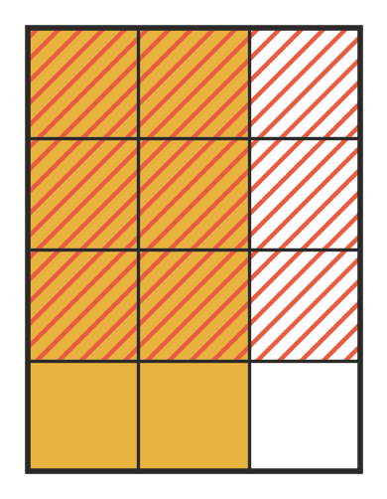
  - Write the multiplication that the area model shows.
  - What fraction of the whole square is both yellow and striped? Write it in simplest form.
- Without calculating, will each answer be bigger or smaller than 12?
  - 12 × $\frac{3}{4}$
  - 12 × $\frac{5}{4}$
  - 12 × $1\frac{1}{2}$
  - 12 × $\frac{7}{8}$

 Fluency
- Calculate. Cancel first where you can, and give each answer in simplest form.
  - $\frac{3}{5}×\frac{4}{7}$ =
  - $\frac{5}{6}×\frac{3}{10}$ =
  - $\frac{4}{9}×\frac{3}{8}$ =
  - $\frac{7}{12}×\frac{8}{21}$ =
  - $\frac{9}{14}×\frac{7}{12}$ =
  - $\frac{10}{27}×\frac{9}{25}$ =
- Calculate. Write improper fractions as mixed numbers.
  - $\frac{4}{7}$ × 21 =
  - 18 × $\frac{5}{6}$ =
  - 7 × $\frac{3}{8}$ =
  - $\frac{2}{9}$ × 15 =
- Calculate. Give each answer as a whole number or mixed number in simplest form.
  - $1\frac{1}{2}×\frac{2}{3}$ =
  - $2\frac{1}{4}×1\frac{1}{3}$ =
  - $3\frac{1}{3}×1\frac{4}{5}$ =
  - $2\frac{2}{5}×1\frac{1}{6}$ =
- Calculate.
  - ${\left(\frac{2}{3}\right)}^{2}$ =
  - ${\left(1\frac{1}{2}\right)}^{2}$ =

 Reasoning
- Explain why you are allowed to cancel the 3 and the 9 in $\frac{2}{3}×\frac{9}{10}$ before multiplying. Then find the answer.
- Ruby says, “When you multiply two numbers, the answer is always bigger than both of them.” Give an example that shows she is wrong, and explain why it happens.

 Problem solving
- At a church camp, $\frac{3}{5}$ of the campers are in Year 7. $\frac{2}{3}$ of the Year 7 campers are coming to camp for the first time. What fraction of all the campers are Year 7 students at their first camp?
- In woodwork, each shelf board is $\frac{3}{4}$ m long. Kai needs 5 boards. What total length of timber does he need?
- A rectangular garden bed is $2\frac{1}{2}$ m long and $1\frac{3}{5}$ m wide. What is its area?
- On a road trip, the car uses $\frac{1}{8}$ of a tank of fuel every hour. What fraction of a tank does it use in $5\frac{1}{2}$ hours?
- A pancake recipe for 8 people uses $2\frac{1}{4}$ cups of flour. Jess makes $\frac{3}{4}$ of the recipe for 6 people. How much flour does she need?

