Investigation: Fraction flowers
Year 7 Maths · A5 question sheet
In a fraction flower, the number in the centre is the “seed”. Every petal holds a fraction that is equivalent to the centre: it is worth the same, even though it looks different. In this investigation you’ll complete fraction flowers, hunt for weeds, grow your own flowers, and then use fractions to plan a real garden bed.

Part A: Equivalent flowers
- Every petal on this flower is equivalent to $\frac{2}{3}$. Find each missing number.
- 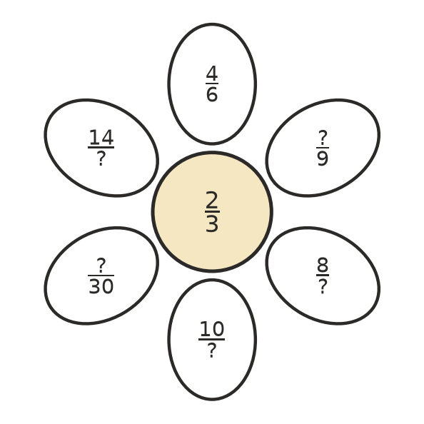
- Missing numbers (going clockwise from the top):
- One petal on this flower is a weed: it is not equivalent to the centre. Find the weed and explain how you know.
- 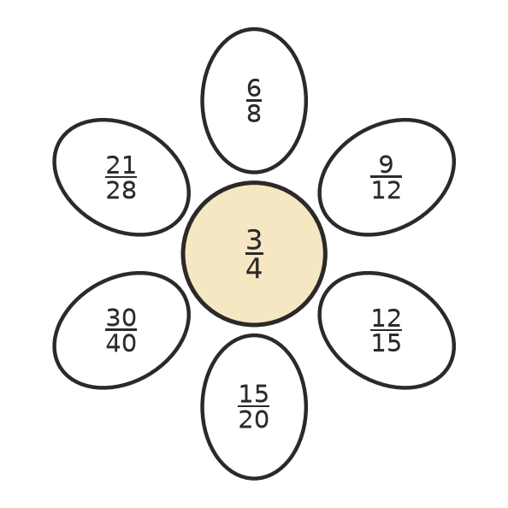
- The weed is:
- The centre of this flower has been rubbed out. What must the centre be, in simplest form? Explain.
- 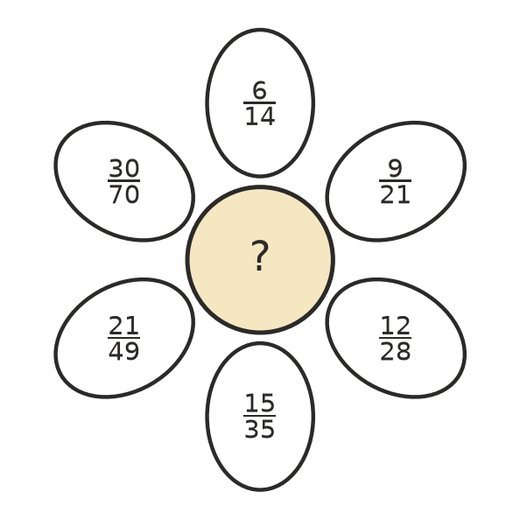
- Centre:
- This flower has a mixed number in the centre. Every petal is an improper fraction equivalent to it. Find each missing number.
- 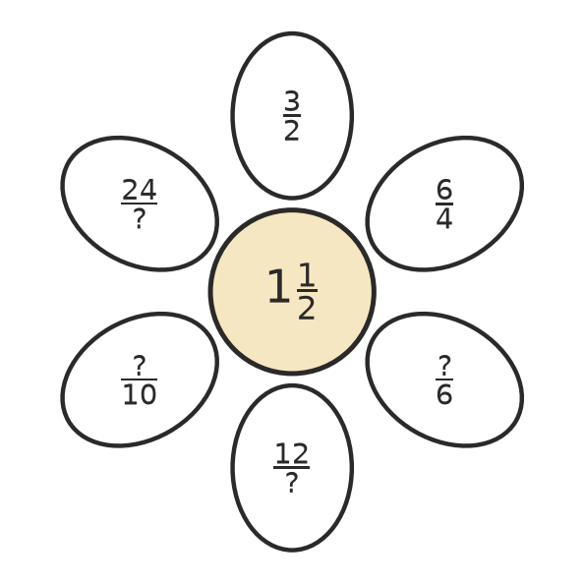
- Missing numbers (going clockwise from the top):
- Grow your own flower. Write a different fraction equivalent to $\frac{5}{8}$ on each petal. At least one petal must have a denominator bigger than 100.
- 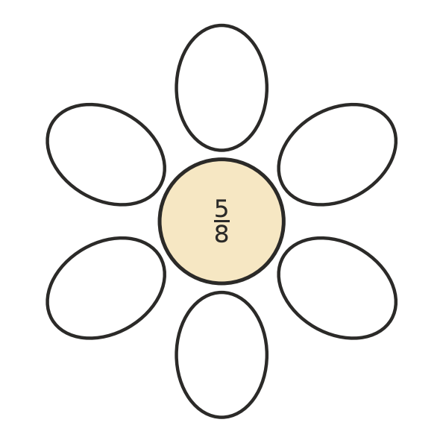

Part B: Order and simplify
- Write these six fractions on the petals in order from smallest to largest, starting at the top petal and going clockwise. (Hint: rewrite them all as twelfths first.)
- $\frac{3}{4}$, $\frac{1}{2}$, $\frac{2}{3}$, $\frac{5}{12}$, $\frac{7}{12}$, $\frac{5}{6}$
- 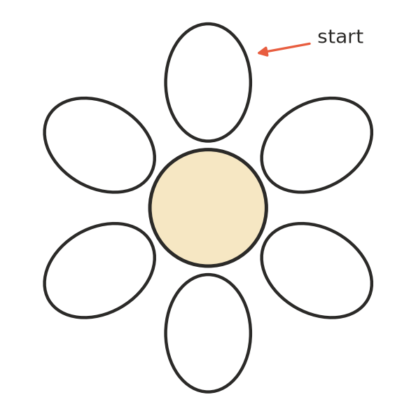
- A gardener picked six petals from different flowers: $\frac{18}{24}$, $\frac{20}{45}$, $\frac{35}{42}$, $\frac{27}{36}$, $\frac{16}{40}$, $\frac{48}{60}$.
  - Write each fraction in simplest form.
  - Which two petals came from the same flower?

Part C: A flower garden
The school is planting a new garden bed beside the chapel. The bed is split into 24 equal squares. Each square holds one type of flower.
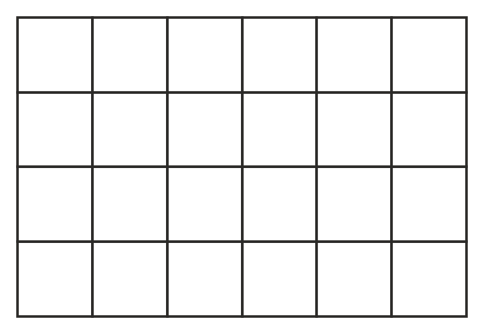
- The plan says: $\frac{1}{3}$ of the bed is roses, $\frac{1}{4}$ is daisies, $\frac{1}{6}$ is tulips, and the rest is native grevilleas.
  - How many squares does each flower get? Roses ______________ Daisies ______________ Tulips
  - How many squares are left for grevilleas?
  - What fraction of the bed is grevilleas, in simplest form?
  - Colour or label the grid above to show one way the garden could look.
- Another gardener suggests $\frac{1}{2}$ roses, $\frac{1}{3}$ daisies and $\frac{1}{4}$ tulips. Explain why this plan can’t work.
- Design your own garden bed of 24 squares. Use at least four types of flower. Each flower must cover a different fraction of the bed, and no squares may be left empty. Write each fraction in simplest form and show that the fractions make one whole bed.
Flower | Number of squares | Fraction of the bed (simplest form)

Check that it makes one whole bed:
- Which unit fractions (fractions with a numerator of 1) give a whole number of squares in a bed of 24 squares? Why can’t a gardener plant exactly $\frac{1}{5}$ of this bed with one flower?
- Look back at your work. What is the quickest way to check whether two fractions are equivalent? Explain your method.

