4.03 Equivalent and simplified fractions
Year 7 Maths · Worksheet · Level 3 · Challenge
Name: ____________________ Date: ______________
This worksheet stretches your skills with equivalent fractions: bigger numbers, missing values and puzzles. Tip: if you can’t spot the HCF straight away, keep dividing by common factors until the only common factor left is 1.

 Understanding
- Use the fraction wall.
- 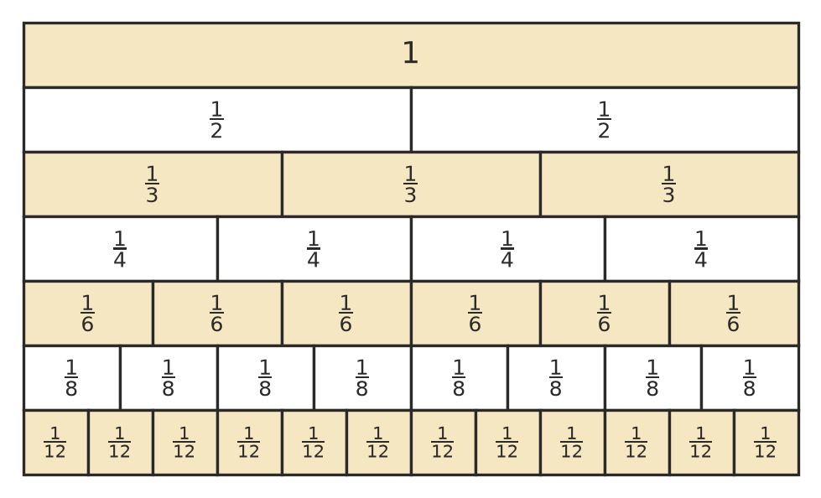
  - List every fraction on the wall that is equal to $\frac{2}{3}$. ______________
  - List every fraction on the wall that is equal to $\frac{3}{4}$. ______________
  - Why is there no fraction in the eighths row that is equal to $\frac{2}{3}$? ______________

- Write true or false. Give an example or a reason for each one.
  - If you add the same number to the numerator and the denominator, you get an equivalent fraction. ______________

  - A fraction with a prime number as its numerator is always in simplest form. ______________

  - $\frac{0}{5}$ = $\frac{0}{9}$ ______________

 Fluency
- Find the missing numbers.
  - $\frac{7}{12}$ = $\frac{▫}{84}$ ______________
  - $\frac{13}{15}$ = $\frac{65}{▫}$ ______________
  - $3\frac{5}{8}$ = $\frac{▫}{8}$ = $\frac{▫}{40}$ ______________
  - $1\frac{1}{6}$ = $\frac{21}{▫}$ ______________
- Write each number in simplest form. Write improper fractions as mixed numbers.
  - $\frac{56}{64}$ = ______________
  - $\frac{84}{108}$ = ______________
  - $\frac{75}{120}$ = ______________
  - $\frac{144}{180}$ = ______________
  - $\frac{132}{36}$ = ______________
  - $4\frac{26}{39}$ = ______________
- Which of these fractions are equivalent to $\frac{3}{8}$?
- $\frac{9}{24}$, $\frac{15}{40}$, $\frac{12}{30}$, $\frac{21}{56}$, $\frac{33}{88}$, $\frac{27}{64}$ ______________
- Find the value of □ in each statement.
  - $\frac{5}{▫}$ = $\frac{35}{63}$ ______________
  - $\frac{12}{16}$ = $\frac{27}{▫}$ ______________
  - $\frac{▫}{36}$ = $\frac{25}{60}$ ______________

 Reasoning
- Explain why dividing by the HCF simplifies a fraction in one step. Use it to simplify $\frac{96}{120}$.

- Explain why $\frac{2}{3}$ cannot be written as an equivalent fraction with a denominator of 10.

- A fraction is equivalent to $\frac{5}{7}$. Its denominator is 24 more than its numerator. What is the fraction? Show your working.

 Problem solving
- In a survey of 84 students, 36 said cricket was their favourite sport and 48 said footy. Write each as a fraction of the students surveyed, in simplest form.
  - Cricket ______________
  - Footy ______________
- In 7A, 18 out of 24 students handed in their homework. In 7B, 21 out of 28 students handed it in. Did the same fraction of each class hand in their homework? Explain.

- Find every fraction equivalent to $\frac{2}{5}$ that has a two-digit numerator less than 20 and a two-digit denominator. ______________

- A fraction is equivalent to $\frac{4}{9}$. When you multiply its numerator by its denominator, you get 324. What is the fraction? Show your working.

