4.03 Equivalent and simplified fractions
Year 7 Maths · A5 question sheet · Level 2 · Core
This worksheet practises making equivalent fractions and simplifying fractions and mixed numbers. Tip: to simplify in one step, divide the numerator and denominator by their highest common factor (HCF).

 Understanding
- Use the fraction wall to answer each question.
- 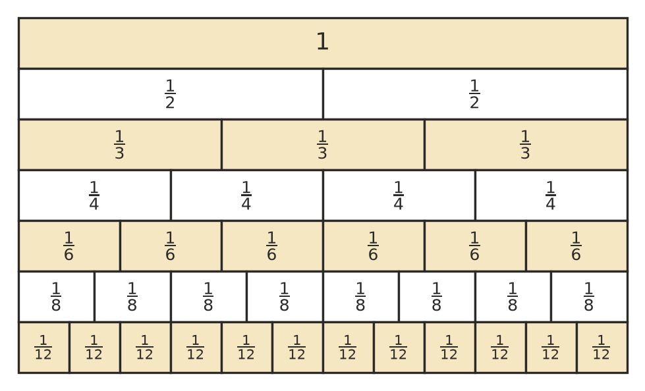
  - Write three fractions on the wall that are equal to $\frac{1}{2}$.
  - $\frac{2}{3}$ = $\frac{▫}{12}$
  - $\frac{5}{6}$ = $\frac{▫}{12}$
  - Which is bigger, $\frac{3}{4}$ or $\frac{5}{8}$?
- Write true or false for each statement.
  - $\frac{4}{6}$ = $\frac{6}{9}$
  - $\frac{9}{12}$ in simplest form is $\frac{3}{4}$.
  - $\frac{15}{25}$ = $\frac{3}{5}$
  - $\frac{10}{14}$ is in simplest form.

 Fluency
- Find the missing number.
  - $\frac{3}{5}$ = $\frac{▫}{20}$
  - $\frac{4}{9}$ = $\frac{▫}{36}$
  - $\frac{7}{8}$ = $\frac{21}{▫}$
  - $\frac{5}{6}$ = $\frac{▫}{42}$
  - $1\frac{3}{4}$ = $1\frac{▫}{12}$
  - $\frac{11}{12}$ = $\frac{55}{▫}$
- Write each fraction in simplest form. Write improper fractions as mixed numbers.
  - $\frac{12}{18}$ =
  - $\frac{15}{20}$ =
  - $\frac{24}{40}$ =
  - $\frac{21}{49}$ =
  - $\frac{36}{48}$ =
  - $\frac{45}{72}$ =
  - $\frac{18}{4}$ =
  - $2\frac{10}{15}$ =
- Find the missing numbers: $\frac{2}{3}$ = $\frac{4}{▫}$ = $\frac{▫}{15}$ = $\frac{20}{▫}$
- Which fraction is not equivalent to the others? $\frac{4}{10}$, $\frac{6}{15}$, $\frac{10}{25}$, $\frac{8}{18}$, $\frac{14}{35}$

 Reasoning
- Explain how you know that $\frac{14}{21}$ and $\frac{10}{15}$ are equivalent.
- Lily simplified $\frac{16}{24}$ and got $\frac{8}{12}$. Is her answer in simplest form? Explain, and finish simplifying if you need to.
- Why can’t $\frac{7}{9}$ be simplified?

 Problem solving
- Of the 32 students at a church camp, 20 chose kayaking as their afternoon activity. What fraction of the students chose kayaking? Write your answer in simplest form.
- In a footy match, a team had 35 scoring shots. 14 of them were goals and the rest were behinds. What fraction of the scoring shots were goals? Write your answer in simplest form.
- A fraction is equivalent to $\frac{3}{4}$. Its numerator and denominator add up to 35. What is the fraction? Show your working.
- A cake recipe uses $\frac{6}{8}$ of a cup of sugar. A muffin recipe uses $\frac{9}{12}$ of a cup. Do they use the same amount of sugar? Explain.

