4.03 Equivalent and simplified fractions
Year 7 Maths · A5 question sheet · Level 1 · Warm-up
This worksheet practises finding equivalent fractions (fractions that are worth the same) and writing fractions in simplest form. Tip: whatever you multiply or divide the numerator by, do the same to the denominator.

 Understanding
- Use the fraction wall to answer each question.
- 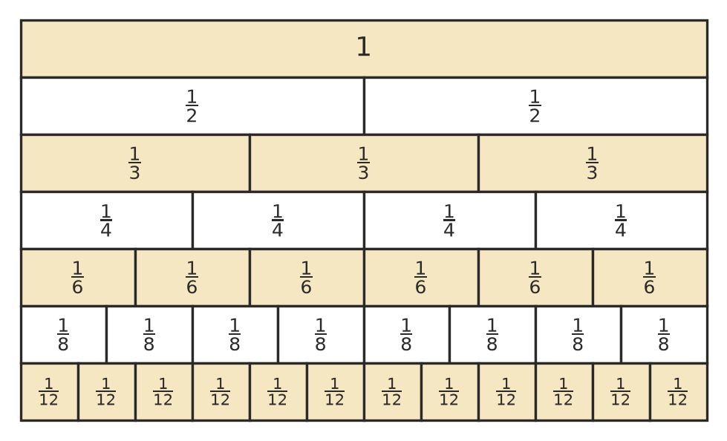
  - How many quarters are the same as $\frac{1}{2}$?
  - How many sixths are the same as $\frac{2}{3}$?
  - $\frac{1}{2}$ = $\frac{▫}{8}$
  - $\frac{3}{4}$ = $\frac{▫}{12}$
  - $\frac{1}{3}$ = $\frac{▫}{12}$
- Look at bars A and B.
- 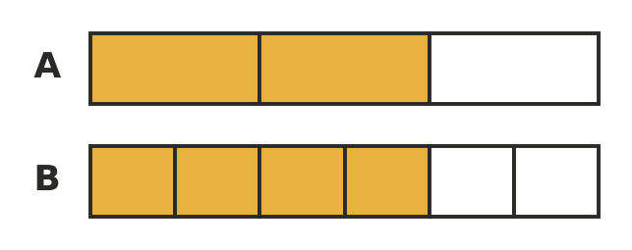
  - What fraction of bar A is shaded?
  - What fraction of bar B is shaded?
  - Write a statement that shows the two fractions are equivalent.
- Write true or false for each statement.
  - $\frac{1}{2}$ = $\frac{2}{4}$
  - $\frac{2}{3}$ = $\frac{3}{4}$
  - $\frac{5}{10}$ = $\frac{1}{2}$
  - Multiplying the numerator and the denominator by the same number gives an equivalent fraction.

 Fluency
- Find the missing number in each pair of equivalent fractions.
  - $\frac{1}{3}$ = $\frac{▫}{6}$
  - $\frac{2}{5}$ = $\frac{▫}{10}$
  - $\frac{3}{4}$ = $\frac{▫}{8}$
  - $\frac{1}{2}$ = $\frac{5}{▫}$
  - $\frac{2}{3}$ = $\frac{8}{▫}$
  - $\frac{3}{7}$ = $\frac{▫}{21}$
- Write each fraction in simplest form.
  - $\frac{2}{4}$ =
  - $\frac{3}{9}$ =
  - $\frac{6}{8}$ =
  - $\frac{5}{15}$ =
  - $\frac{4}{10}$ =
  - $\frac{8}{12}$ =
- Write three different fractions that are equivalent to $\frac{1}{4}$.
- Which of these fractions are equal to $\frac{1}{2}$? Write them down.
- $\frac{3}{6}$, $\frac{4}{9}$, $\frac{6}{12}$, $\frac{5}{8}$, $\frac{10}{20}$

 Reasoning
- Mia says $\frac{3}{6}$ is not in simplest form. Is she right? Explain how to simplify it.
- Jack says $\frac{2}{3}$ = $\frac{3}{4}$, because he added 1 to the top and 1 to the bottom. Explain why Jack is wrong.

 Problem solving
- Josh ate $\frac{3}{8}$ of a pizza. Amy ate $\frac{6}{16}$ of a pizza of the same size. Did they eat the same amount? Explain.
- A footy team won 12 of its 18 games this season. What fraction of its games did it win? Write your answer in simplest form.
- In a class of 20 students, 15 walk to school. What fraction of the class walks to school? Write your answer in simplest form.

