4.02 Negative fractions
Year 7 Maths · Worksheet · Level 2 · Core
Name: ____________________ Date: ______________
This worksheet practises reading, placing and comparing negative fractions and mixed numbers. Tip: to compare two negative fractions, ask which one is closer to zero. The one closer to zero is bigger.

 Understanding
- Write the number at each point. Use a mixed number where you need one.
- 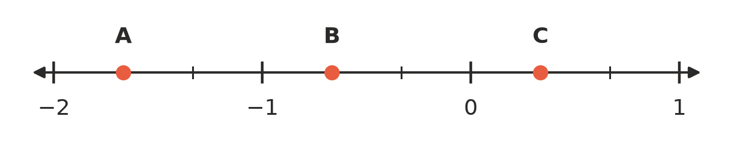
  - A = ______________
  - B = ______________
  - C = ______________
- Write true or false for each statement.
  - $−\frac{5}{4}$ < −1 ______________
  - The opposite of $−1\frac{1}{2}$ is $1\frac{1}{2}$. ______________
  - $−\frac{7}{8}$ is closer to −1 than it is to 0. ______________
  - Every negative fraction is smaller than every positive fraction. ______________
  - $−\frac{1}{10}$ < $−\frac{1}{100}$ ______________

 Fluency
- Write < or > in each box.
  - $−\frac{2}{7}$ □ $−\frac{5}{7}$
  - $−\frac{1}{3}$ □ $−\frac{1}{4}$
  - $−\frac{3}{4}$ □ $−\frac{2}{3}$
  - $−1\frac{1}{2}$ □ $−\frac{5}{4}$
  - $\frac{1}{10}$ □ $−\frac{7}{10}$
  - $−\frac{4}{5}$ □ $−\frac{7}{9}$
- Write each list in order from smallest to largest.
  - $−\frac{3}{8}$, $\frac{1}{4}$, $−\frac{1}{2}$, $−\frac{1}{8}$, 0 ______________
  - $−\frac{5}{3}$, $−1\frac{1}{6}$, $−\frac{3}{2}$, $\frac{1}{3}$ ______________
- Write each improper fraction as a mixed number, and each mixed number as an improper fraction.
  - $−\frac{11}{4}$ = ______________
  - $−2\frac{5}{6}$ = ______________
  - $−\frac{19}{5}$ = ______________
  - $−4\frac{2}{3}$ = ______________
- Mark and label each number on the number line with a dot.
- A: $−1\frac{3}{4}$ B: $−\frac{1}{2}$ C: $\frac{5}{4}$ D: $−\frac{1}{4}$
- 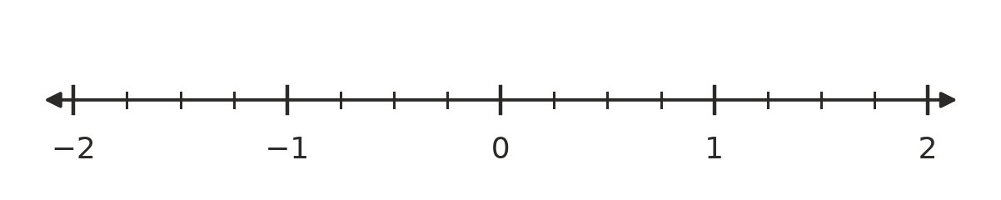

 Reasoning
- $\frac{1}{5}$ is less than $\frac{1}{4}$, but $−\frac{1}{5}$ is greater than $−\frac{1}{4}$. Explain why.

- Jade says the number halfway between $−\frac{1}{2}$ and $\frac{1}{2}$ is 0. Is she right? What number is halfway between $−\frac{3}{4}$ and $\frac{1}{4}$? Explain.

 Problem solving
- A farmer measures the water level in her dam each day, in metres compared with a mark on a post. Below the mark is negative. Monday: $−1\frac{1}{4}$, Tuesday: $−\frac{3}{4}$, Wednesday: $−1\frac{1}{2}$, Thursday: $−\frac{5}{8}$, Friday: −1.
  - Write the days in order from lowest water level to highest. ______________
  - On which day was the water level closest to the mark? ______________

- Fractions in between.
  - Write the only fraction with a denominator of 6 that lies between $−\frac{2}{3}$ and $−\frac{1}{3}$. ______________
  - Write every fraction with a denominator of 12 that lies between $−\frac{2}{3}$ and $−\frac{1}{3}$. ______________
- A frog sits on $\frac{1}{2}$ on a giant number line. Each jump takes it $\frac{1}{4}$ to the left.
  - Where is the frog after 1, 2, 3 and 4 jumps? ______________
  - After how many jumps does the frog land on −2? ______________

- These are the temperatures, in °C, at five places in the snowfields early one morning. Write them in order from coldest to warmest.
- $−2\frac{1}{2}$, $−1\frac{3}{4}$, $−2\frac{1}{4}$, −3, $−\frac{1}{2}$

