4.01 Identify, order and compare fractions
Year 7 Maths · Worksheet · Level 3 · Challenge
Name: ____________________ Date: ______________
This worksheet stretches your skills with number lines that don’t start at zero, harder comparisons and problems with more than one step. Tip: a quick way to find a common denominator is to look for the smallest number that both denominators divide into.

 Understanding
- This number line starts at 1. Write the number at each point as a mixed number and as an improper fraction.
- 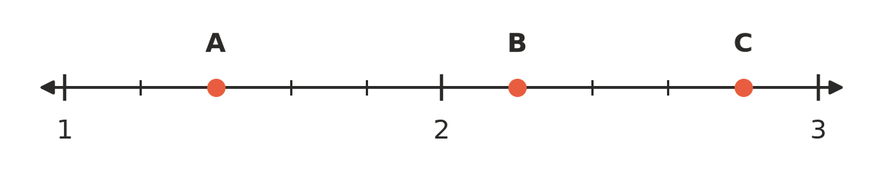
  - A = ______________
  - B = ______________
  - C = ______________
- The square below is cut into parts that are not all the same size. What fraction of the whole square is shaded? Explain how you know.
- 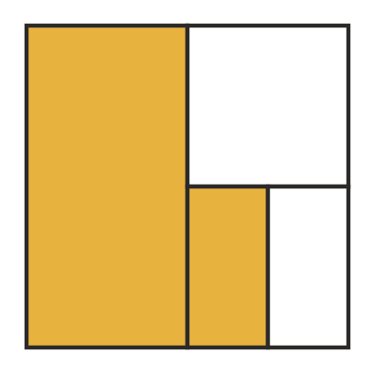

- Which of these fractions is closest to 1? Explain.
- $\frac{5}{6}$, $\frac{9}{10}$, $\frac{7}{8}$, $\frac{11}{12}$

 Fluency
- Write <, > or = in each box.
  - $\frac{7}{12}$ □ $\frac{5}{8}$
  - $\frac{11}{15}$ □ $\frac{8}{11}$
  - $3\frac{5}{9}$ □ $\frac{32}{9}$
  - $\frac{13}{18}$ □ $\frac{17}{24}$
  - $2\frac{4}{7}$ □ $2\frac{3}{5}$
- Write each list in order from smallest to largest.
  - $\frac{5}{8}$, $\frac{7}{12}$, $\frac{2}{3}$, $\frac{13}{24}$ ______________
  - $\frac{17}{6}$, $2\frac{3}{4}$, $\frac{23}{8}$, $2\frac{7}{9}$ ______________
- Convert each number.
  - $\frac{47}{6}$ as a mixed number ______________
  - $9\frac{4}{11}$ as an improper fraction ______________
  - $\frac{100}{7}$ as a mixed number ______________
  - $12\frac{5}{8}$ as an improper fraction ______________
- Find the fraction exactly halfway between each pair.
  - $\frac{1}{4}$ and $\frac{1}{2}$ ______________
  - $\frac{2}{3}$ and $\frac{3}{4}$ ______________
  - $1\frac{1}{5}$ and $1\frac{1}{2}$ ______________

 Reasoning
- Which is bigger, $\frac{2023}{2024}$ or $\frac{2024}{2025}$? Explain without using a calculator.

- Sienna says: “If you add 1 to the numerator and 1 to the denominator of a proper fraction, the fraction gets bigger.” Test her idea with two examples, then explain why it works.

- Use two different digits from 2, 3, 5 and 7 to make proper fractions (one digit on top, one digit on the bottom).
  - What is the largest fraction you can make? ______________
  - What is the smallest fraction you can make? ______________
  - Which fraction you can make is closest to $\frac{1}{2}$? ______________

 Problem solving
- Four friends are walking the same bushwalk. Ruby has walked $\frac{7}{10}$ of the track, Zac $\frac{2}{3}$, Isla $\frac{5}{8}$ and Mason $\frac{3}{4}$.
  - Put them in order from furthest along to least far. ______________
  - There is a lookout exactly $\frac{2}{3}$ of the way along the track. Who has walked past the lookout? ______________

- Two footy players are comparing their goal kicking. Harvey kicked 11 goals from 15 shots. Lachie kicked 13 goals from 18 shots. Who kicked goals from the bigger fraction of their shots? Show your working.

- Write every fraction with a denominator of 12 that lies between $\frac{1}{3}$ and $\frac{3}{4}$ (not including $\frac{1}{3}$ and $\frac{3}{4}$). ______________

- A number line from 0 to 1 is split into equal parts. The fractions $\frac{3}{5}$ and $\frac{2}{3}$ both land exactly on marks. What is the smallest number of equal parts the line could be split into? Explain.

