4.01 Identify, order and compare fractions
Year 7 Maths · Worksheet · Level 1 · Warm-up
Name: ____________________ Date: ______________
This worksheet practises reading fractions from pictures and number lines, and comparing them. Tip: the denominator (bottom number) tells you how many equal parts the whole is cut into. The numerator (top number) tells you how many of those parts you have.

 Understanding
- What fraction of each shape is shaded?
- 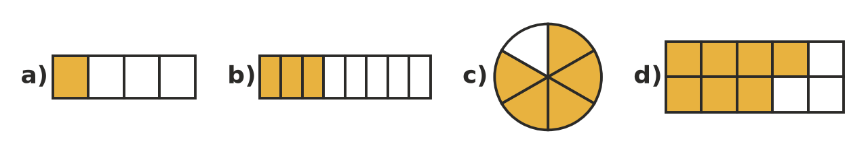
  - ______________
  - ______________
  - ______________
  - ______________
- Look at the fraction $\frac{5}{9}$.
  - What is the numerator? ______________
  - What is the denominator? ______________
  - How many equal parts is the whole split into? ______________
- Write each of these as a fraction.
  - three quarters ______________
  - two fifths ______________
  - seven tenths ______________
  - five out of twelve ______________
- The number line from 0 to 1 is split into equal parts. Write the fraction at each point.
- 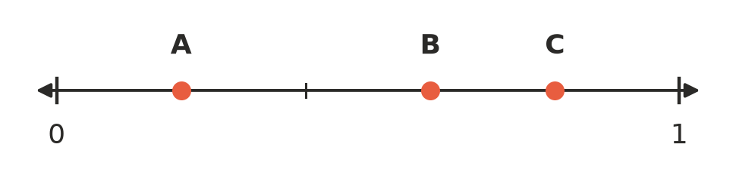
  - A = ______________
  - B = ______________
  - C = ______________

 Fluency
- Write < or > in each box to make the statement true.
  - $\frac{1}{3}$ □ $\frac{2}{3}$
  - $\frac{5}{8}$ □ $\frac{3}{8}$
  - $\frac{1}{2}$ □ $\frac{1}{5}$
  - $\frac{1}{6}$ □ $\frac{1}{4}$
  - $\frac{3}{4}$ □ $\frac{3}{7}$
  - $\frac{7}{10}$ □ $\frac{9}{10}$
- Write each list in order from smallest to largest.
  - $\frac{3}{7}$, $\frac{1}{7}$, $\frac{6}{7}$, $\frac{4}{7}$ ______________
  - $\frac{1}{3}$, $\frac{1}{8}$, $\frac{1}{2}$, $\frac{1}{5}$ ______________
- Write each improper fraction as a mixed number, and each mixed number as an improper fraction.
  - $\frac{7}{4}$ = ______________
  - $\frac{9}{2}$ = ______________
  - $\frac{11}{3}$ = ______________
  - $1\frac{2}{5}$ = ______________
  - $2\frac{3}{4}$ = ______________
- Is each number less than 1, equal to 1 or greater than 1? Fill in the table.
Number | Less than 1, equal to 1 or greater than 1?
$\frac{4}{5}$
$\frac{6}{6}$
$\frac{9}{8}$
$2\frac{1}{3}$
$\frac{3}{10}$

 Reasoning
- Sam says that $\frac{1}{8}$ is bigger than $\frac{1}{4}$ because 8 is bigger than 4. Explain why Sam is wrong.

- A pizza is cut into 6 equal slices. Ella eats 2 slices and Tom eats 3 slices.
  - What fraction of the pizza did Ella eat? ______________
  - What fraction of the pizza did Tom eat? ______________
  - Who ate more? ______________
  - What fraction of the pizza is left? ______________

 Problem solving
- A footy team kicked 7 goals in the first half and 5 goals in the second half. What fraction of the team’s goals were kicked in the first half? ______________
- Three friends started the same fun run course. Ava ran $\frac{3}{4}$ of the course, Ben ran $\frac{3}{5}$ and Chloe ran $\frac{3}{8}$ before they stopped for a drink. Who had run the furthest? Explain how you know.

