4.01 Identify, order and compare fractions
Year 7 Maths · A5 question sheet · Level 2 · Core
This worksheet practises naming fractions, switching between mixed numbers and improper fractions, and comparing fractions with different denominators. Tip: to compare two fractions, rewrite them with the same denominator first. Then the bigger numerator wins.

 Understanding
- What fraction of each picture is shaded? For part c), write your answer as a mixed number and as an improper fraction.
  - 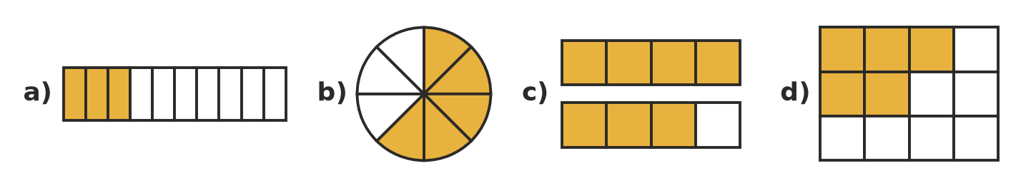

- Write the number at each point as a fraction or mixed number, and then as an improper fraction where you can.
- 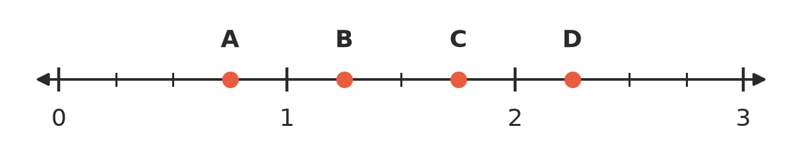
  - A =
  - B =
  - C =
  - D =
- Write true or false for each statement.
  - $\frac{7}{7}$ = 1
  - $\frac{5}{3}$ is a proper fraction.
  - $\frac{1}{10}$ > $\frac{1}{9}$
  - $2\frac{1}{2}$ = $\frac{5}{2}$

 Fluency
- Write each improper fraction as a mixed number.
  - $\frac{13}{5}$ =
  - $\frac{17}{4}$ =
  - $\frac{23}{6}$ =
  - $\frac{31}{8}$ =
- Write each mixed number as an improper fraction.
  - $3\frac{2}{7}$ =
  - $4\frac{5}{6}$ =
  - $6\frac{3}{10}$ =
  - $2\frac{8}{9}$ =
- Write <, > or = in your book. Rewrite the fractions with the same denominator to help you.
  - $\frac{2}{3}$ □ $\frac{3}{4}$
  - $\frac{5}{6}$ □ $\frac{7}{9}$
  - $\frac{3}{5}$ □ $\frac{7}{10}$
  - $\frac{4}{9}$ □ $\frac{1}{2}$
  - $1\frac{2}{5}$ □ $\frac{7}{5}$
  - $\frac{11}{4}$ □ $2\frac{2}{3}$
- Write each list in order from smallest to largest.
  - $\frac{1}{2}$, $\frac{2}{5}$, $\frac{3}{4}$, $\frac{7}{10}$
  - $\frac{5}{3}$, $1\frac{1}{2}$, $\frac{7}{4}$, $1\frac{5}{12}$

 Reasoning
- Without finding a common denominator, explain how you know that $\frac{7}{8}$ is bigger than $\frac{6}{7}$. (Hint: how far is each one from 1?)
- Leo says that $\frac{3}{4}$ of a pizza is always more than $\frac{1}{2}$ of a pizza. Mia says, “Not if my half comes from a much bigger pizza.” Who is right? Explain.
- Fractions in between.
  - Write the only fraction with a denominator of 10 that lies between $\frac{2}{5}$ and $\frac{3}{5}$.
  - Write a fraction that lies between $\frac{1}{3}$ and $\frac{1}{2}$.

 Problem solving
- Jack, Priya and Noah each have the same size water bottle. Jack has drunk $\frac{2}{3}$ of his, Priya has drunk $\frac{5}{8}$ of hers and Noah has drunk $\frac{3}{4}$ of his. Who has drunk the most, and who has drunk the least? Show your working.
- Three classes are selling raffle tickets for a fundraiser. Each class has the same number of tickets. 7A has sold $\frac{5}{6}$ of its tickets, 7B has sold $\frac{7}{9}$ and 7C has sold $\frac{11}{12}$. Put the classes in order from most tickets sold to least. Show your working.
- On a family road trip, the Nguyens pass three towns. Town A is $\frac{3}{8}$ of the way, Town B is $\frac{2}{3}$ of the way and Town C is $\frac{5}{12}$ of the way.
  - In what order do they reach the towns?
  - Which town is closest to the halfway point of the trip?

