9.04 Two-step equations
Year 7 Maths · Worksheet · Level 3 · Challenge
Name: ____________________ Date: ______________
This worksheet extends two-step equations to larger numbers, fractions, brackets and longer word problems. Tip: write each step on a new line, doing the same thing to both sides. Check your answer in the original equation, not in a line of your own working.

 Understanding
- Write an equation for each description, then solve it by working backwards.
  - Start with $x$, multiply by 7, then subtract 11. The result is 52. ______________
  - Start with $x$, add 9, then divide by 4. The result is 6. ______________
- The equations $\frac{x}{3}+4=10$ and $\frac{x+4}{3}=10$ look alike. Explain why their first steps are different, then solve both.

 Fluency
- Solve each equation.
  - $12x+17=113$ ______________
  - $15y−28=167$ ______________
  - $250=9m+25$ ______________
  - $\frac{k}{8}+13=20$ ______________
  - $\frac{3a}{4}=18$ ______________
  - $\frac{n}{6}−7=5$ ______________
- Solve each equation.
  - $5(x−3)=45$ ______________
  - $\frac{y+11}{5}=7$ ______________
  - $4(2m+1)=60$ ______________
  - $\frac{3k−4}{5}=4$ ______________
  - $50−3p=14$ ______________
  - $\frac{84}{x}+5=12$ ______________
- Collect like terms first, then solve.
  - $3x+2x+4=39$ ______________
  - $7y−3y−5=43$ ______________

 Reasoning
- Noah started to solve $3(x+4)=27$ like this: “$3x+4=27$, so $3x=23$.” He then got stuck. Explain his mistake and find the correct solution.

- Explain why $4x+3=30$ has no whole-number solution. Then change the number 30 so that the equation does have a whole-number solution, and solve your new equation.

- Write a two-step equation whose solution is $x=8$ and whose first solving step is “add 5 to both sides”. ______________

 Problem solving
For each question, write an equation, solve it and answer the question.
- Ava is $a$ years old. Her mum’s age is 2 more than 4 times Ava’s age. Her mum is 46. How old is Ava?

- A phone plan has a $40 start-up fee, then costs $15 per month. Lily has paid $220 so far. For how many months, $m$, has she had the plan?

- This isosceles triangle has a perimeter of 50 cm. Find the length of each equal side, $s$.
- 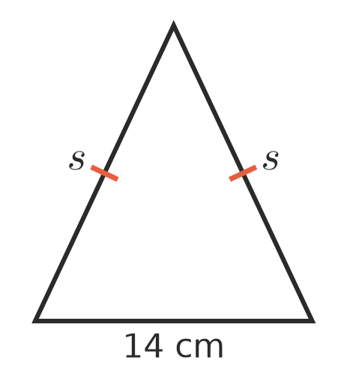

- For a sausage sizzle, the Year 7s pay $85 for supplies. They sell each sausage for $3. They want to make a profit of $200 after paying for supplies. How many sausages, $s$, do they need to sell?

- Four friends share the cost of a $12 pizza and some drinks equally. The drinks cost $d$ dollars, and each friend pays $7. How much did the drinks cost?

- Jess thinks of a number, subtracts 6, then multiplies the result by 5. Her answer is 65. What number did she think of?

