9.04 Two-step equations
Year 7 Maths · Worksheet · Level 2 · Core
Name: ____________________ Date: ______________
This worksheet practises solving two-step equations, including ones with fractions and brackets. Tip: work backwards. Undo the last thing that was done to the variable first, and do the same to both sides each time. Check your solution by substituting it into the original equation.

 Understanding
- This flowchart shows what happens to $x$.
- 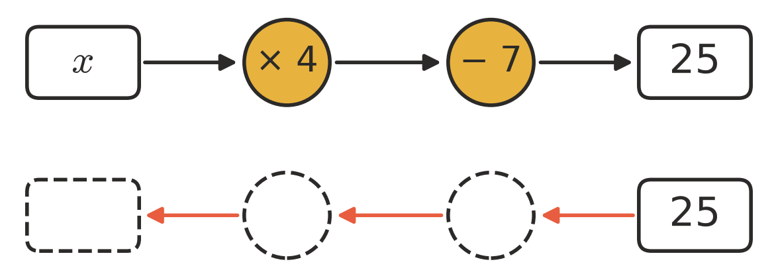
  - Write the equation shown by the top row. ______________
  - Fill in the bottom row by working backwards. Then write the solution. $x$ = ______________
- To solve $\frac{x}{3}+5=9$, you need these two steps:
- Step P: Multiply both sides by 3.
- Step Q: Subtract 5 from both sides.
  - Which step comes first, P or Q? ______________
  - Solve the equation. ______________

 Fluency
- Solve each equation.
  - $3x+7=31$ ______________
  - $5y−9=41$ ______________
  - $8m+3=59$ ______________
  - $7k−12=51$ ______________
  - $4+6a=70$ ______________
  - $9n−15=93$ ______________
- Solve each equation.
  - $\frac{x}{4}+6=11$ ______________
  - $\frac{y}{7}−2=3$ ______________
  - $\frac{m}{3}+8=17$ ______________
  - $\frac{2k}{5}=6$ ______________
- Solve each equation.
  - $2(x+4)=18$ ______________
  - $3(y−2)=21$ ______________
  - $\frac{m+6}{2}=10$ ______________
  - $\frac{n−4}{3}=5$ ______________
- Solve $35=4x+3$. Then check your answer by substituting it back in.

 Reasoning
- Here is Grace’s working to solve $\frac{x}{2}−3=5$.
- Step 1: $\frac{x}{2}=2$
- Step 2: $x=4$
- Explain her mistake and give the correct solution.

- Solve $2(x+5)=24$ and $2x+5=25$. Explain why the two equations have different solutions even though they use similar numbers.

 Problem solving
- Write an equation for each sentence, using $n$ for the number. Then solve it.
  - Multiply a number by 6, then subtract 8. The answer is 46. ______________
  - Divide a number by 4, then add 9. The answer is 15. ______________
  - Add 5 to a number, then double the result. The answer is 34. ______________
For Questions 10 to 13, write an equation, solve it and answer the question.
- A taxi charges $4 to start, plus $3 for each kilometre. A trip cost $43. How many kilometres, $k$, was the trip?

- Five concert tickets plus a $12 booking fee cost $197 altogether. What is the price of one ticket, $t$?

- A rectangle has a length of 15 cm and a width of $w$ cm. Its perimeter is 48 cm. Find its width.

- Church camp costs $40 per night, plus $25 for the bus. Sam paid $185. How many nights, $n$, is the camp?

