9.04 Two-step equations
Year 7 Maths · A5 question sheet · Level 1 · Warm-up
This worksheet practises solving two-step equations. Tip: undo the operations in reverse order. Undo any adding or subtracting first, then undo the multiplying or dividing. For example, for $3x+2=14$: subtract 2 from both sides to get $3x=12$, then divide both sides by 3 to get $x=4$.

 Understanding
- This flowchart shows what happens to $x$.
- 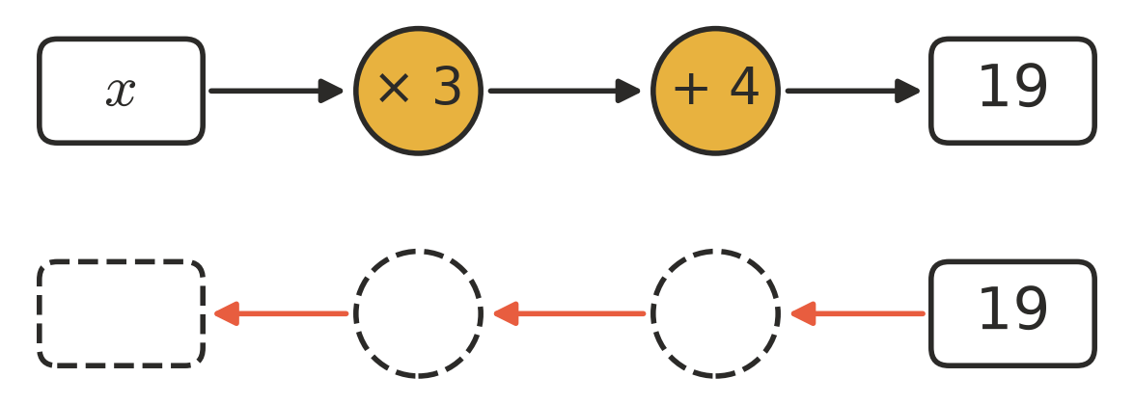
  - Write the equation shown by the top row.
  - Copy and fill in the bottom row by working backwards with the inverse operations. Then write the solution. $x$ =
- The scales are balanced. Each bag weighs $x$ kg and each small block weighs 1 kg.
- 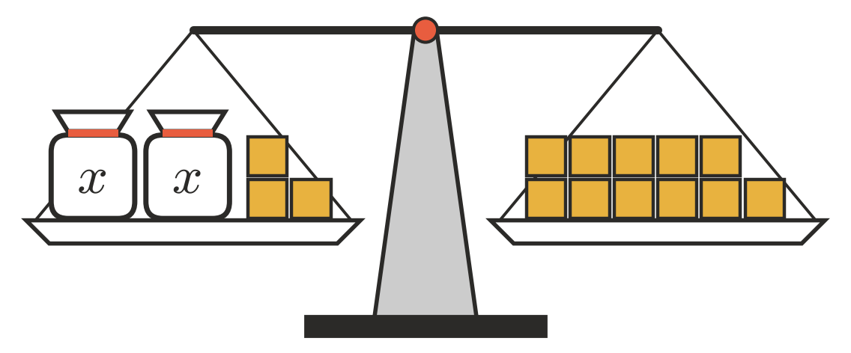
  - Write an equation for the balance.
  - Take 3 blocks off both sides. Write the new equation.
  - Find the weight of one bag. $x$ =
- Copy and fill in the gaps to solve $5x−2=18$.
- Add 2 to both sides: $5x$ =
- Divide both sides by 5: $x$ =

 Fluency
- Solve each equation.
  - $2x+1=9$
  - $3y+5=20$
  - $4m−3=25$
  - $5k−1=29$
  - $2a+7=25$
  - $6n−4=44$
- Solve each equation.
  - $\frac{x}{2}+3=8$
  - $\frac{y}{3}−1=4$
  - $\frac{m}{5}+2=6$
- Solve $3x+8=26$. Then check your answer by substituting it back in.

 Reasoning
- Kai solved $2x+6=20$ like this: “Divide by 2 to get $x+6=10$, so $x=4$.” Substitute $x=4$ to show that Kai is wrong. Then find the correct solution.
- To solve $4x−5=31$, which step should you do first? Explain why, then solve it.

 Problem solving
- I think of a number, multiply it by 3, then add 4. The answer is 25.
  - Write an equation, using $n$ for the number.
  - Solve it to find the number.
- Pool entry costs $5 per person, plus $2 for parking. A family paid $22 altogether. Let $p$ be the number of people.
  - Write an equation.
  - How many people were in the family?
- Charlie has $10. He saves $6 each week. After $w$ weeks he has $46.
  - Write an equation.
  - How many weeks has he been saving?

