9.03 One-step equations
Year 7 Maths · Worksheet · Level 2 · Core
Name: ____________________ Date: ______________
This worksheet practises solving one-step equations and writing them from word problems. Tip: an equation is like a balance. Whatever you do to one side, do the same to the other side so it stays balanced. Then check your answer by substituting it back into the equation.

 Understanding
- The scales are balanced. Each bag weighs $x$ kg and each small block weighs 1 kg.
- 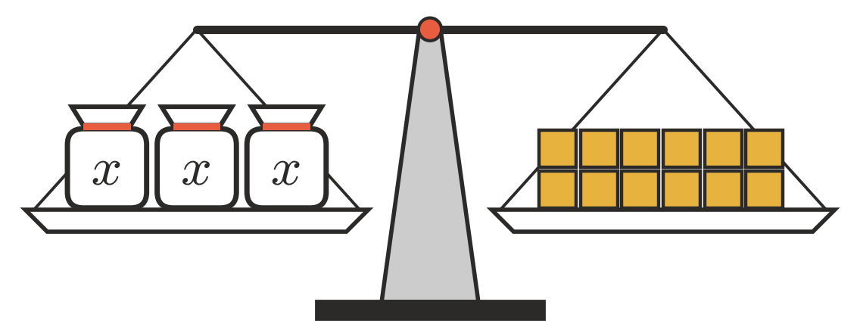
  - Write an equation for the balance. ______________
  - What should you do to both sides to find the weight of one bag? ______________
  - Solve the equation. $x$ = ______________
- Write the operation you would do to both sides to solve each equation.
  - $x+14=30$ ______________
  - $x−9=4$ ______________
  - $8x=56$ ______________
  - $\frac{x}{5}=6$ ______________

 Fluency
- Solve each equation.
  - $x+23=41$ ______________
  - $y−17=38$ ______________
  - $9m=81$ ______________
  - $\frac{k}{6}=7$ ______________
  - $45=n+19$ ______________
  - $12p=144$ ______________
  - $\frac{w}{8}=12$ ______________
  - $t−36=64$ ______________
- Solve each equation.
  - $56=7a$ ______________
  - $63+b=100$ ______________
  - $13=\frac{c}{3}$ ______________
  - $11d=132$ ______________
  - $250=g−175$ ______________
- Solve $15x=225$. Then check your answer by substituting it back in.

 Reasoning
- Chloe solved $\frac{x}{4}=20$ by dividing both sides by 4. She got $x=5$. Explain her mistake and give the correct answer.

- Explain how to solve $30−x=12$, then solve it. (Careful: $x$ is being subtracted from 30.)

- Write a one-step equation that has the solution $x=7$ and uses:
  - addition ______________
  - multiplication ______________
  - division ______________

 Problem solving
- Write an equation for each sentence, using $n$ for the number. Then solve it.
  - A number multiplied by 8 is 96. ______________
  - A number divided by 7 is 9. ______________
  - 26 less than a number is 50. ______________
- Sausage rolls cost $4 each at the canteen. Ben spent $28 on $s$ sausage rolls. Write an equation and solve it to find how many he bought.

- On a road trip, a family drives $d$ km before lunch and 185 km after lunch. They drive 460 km altogether. Write an equation and solve it to find how far they drove before lunch.

- The Year 7s raised $m$ dollars at a fundraiser. They shared it equally among 6 charities, and each charity got $85. Write an equation and solve it to find how much they raised.

- A rectangle has an area of 72 cm². Its width is 6 cm and its length is $l$ cm. Write an equation and solve it to find the length.

