9.03 One-step equations
Year 7 Maths · Worksheet · Level 1 · Warm-up
Name: ____________________ Date: ______________
This worksheet practises solving one-step equations with inverse (opposite) operations. Tip: do the opposite operation to both sides. Adding and subtracting undo each other, and so do multiplying and dividing. For example, $x+5=12$ gives $x$ = 12 − 5 = 7.

 Understanding
- Write the inverse operation that undoes each one.

    - 8 ______________
  - − 3 ______________
  - × 4 ______________
  - ÷ 6 ______________
- The scales are balanced. The bag weighs $x$ kg and each small block weighs 1 kg.
- 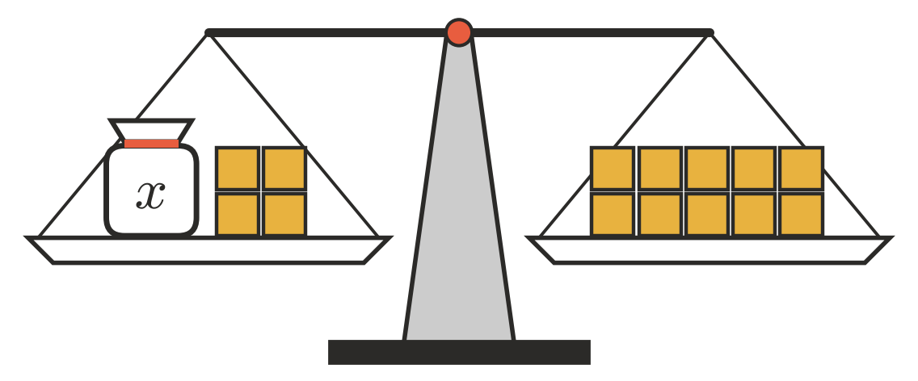
  - Write an equation for the balance. ______________
  - How many blocks should you take off both sides to leave the bag on its own? ______________
  - Solve the equation. $x$ = ______________
- Fill in the gaps.
  - $x+9=15$, so $x$ = 15 − ……. = ______________
  - $4m=28$, so $m$ = 28 ÷ ……. = ______________

 Fluency
- Solve each equation.
  - $x+6=14$ ______________
  - $y+11=20$ ______________
  - $m−4=9$ ______________
  - $k−7=15$ ______________
  - $3a=18$ ______________
  - $5n=40$ ______________
  - $\frac{p}{2}=9$ ______________
  - $\frac{t}{4}=5$ ______________
- Solve each equation.
  - $12+x=30$ ______________
  - $7w=63$ ______________
  - $\frac{r}{10}=6$ ______________
  - $d−15=25$ ______________
- Solve $6x=42$. Then check your answer by substituting it back in.
- $x$ = ______________
- Check: 6 × ……. = ______________

 Reasoning
- Jack solved $x−5=12$ and got $x=7$. Explain his mistake and give the correct answer.

- Which operation would you use to solve $\frac{m}{3}=8$? Explain why, then solve it.

 Problem solving
- Ella’s age plus 5 is 17. Let $a$ be Ella’s age.
  - Write an equation. ______________
  - Solve it to find Ella’s age. ______________
- Four friends share the cost of some pizzas equally. Each person pays $9. Let $c$ be the total cost in dollars.
  - Write an equation. ______________
  - What was the total cost? ______________
- Mr Scott buys $b$ boxes of eggs. There are 6 eggs in each box, and he has 54 eggs altogether.
  - Write an equation. ______________
  - How many boxes did he buy? ______________
- A hike is 21 km long. After walking 8 km, the group still has $d$ km to go.
  - Write an equation. ______________
  - How far does the group still have to walk? ______________

