9.03 One-step equations
Year 7 Maths · A5 question sheet · Level 1 · Warm-up
This worksheet practises solving one-step equations with inverse (opposite) operations. Tip: do the opposite operation to both sides. Adding and subtracting undo each other, and so do multiplying and dividing. For example, $x+5=12$ gives $x$ = 12 − 5 = 7.

 Understanding
- Write the inverse operation that undoes each one.

    - 8
  - − 3
  - × 4
  - ÷ 6
- The scales are balanced. The bag weighs $x$ kg and each small block weighs 1 kg.
- 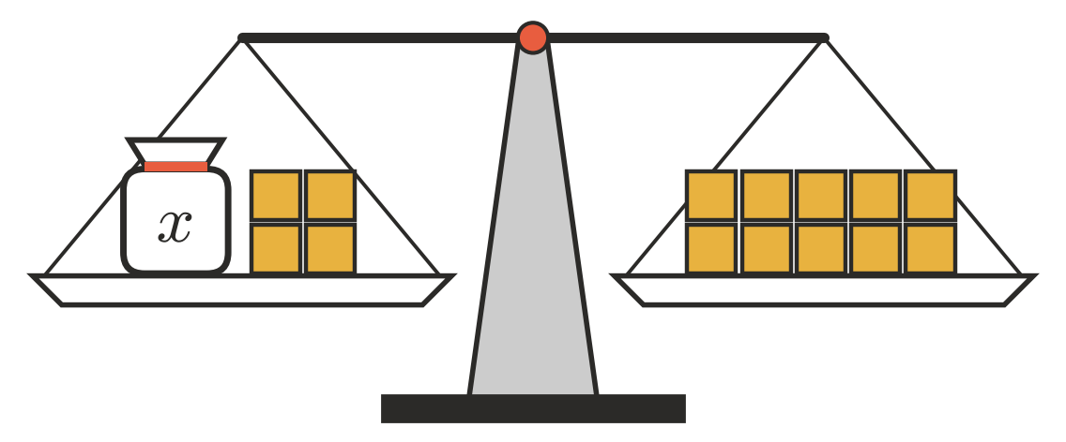
  - Write an equation for the balance.
  - How many blocks should you take off both sides to leave the bag on its own?
  - Solve the equation. $x$ =
- Copy and fill in the gaps.
  - $x+9=15$, so $x$ = 15 − ______________ =
  - $4m=28$, so $m$ = 28 ÷ ______________ =

 Fluency
- Solve each equation.
  - $x+6=14$
  - $y+11=20$
  - $m−4=9$
  - $k−7=15$
  - $3a=18$
  - $5n=40$
  - $\frac{p}{2}=9$
  - $\frac{t}{4}=5$
- Solve each equation.
  - $12+x=30$
  - $7w=63$
  - $\frac{r}{10}=6$
  - $d−15=25$
- Solve $6x=42$. Then check your answer by substituting it back in.
- $x$ =
- Check: 6 × ______________ =

 Reasoning
- Jack solved $x−5=12$ and got $x=7$. Explain his mistake and give the correct answer.
- Which operation would you use to solve $\frac{m}{3}=8$? Explain why, then solve it.

 Problem solving
- Ella’s age plus 5 is 17. Let $a$ be Ella’s age.
  - Write an equation.
  - Solve it to find Ella’s age.
- Four friends share the cost of some pizzas equally. Each person pays $9. Let $c$ be the total cost in dollars.
  - Write an equation.
  - What was the total cost?
- Mr Scott buys $b$ boxes of eggs. There are 6 eggs in your book, and he has 54 eggs altogether.
  - Write an equation.
  - How many boxes did he buy?
- A hike is 21 km long. After walking 8 km, the group still has $d$ km to go.
  - Write an equation.
  - How far does the group still have to walk?

