9.02 Write rules for relationships
Year 7 Maths · Worksheet · Level 2 · Core
Name: ____________________ Date: ______________
This worksheet practises writing rules for tables of values and growing patterns. Tip: find how much $y$ changes each time $x$ goes up by 1. That is the number you multiply $x$ by. Then work out what you need to add or subtract to get the first value right. Always check your rule with another column of the table.

 Understanding
- Complete the table of values for each rule.
$x$ | 1 | 2 | 3 | 4 | 5
$y=5x$
$y=4x+1$
$y=2x+6$

- Write each rule using algebra.
  - $y$ is 7 more than $x$. ______________
  - $y$ is 4 times $x$. ______________
  - $y$ is 2 less than 5 times $x$. ______________
  - $y$ is half of $x$. ______________
- Which rule matches this table? Answer: ______________
$x$ | 1 | 2 | 3
$y$ | 4 | 7 | 10

  - $y=x+3$
  - $y=3x+1$
  - $y=4x$
  - $y=2x+2$

 Fluency
- Each row shows the values of $y$ when $x$ = 1, 2, 3, 4 and 5. Write the rule for each row in the last column.
 | $x=1$ | $x=2$ | $x=3$ | $x=4$ | $x=5$ | Rule
a) $y$ | 9 | 10 | 11 | 12 | 13
b) $y$ | 7 | 14 | 21 | 28 | 35
c) $y$ | 5 | 8 | 11 | 14 | 17
d) $y$ | 3 | 7 | 11 | 15 | 19
e) $y$ | 28 | 25 | 22 | 19 | 16

- Write a rule for $y$ in terms of $x$. Careful: this table starts at $x=0$.
$x$ | 0 | 1 | 2 | 3 | 4
$y$ | 6 | 11 | 16 | 21 | 26

- Rule: ______________
- Write a rule for $y$ in terms of $x$.
$x$ | 2 | 4 | 6 | 8 | 10
$y$ | 1 | 2 | 3 | 4 | 5

- Rule: ______________
- A number pattern starts at 4 and goes up by 6 each time: 4, 10, 16, 22, …
  - Write a rule for $y$, the $n$th number in the pattern. ______________
  - Use your rule to find the 20th number. ______________

 Reasoning
- Ruby found the rule $y=2x+3$ for this table by checking only the first column.
$x$ | 1 | 2 | 3 | 4
$y$ | 5 | 8 | 11 | 14

  - Is Ruby right? Explain. ______________
  - Write the correct rule. ______________
- The rule for a table is $y=6x−4$. Ella says that when $y=32$, $x=6$. Is she right? Show how you know.

- The values in this table follow a rule of the form $y$ = □$x$ + □. Find the rule, then fill in the three gaps.
$x$ | 1 | 2 | 3 | 4 |  | 10
$y$ | 7 | 11 | 15 |  | 31

- Rule: ______________

 Problem solving
- Here is a growing pattern of squares.
- 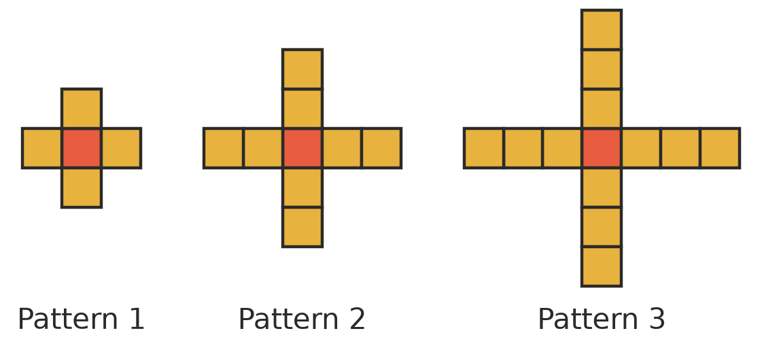
Pattern number, $n$ | 1 | 2 | 3 | 4 | 5
Number of squares, $s$ | 5 | 9 | 13

  - Complete the table.
  - Write a rule for $s$ using $n$. ______________
  - How many squares are in Pattern 15? ______________
  - Which pattern has 101 squares? ______________
- Hiring a canoe costs $12 per hour, plus a $10 fee for life jackets.
Hours, $h$ | 1 | 2 | 3 | 4
Cost in dollars, $C$

  - Complete the table.
  - Write a rule for $C$ using $h$. ______________
  - How much does it cost to hire a canoe for 6 hours? ______________
- A farm water tank holds 200 L. Each day, 15 L is used.
  - Write a rule for the water left, $W$ litres, after $d$ days. ______________
  - How much water is left after 8 days? ______________
  - After how many days will 50 L be left? ______________
- On a school camp there must be 1 leader for every 8 students.
  - Write a rule for the number of leaders, $L$, needed for $s$ students. ______________
  - How many leaders are needed for 96 students? ______________

