9.02 Write rules for relationships
Year 7 Maths · Worksheet · Level 1 · Warm-up
Name: ____________________ Date: ______________
This worksheet practises finding the rule that links two numbers in a table or a pattern. Tip: look at how much $y$ goes up each time $x$ goes up by 1. If $y$ goes up by 3 each time, the rule starts with $y=3x$. Then check whether you need to add or subtract a number.

 Understanding
- Complete the table using the rule $y=x+4$.
$x$ | 1 | 2 | 3 | 4 | 5
$y$

- Complete the table using the rule $y=3x$.
$x$ | 1 | 2 | 3 | 4 | 5
$y$

- Write each rule using algebra.
  - $y$ is 3 more than $x$. ______________
  - $y$ is 3 times $x$. ______________
  - $y$ is 3 less than $x$. ______________
- Which rule matches this table? Answer: ______________
$x$ | 1 | 2 | 3 | 4
$y$ | 2 | 4 | 6 | 8

  - $y=x+2$
  - $y=2x$
  - $y=x+1$
  - $y=4x$

 Fluency
- Each row of the table shows the values of $y$ when $x$ = 1, 2, 3, 4 and 5. Write the rule for each row in the last column.
 | $x=1$ | $x=2$ | $x=3$ | $x=4$ | $x=5$ | Rule
a) $y$ | 6 | 7 | 8 | 9 | 10
b) $y$ | 4 | 8 | 12 | 16 | 20
c) $y$ | 0 | 1 | 2 | 3 | 4
d) $y$ | 10 | 20 | 30 | 40 | 50

- Look at this table.
$x$ | 1 | 2 | 3 | 4
$y$ | 4 | 7 | 10 | 13

  - How much does $y$ go up each time $x$ goes up by 1? ______________
  - Complete the rule: $y$ = ……. × $x$ + ______________
- Complete the table using the rule $y=2x+3$.
$x$ | 1 | 2 | 3 | 4 | 5
$y$

 Reasoning
- Ben looked at this table and said the rule is $y=x+2$, because 1 + 2 = 3.
$x$ | 1 | 2 | 3 | 4
$y$ | 3 | 5 | 7 | 9

  - Explain why Ben’s rule is wrong. ______________
  - Write the correct rule. ______________

 Problem solving
- Tables are pushed together in a row for a youth group dinner. The pictures show how many people can sit around them.
- 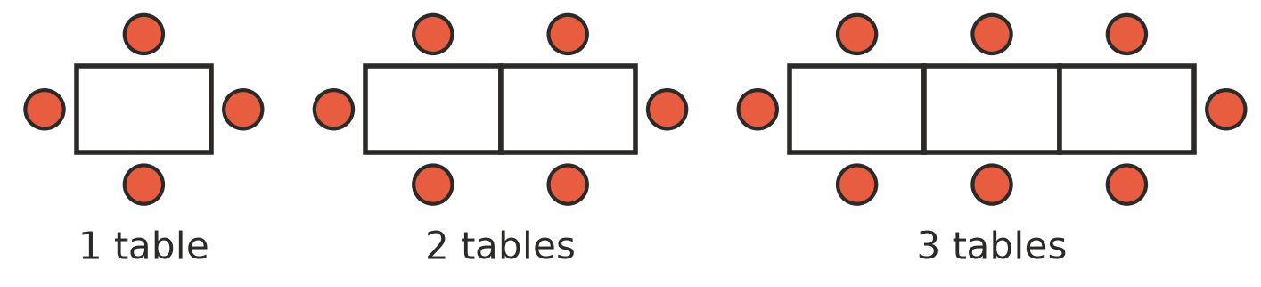
Number of tables, $t$ | 1 | 2 | 3 | 4 | 5
Number of people, $p$ | 4 | 6 | 8

  - Complete the table.
  - Complete the rule: $p=2t$ + ______________
  - How many people can sit at 10 tables? ______________
- A tomato plant is 5 cm tall when it is planted. It grows 2 cm every week.
Weeks, $w$ | 0 | 1 | 2 | 3 | 4
Height in cm, $h$ | 5

  - Complete the table.
  - Write a rule for $h$ using $w$. ______________
  - How tall will the plant be after 10 weeks? ______________
- Entry to the local pool costs $4 per person.
  - Write a rule for the cost, $C$ dollars, for $n$ people. ______________
  - How much does it cost for 7 people? ______________

