9.02 Write rules for relationships
Year 7 Maths · A5 question sheet · Level 3 · Challenge
This worksheet extends rules to harder tables, tables whose $x$ values don’t go up by 1, and growing patterns with more parts. Tip: if the $x$ values go up by more than 1, divide the change in $y$ by the change in $x$. That gives the number you multiply $x$ by. Always check your rule in at least two columns.

 Understanding
- Write each rule using algebra.
  - $y$ is 4 less than 3 times $x$.
  - $y$ is the sum of $x$ and 9, all multiplied by 2.
  - $y$ is $x$ divided by 3, then 5 is added.
  - $y$ is 50 take away 6 times $x$.
- Copy and complete the table of values for each rule.
$x$ | 0 | 1 | 2 | 3 | 4
$y=2(x+3)$
$y=x^{2}+1$

 Fluency
- Each row shows the values of $y$ when $x$ = 1, 2, 3, 4 and 5. Write the rule for each row in the last column.
 | $x=1$ | $x=2$ | $x=3$ | $x=4$ | $x=5$
a) $y$ | 2 | 9 | 16 | 23 | 30
b) $y$ | 44 | 39 | 34 | 29 | 24
c) $y$ | 10 | 12 | 14 | 16 | 18
d) $y$ | 1 | 4 | 9 | 16 | 25

- Write a rule for $y$ in terms of $x$.
$x$ | 0 | 1 | 2 | 3 | 4
$y$ | 15 | 19 | 23 | 27 | 31

- Rule:
- Write a rule for $y$ in terms of $x$.
$x$ | 2 | 4 | 6 | 8 | 10
$y$ | 7 | 13 | 19 | 25 | 31

- Rule:
- Write a rule for $y$ in terms of $x$.
$x$ | 1 | 3 | 5 | 7 | 9
$y$ | 45 | 39 | 33 | 27 | 21

- Rule:
- The values in this table follow a rule of the form $y$ = □$x$ − □. Find the rule, then copy and fill in the three gaps.
$x$ | 1 | 2 | 3 |  | 8
$y$ | 4 | 9 | 14 | 24 |  | 99

- Rule:

 Reasoning
- Noah and Grace each found a rule for this table. Noah says $y=3x+2$. Grace says $y=3x+5$.
$x$ | 2 | 3 | 4 | 5
$y$ | 11 | 14 | 17 | 20

- Who is right? Explain how you know.
- Explain why the values in this table cannot follow a rule like $y=2x+1$ or $y=5x−3$ (multiply by a number, then add or subtract a number).
$x$ | 1 | 2 | 3 | 4
$y$ | 3 | 6 | 10 | 15

 Problem solving
- Here is a growing pattern made from matchsticks.
- 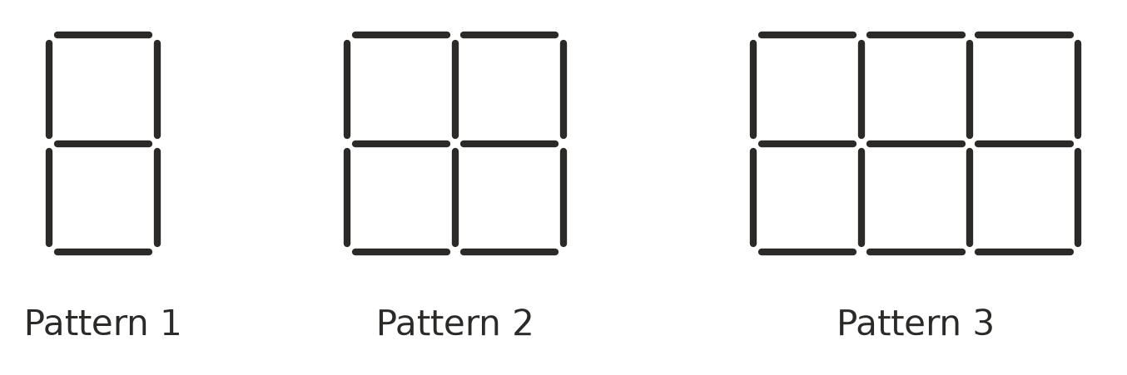
Pattern number, $n$ | 1 | 2 | 3 | 4 | 5
Number of matchsticks, $M$

  - Copy and complete the table.
  - Write a rule for $M$ using the pattern number, $n$.
  - Explain where each number in your rule comes from in the pictures.
  - Which pattern uses 152 matchsticks?
  - Could a pattern use exactly 100 matchsticks? Explain.
- A phone company has two plans. Plan A costs $24 plus $5 per GB of data. Plan B costs $8 per GB of data.
Data in GB, $g$ | 2 | 4 | 6 | 8 | 10
Plan A cost ($)
Plan B cost ($)

  - Write a rule for the cost of each plan, $A$ and $B$, using $g$.
  - Copy and complete the table.
  - For how many GB do the two plans cost the same?
  - Which plan is cheaper for 10 GB? By how much?
- A candle is 30 cm tall. It burns down 2 cm every hour.
  - Write a rule for the height of the candle, $h$ cm, after $t$ hours.
  - How tall is the candle after 6 hours?
  - After how many hours will the candle be 12 cm tall?
  - How long will the candle burn altogether?
- In one section of a footy stadium, Row 1 has 12 seats and each row has 3 more seats than the row in front of it.
  - Write a rule for the number of seats, $S$, in row $r$.
  - How many seats are in Row 20?
  - Which row has 51 seats?
- One hexagon-shaped table seats 6 people. When two of them are pushed together side by side, 10 people can sit. With three tables in a row, 14 people can sit.
  - Write a rule for the number of people, $P$, who can sit at $n$ tables in a row.
  - How many tables are needed in a row to seat 50 people?

