9.01 Introduction to equations
Year 7 Maths · Worksheet · Level 1 · Warm-up
Name: ____________________ Date: ______________
This worksheet introduces equations. An equation says that two things are equal, so it always has an = sign. Tip: to check a solution, put the number in place of the letter. If both sides come out the same, it is correct. For example, $x=4$ is the solution of $x+6=10$ because 4 + 6 = 10.

 Understanding
- Write equation or expression for each one.
  - $x+9$ ______________
  - $x+9=14$ ______________
  - $3m=21$ ______________
  - $5k−2$ ______________
  - $20=y+4$ ______________
  - $\frac{p}{2}$ ______________
- Write true or false for each number sentence.
  - 7 + 5 = 12 ______________
  - 4 × 6 = 20 ______________
  - 18 − 9 = 3 × 3 ______________
  - 30 ÷ 5 = 2 + 3 ______________
- The scales are balanced. The bag weighs $x$ kg and each small block weighs 1 kg.
- 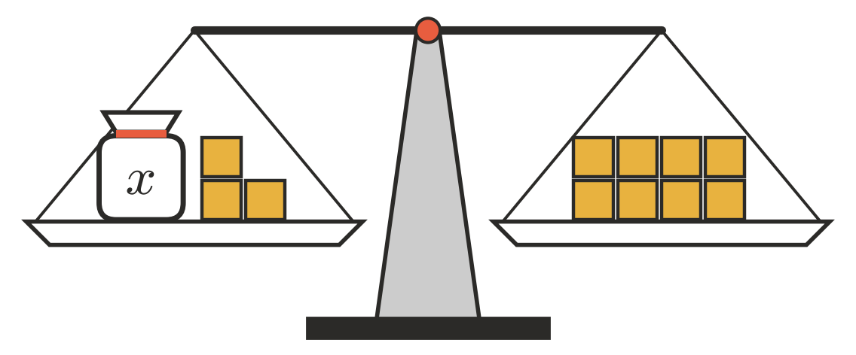
  - Write an equation for the balance. ______________
  - How much does the bag weigh? ______________

 Fluency
- Is the given value the solution of the equation? Write yes or no.
  - $x+4=11$, when $x=7$ ______________
  - $y−3=9$, when $y=6$ ______________
  - $5m=30$, when $m=6$ ______________
  - $\frac{n}{2}=8$, when $n=4$ ______________
  - $2a+1=9$, when $a=4$ ______________
  - $3k−2=10$, when $k=3$ ______________
- Find the number that makes each equation true.
  - $x+5=12$ ______________
  - $y−4=10$ ______________
  - $6m=24$ ______________
  - $\frac{t}{3}=5$ ______________
  - $20−p=13$ ______________
  - $9+n=20$ ______________
- Each equation has one of these numbers as its solution: 2, 3, 4 or 5. Find the solution of each.
  - $4x+1=17$ ______________
  - $2x+5=11$ ______________
  - $10−x=5$ ______________
  - $7x=14$ ______________

 Reasoning
- Tom says $x+8$ is an equation because it has a letter in it. Explain why Tom is wrong.

- Mia says the solution of $3x=12$ is $x=9$, because 3 + 9 = 12. Explain her mistake and give the correct solution.

 Problem solving
- I think of a number and add 6. The answer is 15.
  - Write an equation, using $n$ for the number. ______________
  - What is the number? ______________
- Pencils come in packets of $p$ pencils. Jo buys 4 packets and gets 32 pencils altogether.
  - Write an equation for this. ______________
  - How many pencils are in each packet? ______________
- Ella had $m$ dollars. She spent $7 at the canteen and had $13 left.
  - Write an equation for this. ______________
  - How much money did Ella have to start with? ______________

