9.01 Introduction to equations
Year 7 Maths · A5 question sheet · Level 2 · Core
This worksheet practises telling equations from expressions, checking solutions by substitution, and writing equations from words. Tip: a solution makes both sides of the equation equal. Substitute it into each side and compare. For example, for $2x+3=11$, try $x=4$: 2 × 4 + 3 = 11, so $x=4$ is the solution.

 Understanding
- Write equation or expression for each one.
  - $4y−7$
  - $4y=28$
  - $15=2k+1$
  - $\frac{m}{3}+2$
  - $a+b=10$
  - $6(x+1)$
- Write true or false for each number sentence.
  - 6 × 7 = 40 + 2
  - 5 + 3 × 2 = 16
  - 36 ÷ 4 = 3 × 3
  - 50 − 18 = 8 × 4
  - $2^{3}$ = 6
- The scales are balanced. Each bag weighs $x$ kg and each small block weighs 1 kg.
- 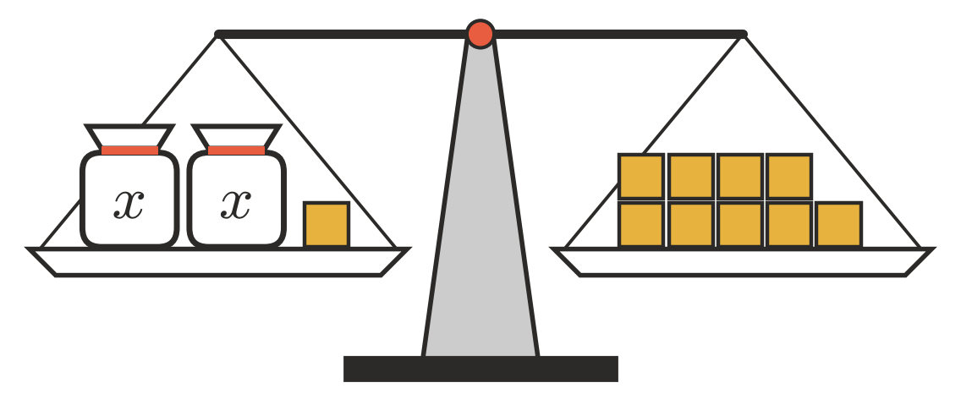
  - Write an equation for the balance.
  - How much does one bag weigh?

 Fluency
- Substitute to check whether the given value is the solution. Write yes or no.
  - $x+13=21$, when $x=8$
  - $7y=56$, when $y=9$
  - $3m+4=25$, when $m=7$
  - $\frac{k}{4}=6$, when $k=24$
  - $5n−9=31$, when $n=7$
  - $2(a+3)=18$, when $a=6$
  - $40−3p=16$, when $p=9$
  - $\frac{w+6}{2}=9$, when $w=12$
- Find the solution of each equation.
  - $x+17=30$
  - $y−9=25$
  - $8m=72$
  - $\frac{t}{5}=7$
  - $45−p=28$
  - $2k+1=15$
- Use guess, check and improve to solve $6x+5=53$. The first guess has been done for you.
Try $x$ = | $6x+5$ | Too small, too big or correct?
5 | 35 | too small

- Solution: $x$ =

 Reasoning
- Explain the difference between an expression and an equation. Give an example of each.
- Sam says that $x=3$ is the solution of $4x−2=2x+4$. Substitute $x=3$ into both sides to check whether he is right. Show your working.
- Write an equation that uses multiplication and addition and has the solution $x=6$.

 Problem solving
- Write an equation for each sentence, using $n$ for the number. Then find the number.
  - I think of a number and multiply it by 5. The answer is 65.
  - I think of a number and subtract 12. The answer is 29.
  - Half of a number is 18.
- A farm ute carries $b$ bales of hay on each trip. In 6 trips it carries 84 bales.
  - Write an equation for this.
  - How many bales does it carry on each trip?
- In Aussie Rules footy, a goal is worth 6 points and a behind is worth 1 point. A team kicked $g$ goals and 7 behinds and scored 55 points.
  - Write an equation for the team’s score.
  - How many goals did the team kick?
- Liam is $l$ years old. His dad is 3 times as old as Liam, and his dad is 42.
  - Write an equation for this.
  - How old is Liam?

