5.06 Round decimals
Year 7 Maths · Worksheet · Level 2 · Core
Name: ____________________ Date: ______________
This worksheet practises rounding to a given number of decimal places, choosing a sensible accuracy, and using estimates to check answers. Tip: always round from the original number in one step. Look only at the digit just to the right of the place you are rounding to.

 Understanding
- Round the number shown by each letter to one decimal place.
- 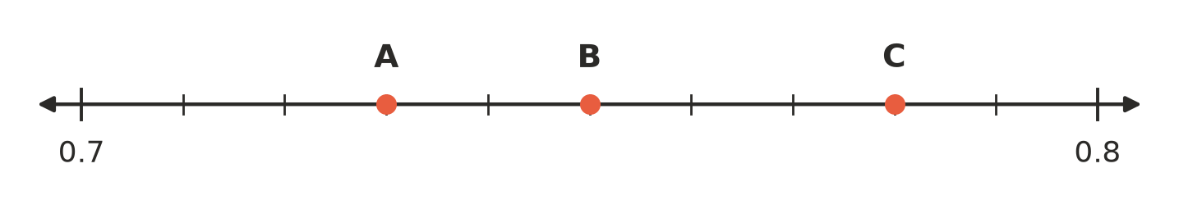
  - A ______________
  - B ______________
  - C ______________
- Round 7.3846 to:
  - the nearest whole number ______________
  - one decimal place ______________
  - two decimal places ______________
  - three decimal places ______________

 Fluency
- Round each number to one decimal place.
  - 14.67 ______________
  - 0.351 ______________
  - 9.96 ______________
  - 23.149 ______________
  - 5.555 ______________
- Round each number to two decimal places.
  - 3.14159 ______________
  - 0.0872 ______________
  - 12.995 ______________
  - 6.4049 ______________
- Round each number to the accuracy shown.
  - 2.71828 (three decimal places) ______________
  - 0.66666 (nearest tenth) ______________
  - 45.8961 (nearest hundredth) ______________
  - 199.5 (nearest whole number) ______________
- Write each fraction as a decimal, rounded to two decimal places.
  - $\frac{2}{3}$ ≈ ______________
  - $\frac{5}{7}$ ≈ ______________
  - $\frac{1}{6}$ ≈ ______________
- Estimate each answer by rounding. Then use a calculator to find the exact answer, rounded to two decimal places if needed.
  - 18.7 × 4.9 estimate ______________ exact ______________
  - 61.2 ÷ 2.9 estimate ______________ exact ______________

 Reasoning
- Sophie rounded 4.349 to one decimal place. She first rounded it to 4.35, then rounded 4.35 to 4.4. Explain why her answer is wrong, and give the correct answer.

- A number with two decimal places rounds to 6.2 when it is rounded to one decimal place.
  - What is the smallest the number could be? ______________
  - What is the largest the number could be? ______________

 Problem solving
- Three friends share a $50 restaurant bill equally.
  - How much should each person pay, to the nearest cent? ______________
  - If each person pays that amount, will the bill be paid exactly? Explain.

- A farmer needs to build a fence 24.6 m long. Fence panels are 2.4 m long. How many panels must she buy? Explain why you rounded the way you did.

- Round each measurement to a sensible accuracy for the situation.
  - A student’s height is 1.6348 m. Round to the nearest centimetre (hundredth of a metre). ______________
  - Bananas cost $3.99 per kg. Kate buys 1.27 kg, so the cost is 3.99 × 1.27 = $5.0673. What does she pay? ______________
  - A sprinter’s time is measured as 12.4562 s. The scoreboard shows times to the nearest hundredth of a second. What does it show? ______________
- Isla’s calculator shows 4.8 × 21.3 = 1022.4. Use an estimate to show that this answer is not reasonable, and give the correct answer.

