5.06 Round decimals
Year 7 Maths · A5 question sheet · Level 1 · Warm-up
This worksheet practises rounding decimals and using rounding to estimate. Tip: find the place you are rounding to, then look at the next digit to the right. If it is 5 or more, round up. If it is 4 or less, keep the digit the same. Then drop the digits after it.

 Understanding
- Look at the number line.
- 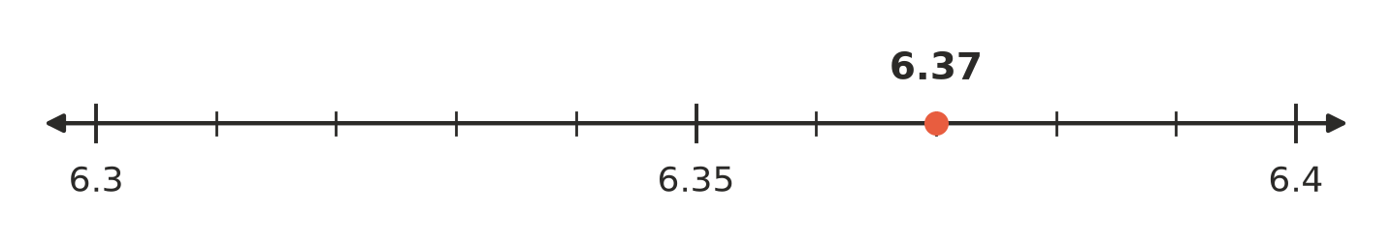
  - Is 6.37 closer to 6.3 or to 6.4?
  - Round 6.37 to one decimal place.
- Round each number to the nearest whole number.
  - 4.7
  - 12.3
  - 8.5
  - 19.62

 Fluency
- Round each number to one decimal place.
  - 3.46
  - 7.82
  - 0.95
  - 12.349
  - 5.05
  - 2.98
- Round each number to two decimal places.
  - 4.567
  - 0.123
  - 3.405
  - 6.0749
- Round each amount to the nearest cent.
  - $4.736
  - $12.091
  - $0.555
- Estimate each answer by rounding each number to the nearest whole number first.
  - 5.8 + 3.1 ≈
  - 9.7 − 4.2 ≈
  - 3.9 × 5.1 ≈

 Reasoning
- Leah rounded 2.96 to one decimal place and got 2.10. Explain her mistake and give the correct answer.
- When you round 2.98 to one decimal place, why do you write 3.0 and not just 3?

 Problem solving
- Max ran 2.68 km around the footy oval. Round this distance to the nearest tenth of a kilometre.
- At the shop, Zoe buys items costing $3.85, $6.20 and $1.95.
  - Estimate the total by rounding each price to the nearest dollar.
  - Find the exact total.
- 98 students are going on an excursion. Each bus holds 45 students. 98 ÷ 45 = 2.177…
  - Rounded to the nearest whole number, 2.177… is 2. Explain why 2 buses is not enough.
  - How many buses are needed?

