5.01 Decimals and place value
Year 7 Maths · Worksheet · Level 2 · Core
Name: ____________________ Date: ______________
This worksheet practises place value to thousandths, expanded form, and comparing and ordering decimals. Tip: to compare two decimals, give them the same number of decimal places by adding zeros at the end, then compare them like whole numbers.

 Understanding
- Write the decimal shown by each letter on the number line.
- 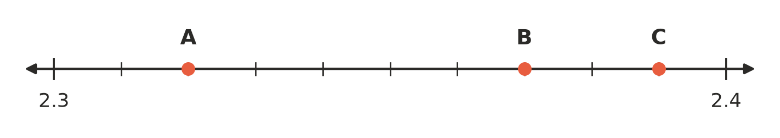
  - A = ______________
  - B = ______________
  - C = ______________
- Write the value of the digit 7 in each number, first as a fraction and then as a decimal.
  - 0.7 fraction ______________ decimal ______________
  - 3.07 fraction ______________ decimal ______________
  - 1.257 fraction ______________ decimal ______________
  - 4.572 fraction ______________ decimal ______________

 Fluency
- Write each as a decimal.
  - $\frac{63}{100}$ = ______________
  - $\frac{8}{1000}$ = ______________
  - $4\frac{27}{100}$ = ______________
  - 3 + 0.4 + 0.006 = ______________
  - $\frac{15}{1000}$ = ______________
  - 9 + $\frac{3}{10}$ + $\frac{1}{1000}$ = ______________
- Write each number in expanded form.
  - 6.29 = ______________
  - 18.054 = ______________
  - 0.307 = ______________
- Write each number in digits, or in words.
  - four and fifty-six hundredths ______________
  - twenty and seven thousandths ______________
  - Write 0.091 in words. ______________
- Write <, > or = in each box.
  - 0.48 □ 0.408
  - 5.6 □ 5.60
  - 0.099 □ 0.1
  - 12.305 □ 12.35
  - 7.02 □ 7.002
  - 3.050 □ 3.05
- Write these decimals in order.
  - Smallest to largest: 0.6, 0.06, 0.66, 0.606, 0.066

  - Largest to smallest: 2.14, 2.4, 2.041, 2.104, 2.401

- Write a decimal that lies between each pair of numbers.
  - 0.3 and 0.4 ______________
  - 1.7 and 1.71 ______________
  - 0.09 and 0.1 ______________

 Reasoning
- Tom says, “0.250 is bigger than 0.25, because it has more digits.” Explain why Tom is wrong.

- Explain why writing a zero at the end of 4.6 (to make 4.60) does not change its value, but putting a zero straight after the decimal point (to make 4.06) does.

 Problem solving
- The table shows the scores of five gymnasts at a school competition. The highest score wins.
Gymnast | Score
Ella | 13.45
Grace | 13.405
Hana | 13.5
Isla | 13.054
Jade | 13.54

  - Who won? ______________
  - Who came last? ______________
  - Write the gymnasts in order from first place to last place.

- A carpenter has four pieces of timber: 1.2 m, 1.25 m, 1.205 m and 1.52 m. A shelf needs a piece that is at least 1.21 m long but shorter than 1.3 m. Which piece should she use? Explain.

- Use each of the digits 3, 5 and 8 once to make a number like this: □.□□
  - What is the largest number you can make? ______________
  - What is the smallest number you can make? ______________
  - Which number you can make is closest to 5? ______________

