5.01 Decimals and place value
Year 7 Maths · Worksheet · Level 1 · Warm-up
Name: ____________________ Date: ______________
This worksheet practises reading and writing decimals, finding what each digit is worth, and comparing decimals. Tip: the first place after the decimal point is tenths, the second is hundredths and the third is thousandths.

 Understanding
- The large square is split into 100 equal small squares.
- 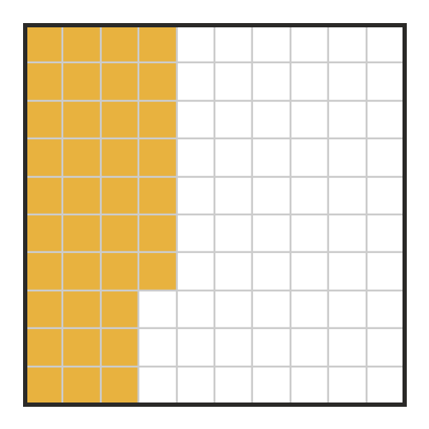
  - How many small squares are shaded? ______________
  - Write the shaded part as a fraction. ______________
  - Write the shaded part as a decimal. ______________
- Write each fraction as a decimal.
  - $\frac{7}{10}$ = ______________
  - $\frac{9}{100}$ = ______________
  - $\frac{43}{100}$ = ______________
  - $\frac{5}{1000}$ = ______________
- Write the decimal shown by each letter on the number line.
- 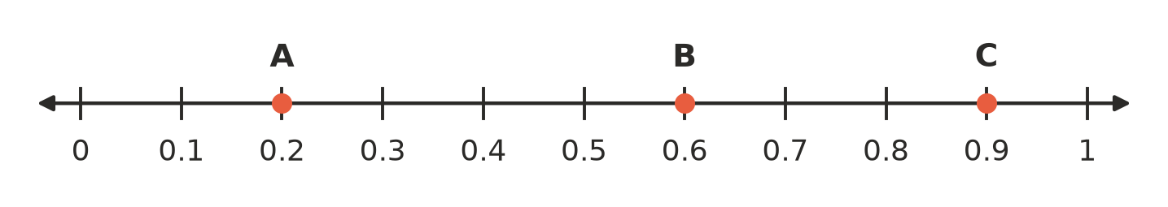
  - A = ______________
  - B = ______________
  - C = ______________

 Fluency
- Write the place value of the digit 6 in each number: ones, tenths, hundredths or thousandths.
  - 3.6 ______________
  - 0.46 ______________
  - 6.21 ______________
  - 2.096 ______________
- Write the value of the digit 8 in each number as a decimal or whole number.
  - 2.8 ______________
  - 4.18 ______________
  - 7.008 ______________
  - 8.5 ______________
- Write each as a decimal.
  - 4 + 0.3 + 0.05 = ______________
  - 2 + 0.07 = ______________
  - six and four tenths ______________
  - twelve and thirty-five hundredths ______________
- Write < or > in each box.
  - 0.6 □ 0.4
  - 0.35 □ 0.53
  - 0.7 □ 0.65
  - 2.09 □ 2.1
- Write these decimals in order from smallest to largest.
  - 0.5, 0.25, 0.8, 0.05 ______________
  - 1.3, 1.03, 1.33, 1.31 ______________

 Reasoning
- Mia says, “0.45 is bigger than 0.5, because 45 is bigger than 5.” Explain why Mia is wrong.

- Is 3.40 the same as 3.4? Explain how you know.

 Problem solving
- Four students swam 50 m at the school swimming carnival. The table shows their times.
Swimmer | Time (seconds)
Ava | 38.6
Ben | 38.06
Chloe | 39.1
Dan | 38.65

  - The fastest swimmer has the smallest time. Who was the fastest? ______________
  - Write the swimmers in order from fastest to slowest.

- In the long jump, Jess jumped 4.25 m, 4.3 m and 4.205 m. Which was her longest jump? Explain how you know.

