5.01 Decimals and place value
Year 7 Maths · A5 question sheet · Level 3 · Challenge
This worksheet stretches your place value skills to thousandths and ten-thousandths, with harder comparisons and number puzzles. Tip: each place is worth ten times the place to its right, so 10 thousandths make 1 hundredth and 10 hundredths make 1 tenth.

 Understanding
- Write the decimal shown by each letter on the number line.
- 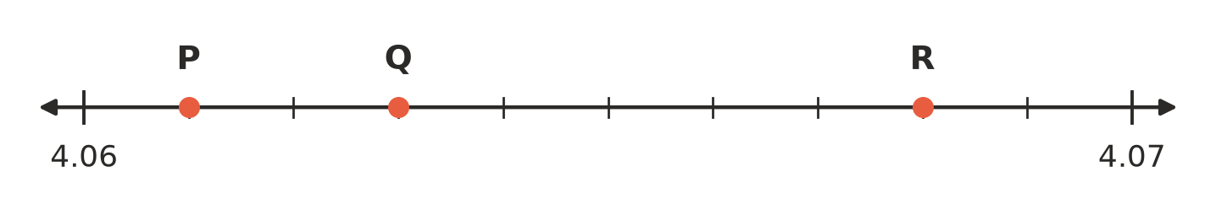
  - P =
  - Q =
  - R =
- Write the value of the digit 5 in each number as a whole number or a fraction.
  - 0.0251
  - 52.13
  - 6.3075
  - 1.5

 Fluency
- Write each as a decimal.
  - 7 + $\frac{4}{100}$ + $\frac{9}{10000}$ =
  - 3 tens and 6 thousandths
  - $\frac{152}{1000}$ =
  - $\frac{2305}{1000}$ =
  - $\frac{48}{10000}$ =
- Write each as a single decimal. Be careful when a place has more than 9.
  - 3 + 0.7 + 0.02 + 0.005 =
  - 40 + 0.08 + 0.0001 =
  - 6 tenths + 14 hundredths =
  - 23 hundredths + 15 thousandths =
- Write <, > or = in your book.
  - 0.7 □ 0.69999
  - 3.1415 □ 3.142
  - 0.40 □ $\frac{4}{10}$
  - 10.01 □ 10.009
  - 5.0505 □ 5.055
  - 2.3 □ $\frac{23}{100}$
- Write these decimals in order from smallest to largest.
- 0.0808 0.808 0.088 0.8 0.8008 0.08
- Find the number exactly halfway between each pair.
  - 2.4 and 2.5
  - 0.06 and 0.07
  - 1.99 and 2.01
  - 3.7 and 3.75
- What number is:
  - 0.01 more than 4.99?
  - 0.001 less than 2.1?
  - 0.1 more than 6.95?
  - 10 thousandths more than 0.395?

 Reasoning
- Explain why there is no “next” decimal after 0.5. Then write three different decimals that lie between 0.5 and 0.51.
- A decimal with more digits is not always bigger. Explain why, and give an example of two decimals to show it.

 Problem solving
- Five cyclists rode 1 km at a velodrome. The table shows their times.
Cyclist | Time (seconds)
Kai | 72.405
Lily | 72.45
Mason | 72.054
Nina | 72.5
Oscar | 72.045

  - Write the cyclists in order from fastest (smallest time) to slowest.
  - How much faster was the fastest cyclist than the slowest?
- I am a decimal between 4 and 5 with three decimal places. My tenths digit is double my ones digit. My hundredths digit is one less than my tenths digit. My thousandths digit is half my ones digit. What number am I?
- Use each of the digits 0, 2, 6 and 9 once to make a number like this: □.□□□
  - What is the largest number you can make?
  - What is the smallest number you can make that is greater than 1?
  - Which number you can make is closest to 6?

