Angles, lines and shapes: Practice test 3
Year 7 Maths · Test · Test 3
Name: ____________________ Date: ______________
Time: 45 minutes
Total: 40 marks
Show your working in the boxes. Then write each final answer on the answer sheet on the last page. You will need a protractor for Section B. Diagrams marked “Not to scale” are not drawn accurately, so work out those angles with reasons instead of measuring.

 Section A: No calculator
- Write the type of each angle (acute, right, obtuse, straight, reflex or revolution).
  - 92° (1 mark)
  - 360° (1 mark)

- Answer each question.
  - What angle is complementary to 17°? (1 mark)
  - Two angles are supplementary and equal to each other. How big is each angle? (1 mark)

- Find the value of each pronumeral. Give a reason for each answer.
- 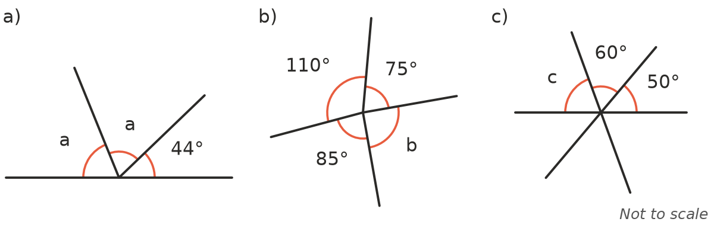
  - a (1 mark)
  - b (1 mark)
  - c (1 mark)

- The diagram shows two parallel lines crossed by a transversal. Use the letters in the diagram to answer each part.
- 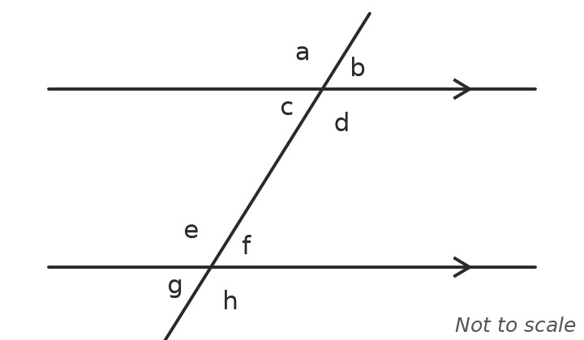
  - Which angle is corresponding to angle b? (1 mark)
  - Which angle is alternate to angle d? (1 mark)
  - Which angle is co-interior with angle e? (1 mark)

- Find the value of each pronumeral. Give a reason for each answer.
- 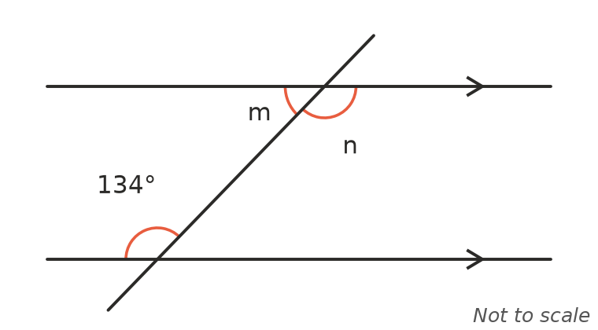
  - m (2 marks)
  - n (2 marks)

- Find the value of x that makes AB parallel to CD. Explain your answer. (2 marks)
- 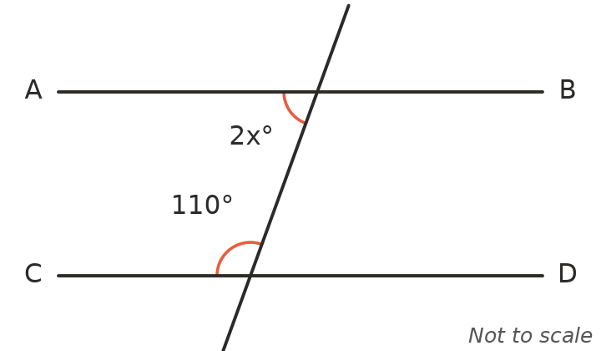

- Name each quadrilateral as precisely as you can. Use the markings on the sides.
- 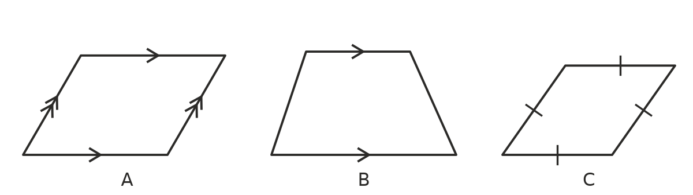
  - Shape A (1 mark)
  - Shape B (1 mark)
  - Shape C (1 mark)

- Answer each part about triangles.
- 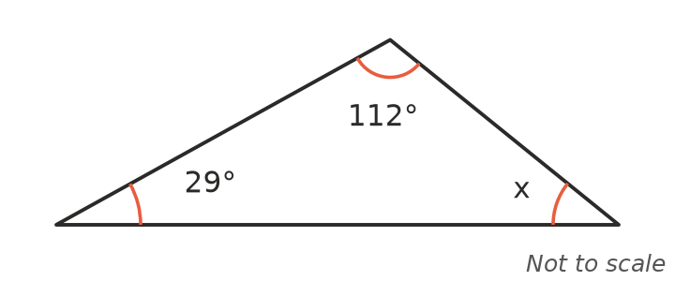
  - Find the value of x in the diagram. (1 mark)
  - An isosceles triangle has two base angles of 47°. Find the third angle. (1 mark)
  - Explain why a triangle can never have two obtuse angles. (2 marks)

- The diagram shows a trapezium. Find the values of p and q. (2 marks)
- 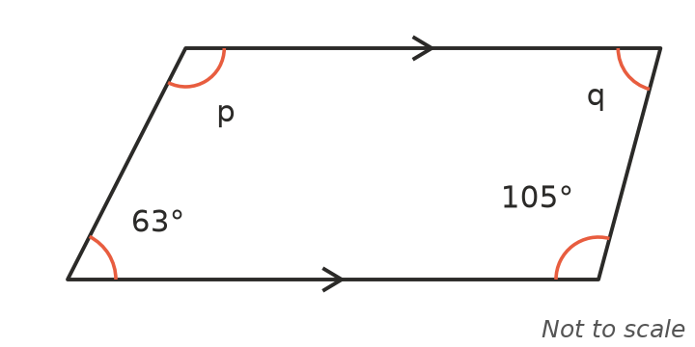

- In the diagram, AF is parallel to CG. Find the value of x. Show your reasoning. (Hint: draw a line through E parallel to AF.) (3 marks)
- 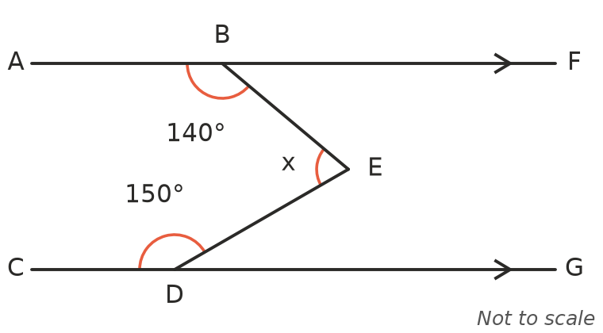

 Section B: Calculator allowed
- Triangle PQR is drawn accurately.
- 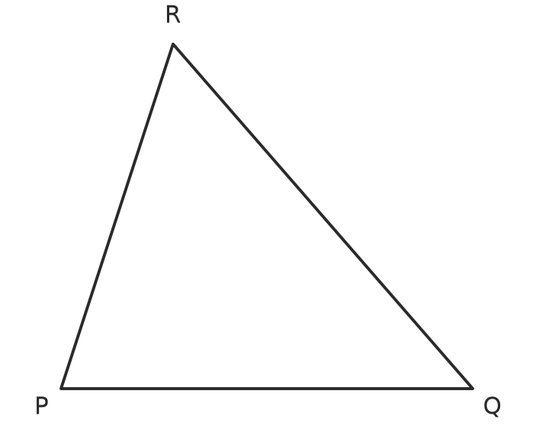
  - Use a protractor to measure ∠P, ∠Q and ∠R. (2 marks)
  - Add your three measurements. What should the total be? (1 mark)

- A hexagon has 6 sides.
  - Show that the interior angles of a hexagon add to 720°. (1 mark)
  - Five of the angles of a hexagon are 118°, 125°, 130°, 96° and 141°. Find the sixth angle. (1 mark)

- Ruby wrote this algorithm to label quadrilaterals.
- Step 1: Does it have two pairs of parallel sides? If yes, go to Step 2. If no, go to Step 3.
- Step 2: Are all four sides the same length? If yes, label it R. If no, label it P.
- Step 3: Does it have exactly one pair of parallel sides? If yes, label it T. If no, label it K.
- What label does each shape get?
  - A rectangle that is not a square (1 mark)
  - A rhombus (1 mark)
  - A kite (1 mark)

- ABCDE is a regular pentagon. The diagonal AC is drawn. Find the size of ∠BAC. Show your working. (2 marks)
- 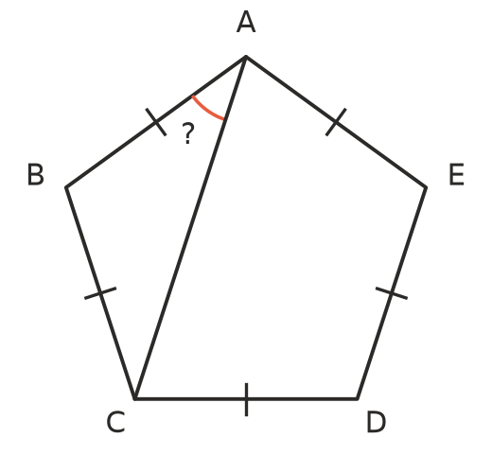

- A farm gate has two parallel rails (top and bottom) and a vertical post. A diagonal brace makes an angle of 38° with the bottom rail.
- 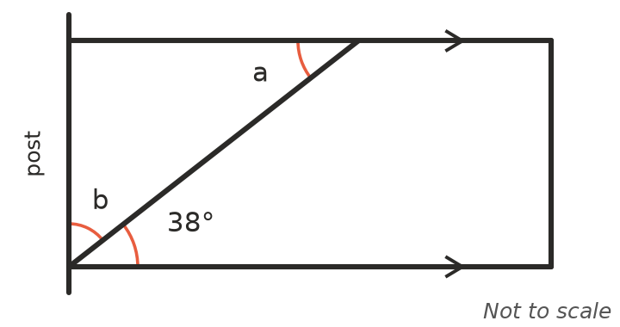
  - Find angle a, between the brace and the top rail. Give a reason. (1 mark)
  - Find angle b, between the brace and the post. (1 mark)

 Answer sheet
Name: ____________________
Write your final answer for each question in the table.
Question | Answer | Marks | Question | Answer | Marks
1a |  | /1 | 8a |  | /1
1b |  | /1 | 8b |  | /1
2a |  | /1 | 8c |  | /2
2b |  | /1 | 9 |  | /2
3a |  | /1 | 10 |  | /3
3b |  | /1 | 11a |  | /2
3c |  | /1 | 11b |  | /1
4a |  | /1 | 12a |  | /1
4b |  | /1 | 12b |  | /1
4c |  | /1 | 13a |  | /1
5a |  | /2 | 13b |  | /1
5b |  | /2 | 13c |  | /1
6 |  | /2 | 14 |  | /2
7a |  | /1 | 15a |  | /1
7b |  | /1 | 15b |  | /1
7c |  | /1
 |  |  |  | Total | /40

