Angles, lines and shapes: Practice test 2
Year 7 Maths · Test · Test 2
Name: ____________________ Date: ______________
Time: 45 minutes
Total: 40 marks
Show your working in the boxes. Then write each final answer on the answer sheet on the last page. You will need a protractor for Section B. Diagrams marked “Not to scale” are not drawn accurately, so work out those angles with reasons instead of measuring.

 Section A: No calculator
- Write the type of each angle (acute, right, obtuse, straight, reflex or revolution).
  - 90° (1 mark)
  - 179° (1 mark)

- Look at the marked angle.
- 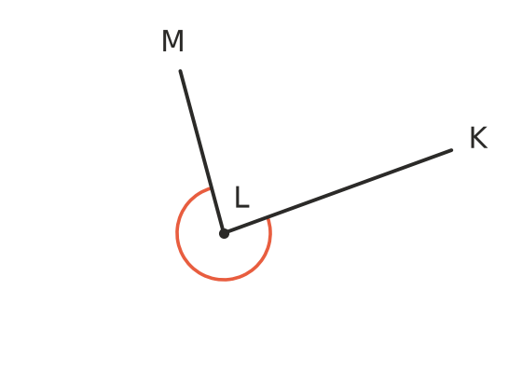
  - Name the marked angle using three letters. (1 mark)
  - What type of angle is it? (1 mark)

- Find the value of each pronumeral. Give a reason for each answer.
- 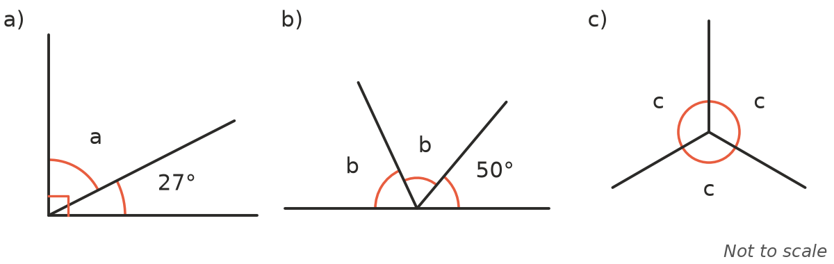
  - a (1 mark)
  - b (1 mark)
  - c (1 mark)

- The diagram shows two parallel lines crossed by a transversal. Use the letters in the diagram to answer each part.
- 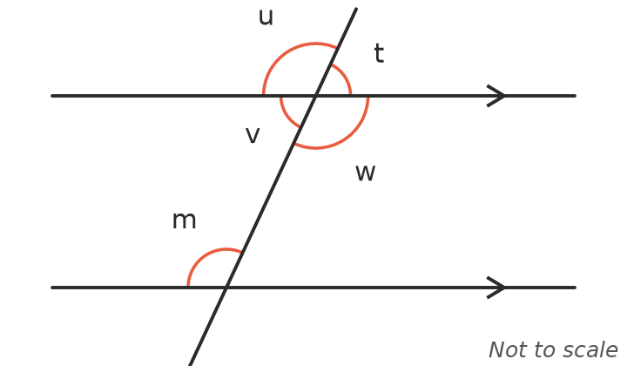
  - Which angle is corresponding to angle m? (1 mark)
  - Which angle is alternate to angle m? (1 mark)
  - Which angle is co-interior with angle m? (1 mark)

- Find the value of each pronumeral. Give a reason for each answer.
- 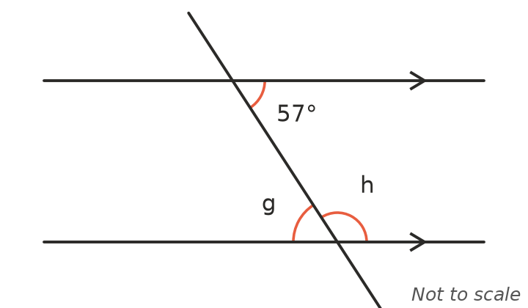
  - g (2 marks)
  - h (2 marks)

- Is PQ parallel to RS? Give a reason. (2 marks)
- 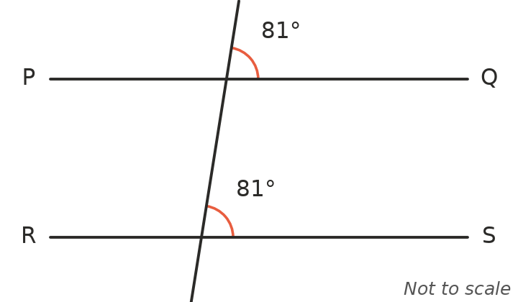

- Classify each triangle by its sides (equilateral, isosceles or scalene) and by its angles (acute, right or obtuse).
  - A triangle with angles of 35°, 55° and 90° (1 mark)
  - A triangle with sides of 7 cm, 7 cm and 7 cm (1 mark)
  - A triangle with angles of 20°, 20° and 140° (1 mark)

- Find the value of each pronumeral.
- 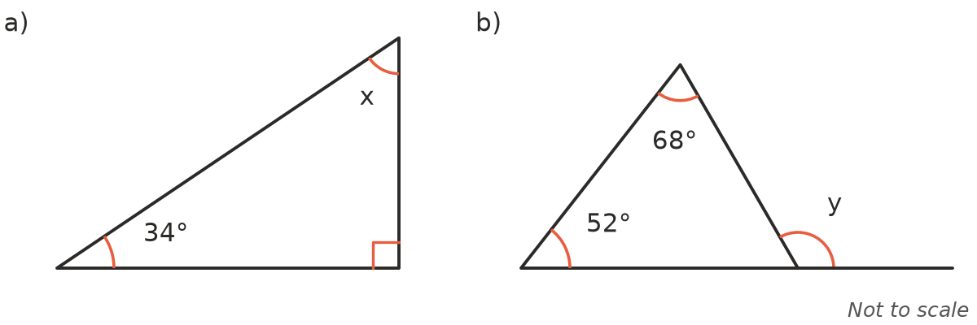
  - x (1 mark)
  - y (2 marks)

- The diagram shows a kite. Find the value of m. (2 marks)
- 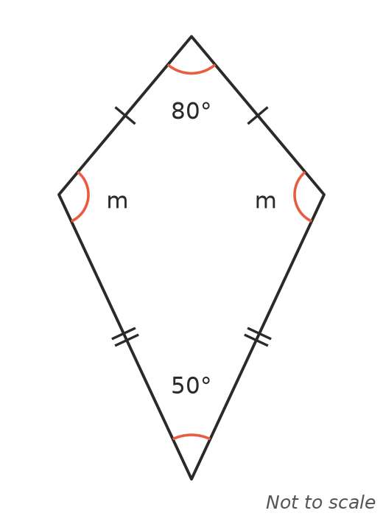

- Write true or false for each statement.
  - Every rhombus is a parallelogram. (1 mark)
  - Every rectangle is a square. (1 mark)
  - A trapezium has two pairs of parallel sides. (1 mark)

- In the diagram, PQ is parallel to BC. Use the diagram to explain why the three angles of triangle ABC add to 180°. (2 marks)
- 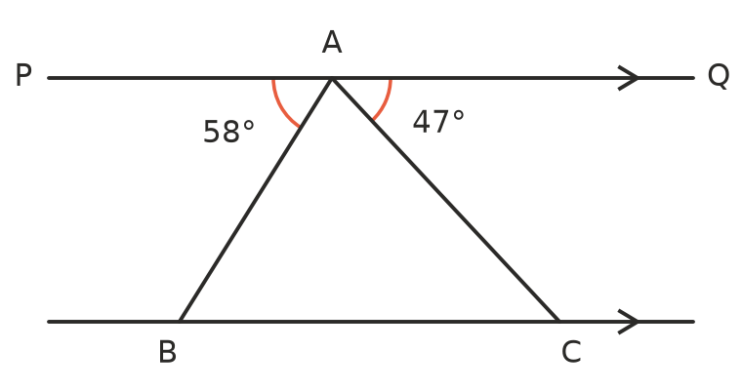

 Section B: Calculator allowed
- Use a protractor to measure each marked angle.
- 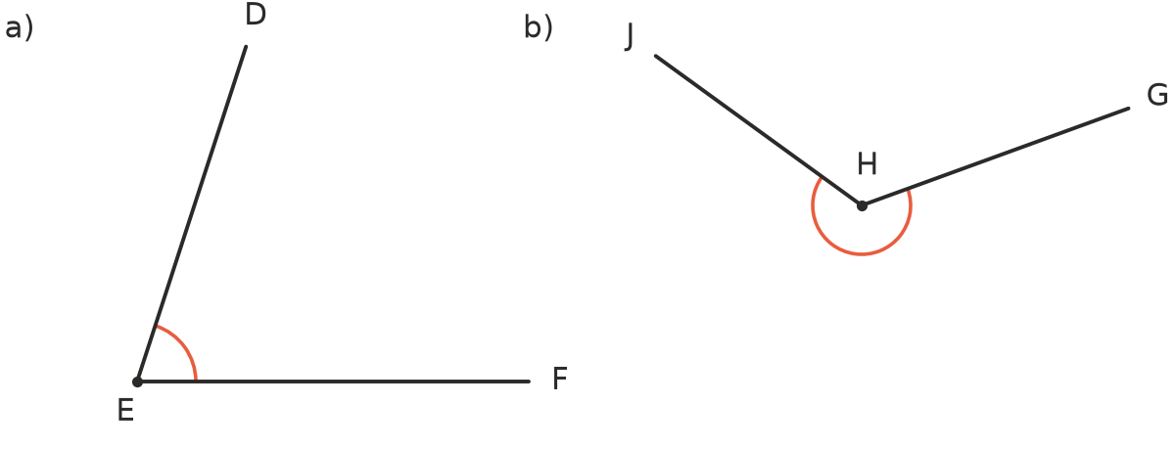
  - ∠DEF (1 mark)
  - Reflex ∠GHJ (1 mark)

- A decagon has 10 sides.
  - Find the sum of the interior angles of a decagon. (1 mark)
  - Find the size of each interior angle of a regular decagon. (1 mark)

- Zara wrote this algorithm to sort triangles.
- Step 1: Are all three sides the same length? If yes, the output is “equilateral”. If no, go to Step 2.
- Step 2: Are two of the sides the same length? If yes, the output is “isosceles”. If no, the output is “scalene”.
  - What is the output for a triangle with sides of 6 cm, 9 cm and 6 cm? (1 mark)
  - What is the output for a triangle with sides of 4 cm, 5 cm and 6 cm? (1 mark)
  - Zara wants her algorithm to also say whether a scalene triangle is right-angled. Write an extra step she could add, with its two outputs. (1 mark)

- Each interior angle of a regular polygon is 150°. How many sides does the polygon have? Show how you worked it out. (2 marks)

- A roof truss is an isosceles triangle. The two sloping rafters are the same length and meet at the top at an angle of 116°.
  - Find the angle between each rafter and the horizontal beam at the bottom of the truss. (1 mark)
  - A vertical post runs from the top of the truss straight down to the middle of the beam, cutting the 116° angle in half. Find the angle between the post and each rafter. (1 mark)

 Answer sheet
Name: ____________________
Write your final answer for each question in the table.
Question | Answer | Marks | Question | Answer | Marks
1a |  | /1 | 8b |  | /2
1b |  | /1 | 9 |  | /2
2a |  | /1 | 10a |  | /1
2b |  | /1 | 10b |  | /1
3a |  | /1 | 10c |  | /1
3b |  | /1 | 11 |  | /2
3c |  | /1 | 12a |  | /1
4a |  | /1 | 12b |  | /1
4b |  | /1 | 13a |  | /1
4c |  | /1 | 13b |  | /1
5a |  | /2 | 14a |  | /1
5b |  | /2 | 14b |  | /1
6 |  | /2 | 14c |  | /1
7a |  | /1 | 15 |  | /2
7b |  | /1 | 16a |  | /1
7c |  | /1 | 16b |  | /1
8a |  | /1
 |  |  |  | Total | /40

