Angles, lines and shapes: Practice test 1
Year 7 Maths · Test · Test 1
Name: ____________________ Date: ______________
Time: 45 minutes
Total: 40 marks
Show your working in the boxes. Then write each final answer on the answer sheet on the last page. You will need a protractor for Section B. Diagrams marked “Not to scale” are not drawn accurately, so work out those angles with reasons instead of measuring.

 Section A: No calculator
- Write the type of each angle (acute, right, obtuse, straight, reflex or revolution).
  - 128° (1 mark)
  - 305° (1 mark)

- Find each angle.
  - The complement of 58° (1 mark)
  - The supplement of 58° (1 mark)

- Find the value of each pronumeral. Give a reason for each answer.
- 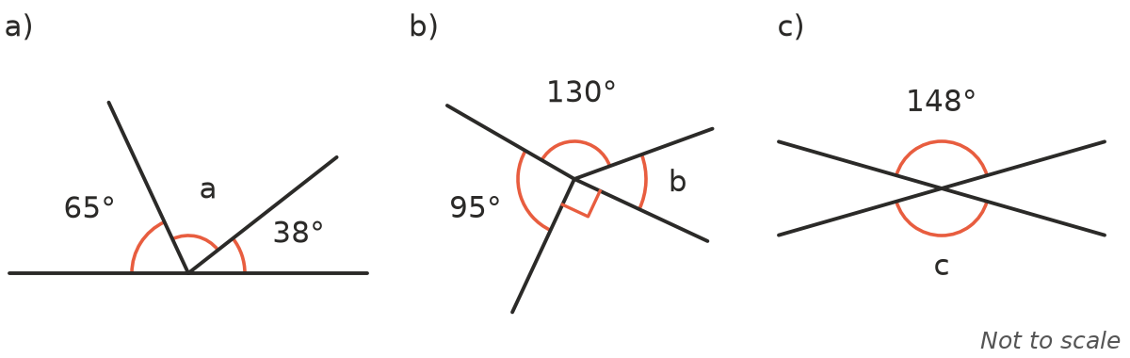
  - a (1 mark)
  - b (1 mark)
  - c (1 mark)

- The diagram shows two parallel lines crossed by a transversal. Write whether each pair of angles is corresponding, alternate or co-interior.
- 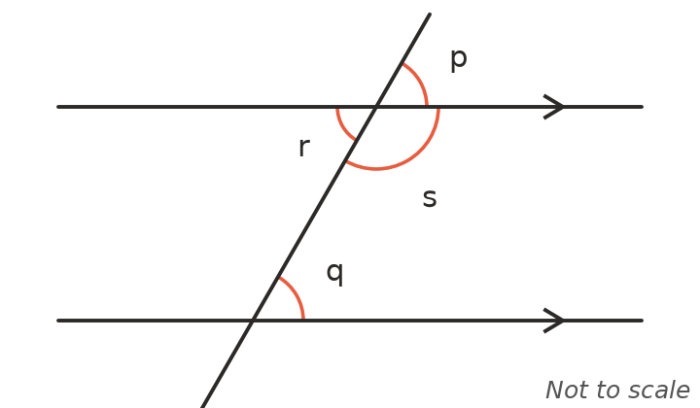
  - p and q (1 mark)
  - q and r (1 mark)
  - q and s (1 mark)

- Find the value of each pronumeral. Give a reason for each answer.
- 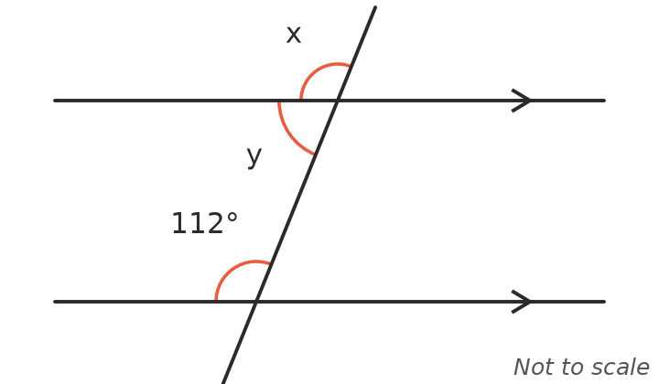
  - x (2 marks)
  - y (2 marks)

- Is AB parallel to CD? Explain how you know. (2 marks)
- 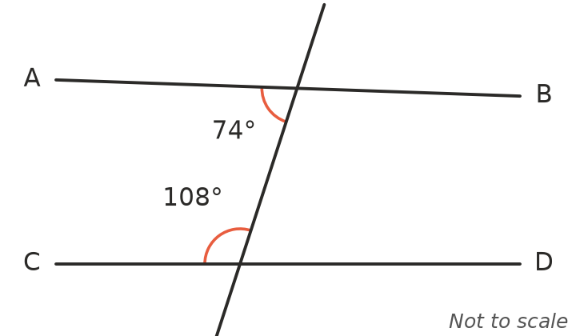

- Classify each triangle by its sides (equilateral, isosceles or scalene) and by its angles (acute, right or obtuse).
- 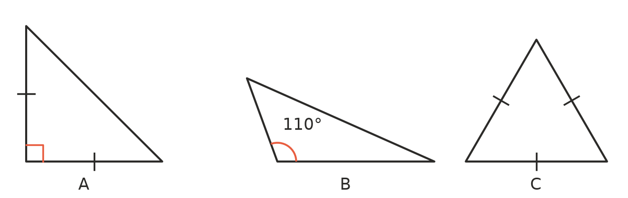
  - Triangle A (1 mark)
  - Triangle B (1 mark)
  - Triangle C (1 mark)

- Find the value of each pronumeral.
- 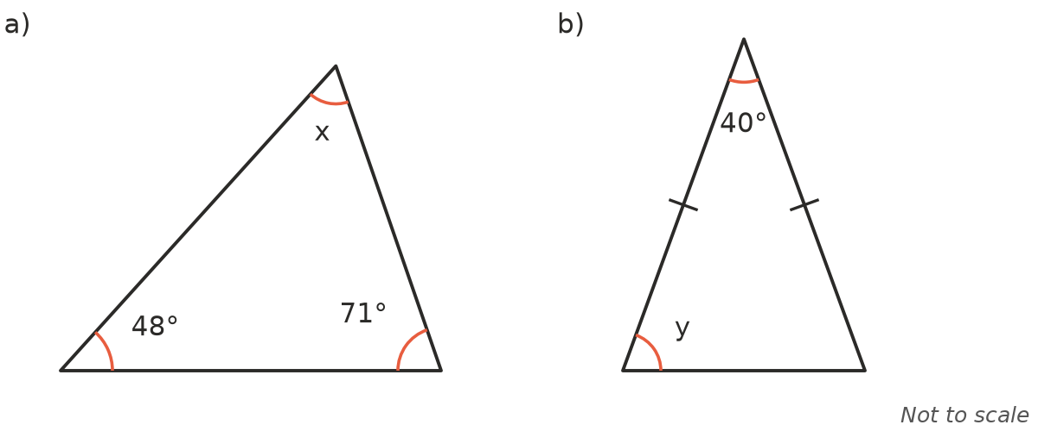
  - x (1 mark)
  - y (2 marks)

- Find the unknown angles.
- 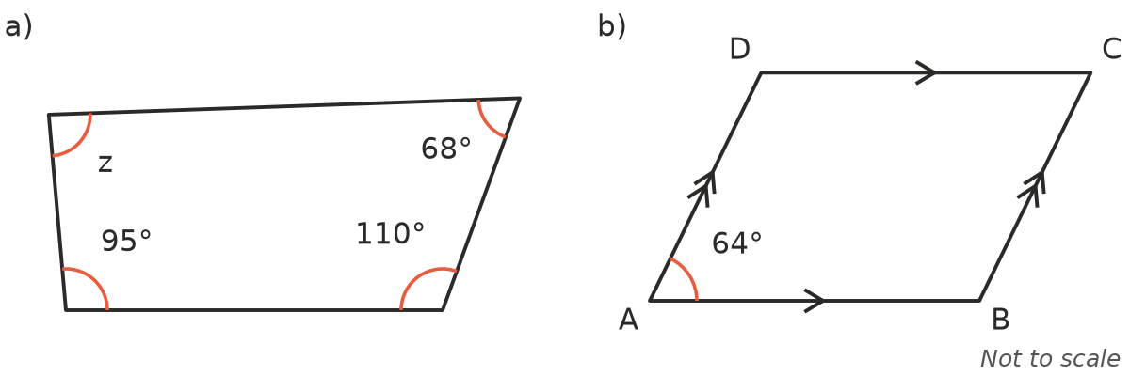
  - Find z. (1 mark)
  - ABCD is a parallelogram. Find ∠ABC and ∠BCD. (2 marks)

- Ella says, “A square is not a rectangle, because a rectangle has two long sides and two short sides.” Is Ella right? Explain your answer. (2 marks)

- In the diagram, PA is parallel to QC. Find the size of ∠BED. Show your reasoning. (Hint: draw a line through E parallel to PA.) (2 marks)
- 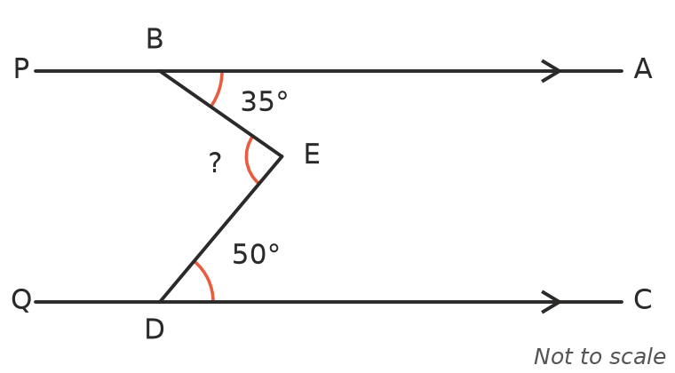

 Section B: Calculator allowed
- Use a protractor to measure each angle.
- 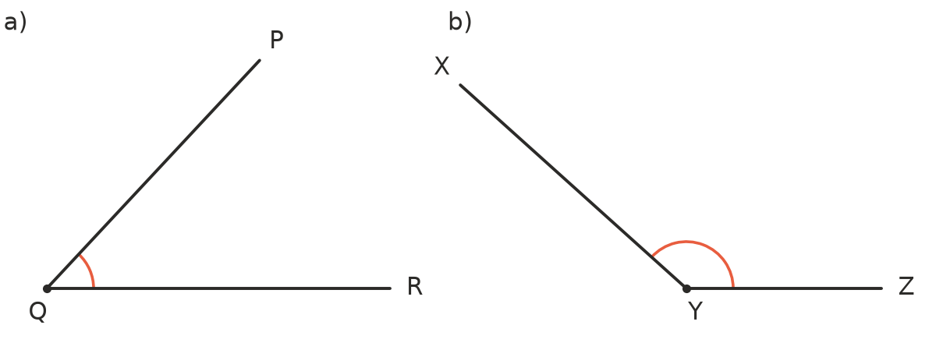
  - ∠PQR (1 mark)
  - ∠XYZ (1 mark)

- An octagon has 8 sides. (Hint: split it into triangles from one corner.)
  - Find the sum of the interior angles of an octagon. (1 mark)
  - Find the size of each interior angle of a regular octagon. (1 mark)

- Max wrote this algorithm to sort shapes into piles.
- Step 1: Does the shape have exactly 4 sides? If no, put it in pile W. If yes, go to Step 2.
- Step 2: Are all four angles right angles? If no, put it in pile X. If yes, go to Step 3.
- Step 3: Are all four sides the same length? If yes, put it in pile Y. If no, put it in pile Z.
- Which pile does each shape end up in?
  - A rectangle that is not a square (1 mark)
  - A square (1 mark)
  - A kite (1 mark)

- In triangle ABC, ∠A = x°, ∠B = 2x° and ∠C = (x + 40)°. Find the size of each angle. (2 marks)

- A school garden bed is shaped like a pentagon. Three of its angles are 100°, 112° and 124°. The other two angles are equal. Find the size of each of the two equal angles. (2 marks)

 Answer sheet
Name: ____________________
Write your final answer for each question in the table.
Question | Answer | Marks | Question | Answer | Marks
1a |  | /1 | 8a |  | /1
1b |  | /1 | 8b |  | /2
2a |  | /1 | 9a |  | /1
2b |  | /1 | 9b |  | /2
3a |  | /1 | 10 |  | /2
3b |  | /1 | 11 |  | /2
3c |  | /1 | 12a |  | /1
4a |  | /1 | 12b |  | /1
4b |  | /1 | 13a |  | /1
4c |  | /1 | 13b |  | /1
5a |  | /2 | 14a |  | /1
5b |  | /2 | 14b |  | /1
6 |  | /2 | 14c |  | /1
7a |  | /1 | 15 |  | /2
7b |  | /1 | 16 |  | /2
7c |  | /1
 |  |  |  | Total | /40

