11.04 Quadrilaterals
Year 7 Maths · A5 question sheet · Level 3 · Challenge
This worksheet practises reasoning about the properties of quadrilaterals and the angle sums of polygons, including problems with algebra. Tip: the angle sum of a polygon with $n$ sides is ($n$ − 2) × 180°. If a polygon is regular, divide by $n$ to get each angle.

 Understanding
- Which quadrilateral has diagonals that:
  - are equal in length and cut each other in half, but do not cross at right angles?
  - cross at right angles and cut each other in half, but are not equal?
  - cross at right angles, but only one diagonal is cut in half?
  - are equal, cross at right angles and cut each other in half?
- Explain each statement in one sentence.
  - Every rhombus is a parallelogram.
  - A square is both a rectangle and a rhombus.
  - A kite with four equal sides is a rhombus.

 Fluency
- Find the value of each pronumeral. In part c), $y$ = $x$ + 30.
- 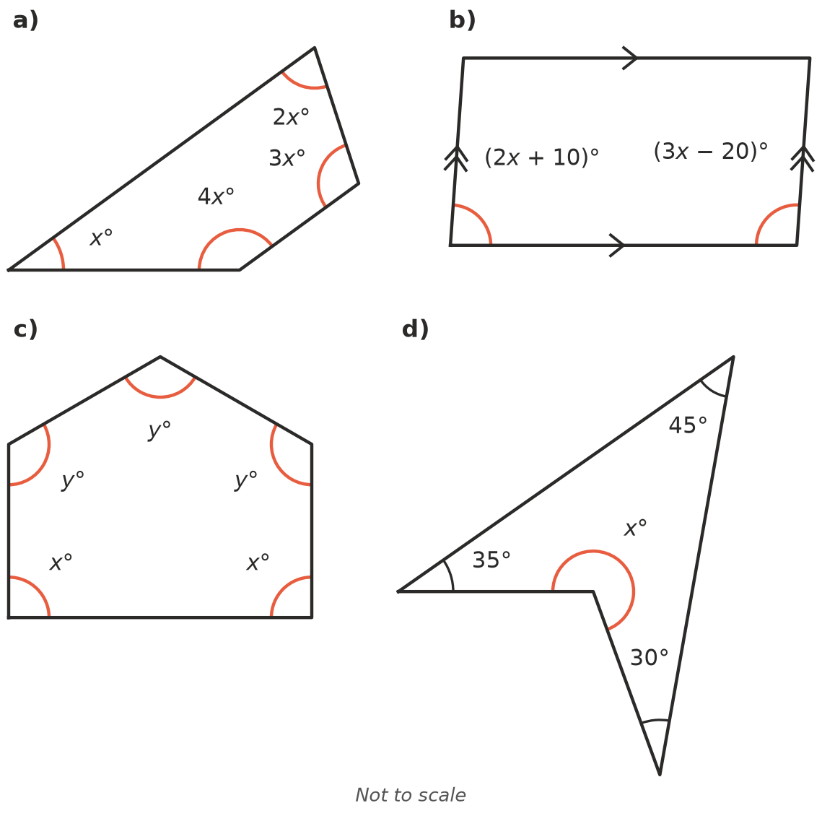
  - $x$ = ______________ b) $x$ =
  - $x$ = ______________ $y$ = ______________ d) $x$ =
- Find the number of sides of each polygon.
  - Its angles add to 1260°.
  - Its angles add to 1800°.
  - It is a regular polygon and each angle is 150°.
- The angles of a quadrilateral are in the ratio 3 : 4 : 5 : 6. Find each angle and name a quadrilateral that could have these angles.

 Reasoning
- Answer Yes or No and explain.
  - Can a quadrilateral have three obtuse angles?
  - Can a quadrilateral have four obtuse angles?
  - Can a quadrilateral have a reflex angle?
- Explain why the angles of any polygon with $n$ sides add to ($n$ − 2) × 180°. A sketch may help.
- Explain why the four angles of any trapezium make two pairs, each adding to 180°.

 Problem solving
- A pentagon has three right angles. Its other two angles are equal. Find them.
- The six angles of a hexagon are $x$°, ($x$ + 10)°, ($x$ + 20)°, ($x$ + 30)°, ($x$ + 40)° and ($x$ + 50)°. Find all six angles.
- Regular polygons of one kind can cover a floor with no gaps only if their angle divides exactly into 360°. Explain why the equilateral triangle, the square and the regular hexagon are the only regular polygons that can do this. Hint: what is the smallest possible angle of a regular polygon, and what is the largest?
- A quadrilateral has angles of 3$x$°, 3$x$°, 4$x$° and ($x$ + 30)°. Find $x$. Which angle is the largest, and what type of angle is it?

