11.04 Quadrilaterals
Year 7 Maths · A5 question sheet · Level 2 · Core
This worksheet practises classifying quadrilaterals by their sides, angles and diagonals, and finding unknown angles in quadrilaterals and other polygons. Tip: any polygon can be cut into triangles from one corner. A shape with $n$ sides makes $n$ − 2 triangles, so its angles add to ($n$ − 2) × 180°.

 Understanding
- Give the most exact name for each quadrilateral. (A square, for example, is also a rectangle, but “square” is the most exact name.)
- 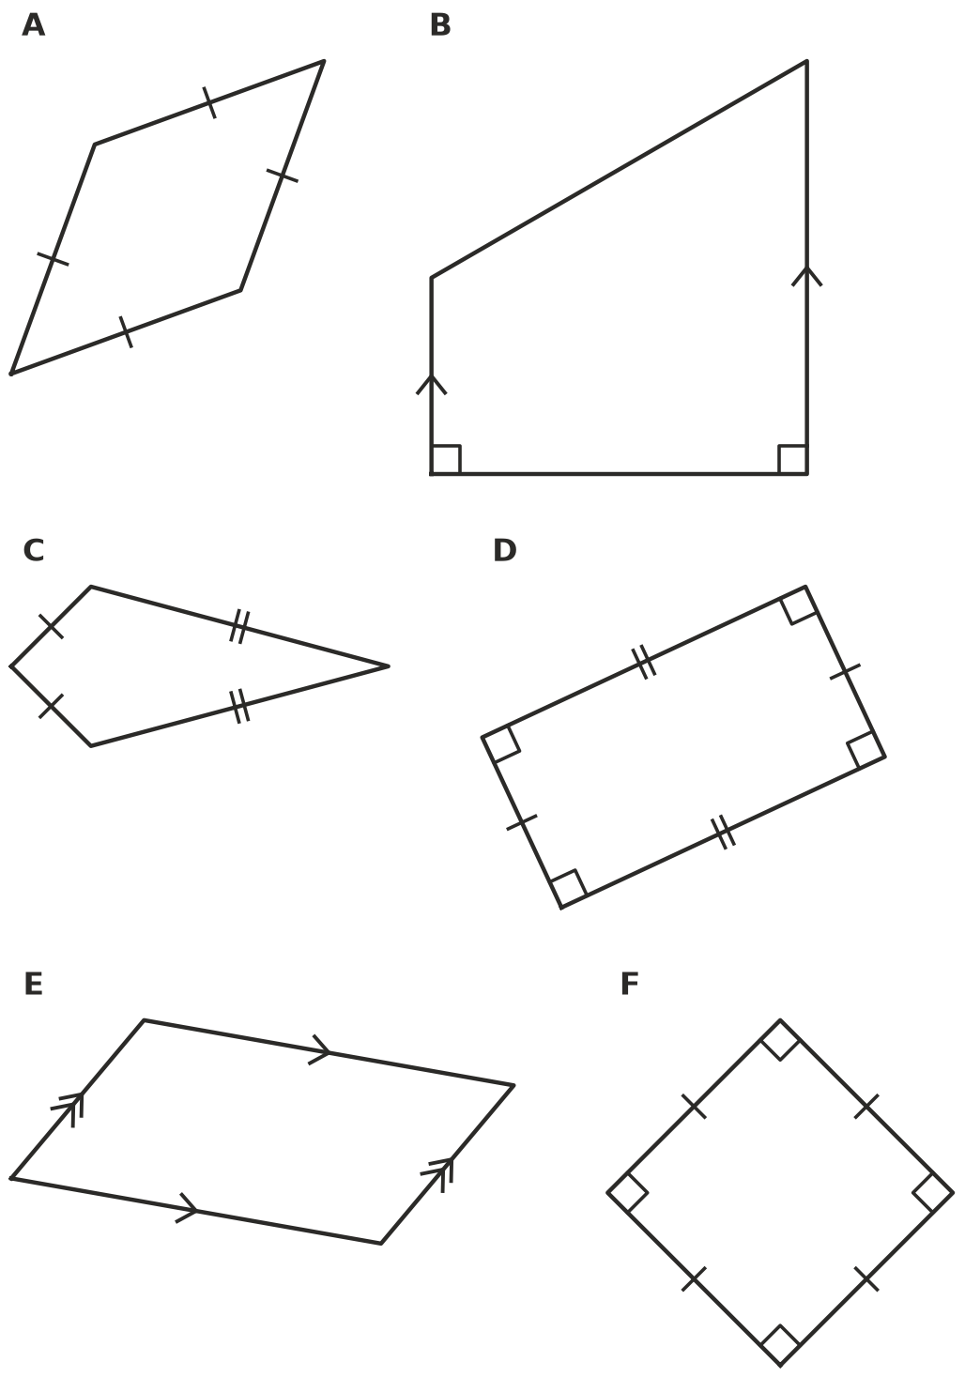
- The diagonals of a quadrilateral join opposite corners. Draw the diagonals on some quadrilaterals if it helps, then write Yes or No in your book.
Property of the diagonals | Square | Rectangle | Rhombus | Parallelogram
They are equal in length
They cross at right angles
They cut each other in half

- Is each statement true or false? Write True or False in your book.
Statement
Every square is a rhombus.
Every rhombus is a square.
Every rectangle is a parallelogram.
A kite can have a right angle.
Every trapezium is a parallelogram.

 Fluency
- Find the value of each pronumeral.
- 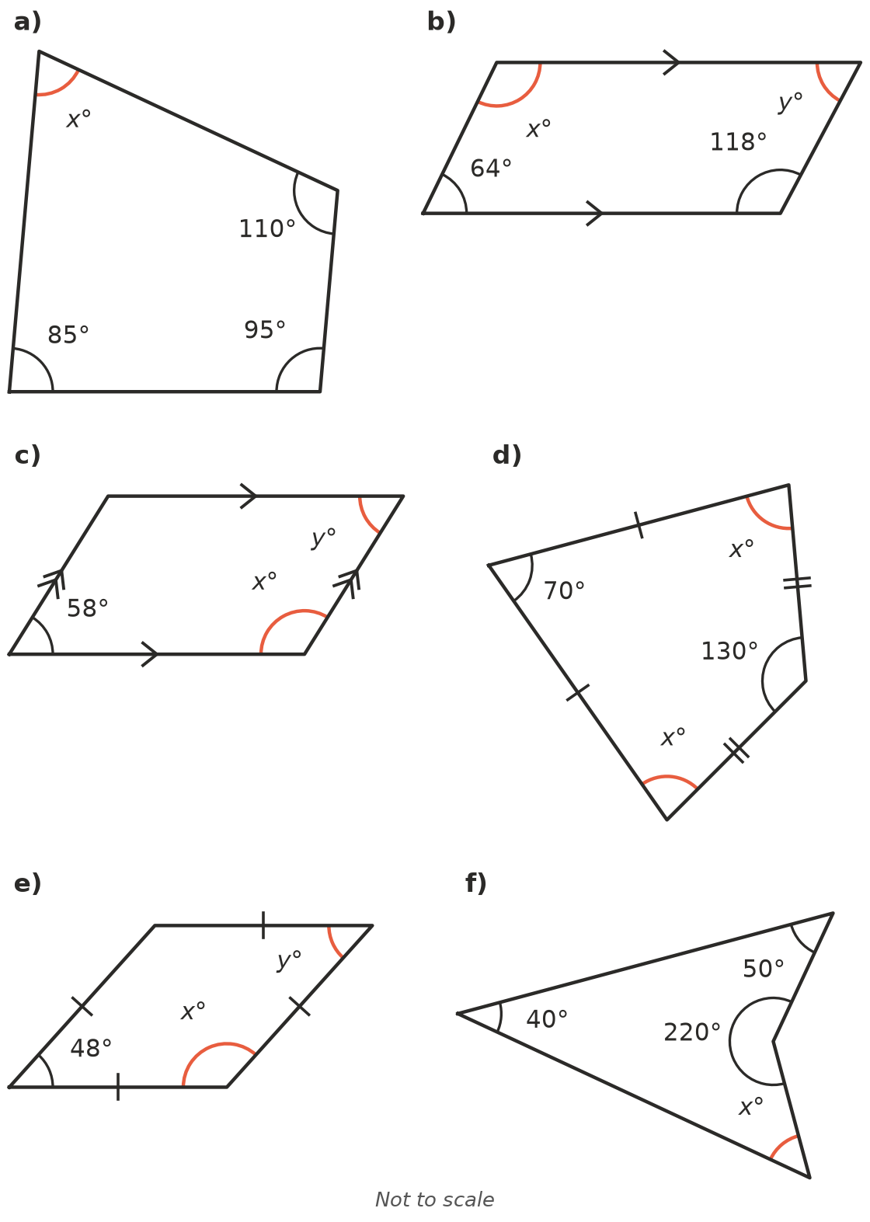
  - $x$ = ______________ b) $x$ = ______________ $y$ =
  - $x$ = ______________ $y$ = ______________ d) $x$ =
  - $x$ = ______________ $y$ = ______________ f) $x$ =
- Copy and complete the table.
Polygon | Number of sides | Number of triangles
Quadrilateral | 4
Pentagon | 5
Hexagon | 6
Octagon | 8
Decagon | 10

- Find $x$ in this hexagon.
- 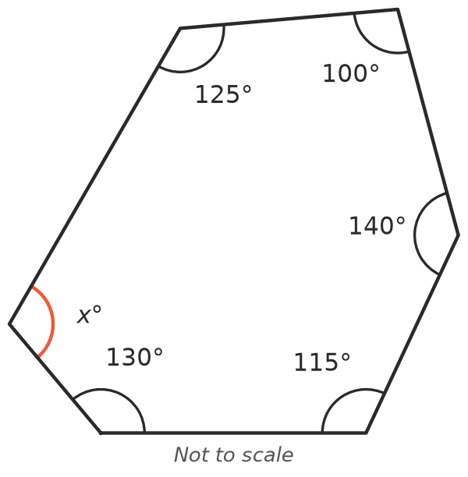
- $x$ =
- A regular polygon has all sides equal and all angles equal. Find the size of each angle.
  - a regular pentagon
  - a regular hexagon
  - a regular octagon
  - a regular decagon

 Reasoning
- Use co-interior angles to explain why the opposite angles of a parallelogram are equal. A labelled sketch may help.
- Kai cut a pentagon into 5 triangles by joining every corner to a point in the middle. He said the angles of a pentagon add to 5 × 180° = 900°. Explain his mistake and find the correct angle sum.

 Problem solving
- A kite has two equal angles of 120° each. Of its other two angles, one is twice as big as the other. Find all four angles.
- Tiles are laid so that their corners meet at a point with no gaps.
  - Can regular hexagons do this? Explain using their angles.
  - Can regular pentagons do this? Explain.
  - Name one other regular polygon that can do this.

