11.04 Quadrilaterals
Year 7 Maths · A5 question sheet · Level 1 · Warm-up
This worksheet practises naming quadrilaterals from their sides and angles, and using the fact that the angles in a quadrilateral add to 360°. Tip: arrows show parallel sides, tick marks show equal sides and a small square shows a right angle.

 Understanding
- Name each quadrilateral. Choose from: square, rectangle, rhombus, parallelogram, trapezium, kite.
- 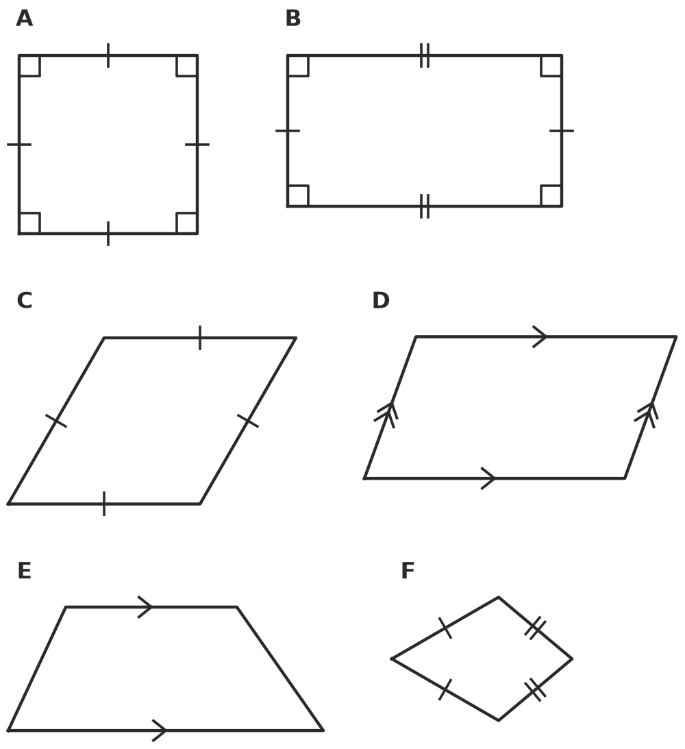
- Write Yes or No in your book.
Property | Square | Rectangle | Rhombus | Parallelogram | Trapezium
All four sides are equal
Four right angles
Two pairs of parallel sides
Exactly one pair of parallel sides
Opposite sides are equal

- The quadrilateral ABCD has been cut into two triangles by the dashed line AC.
- 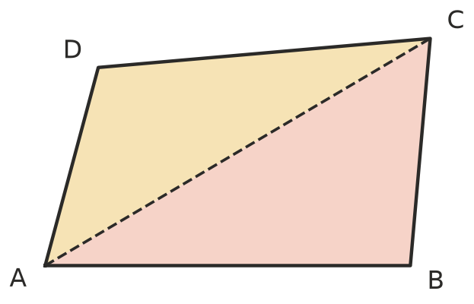
  - What do the angles in each triangle add to?
  - The angles of the two triangles together make up the angles of the quadrilateral. What do the angles of a quadrilateral add to?

 Fluency
- Find the value of $x$.
- 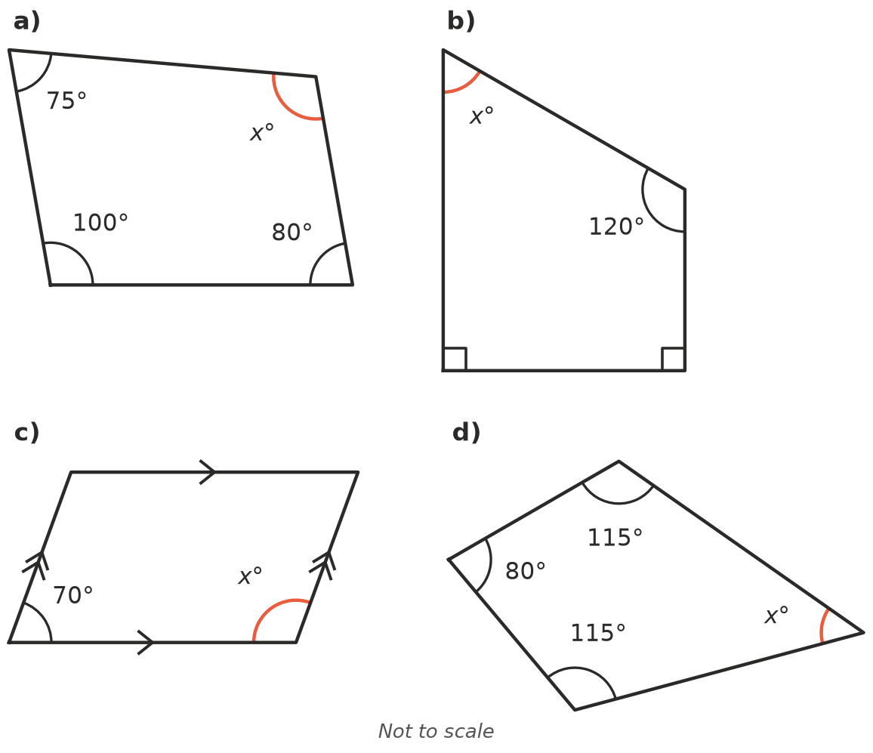
  - $x$ = ______________ b) $x$ =
  - $x$ = ______________ d) $x$ =
- Three angles of a quadrilateral are given. Find the fourth angle.
  - 90°, 90°, 90°
  - 120°, 60°, 120°
  - 75°, 85°, 95°
  - 140°, 30°, 100°

 Reasoning
- Is a square also a rectangle? Explain.
- Max says he drew a quadrilateral with four angles of 100°. Explain why this is impossible.
- Which quadrilateral am I?
  - I have four equal sides but no right angles.
  - I have exactly one pair of parallel sides.
  - I have four right angles, but my sides are not all equal.

 Problem solving
- Polygons with more sides can also be cut into triangles from one corner.
- 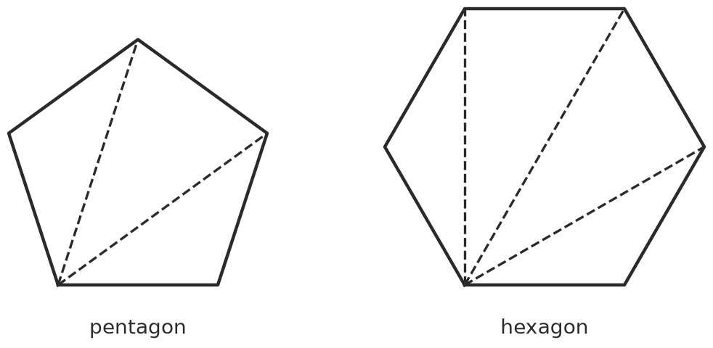
Shape | Number of sides | Number of triangles | Angle sum
Triangle | 3 | 1 | 180°
Quadrilateral | 4 | 2
Pentagon | 5
Hexagon | 6

- Use your answer to Question 9 to find $x$ in this pentagon.
- 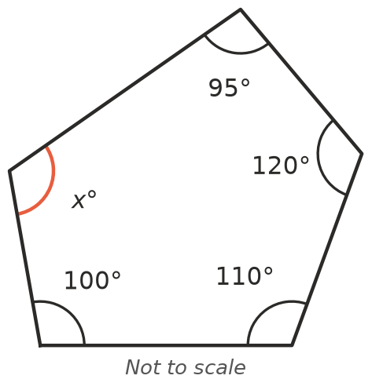
- $x$ =
- A garden bed is shaped like a trapezium. Its two angles at the front are 70° each, and the two angles at the back are equal to each other. How big is each angle at the back? Show your working.

