Investigation: Sort shapes with algorithms
Year 7 Maths · Worksheet
Name: ____________________ Date: ______________
An algorithm is a list of steps and decisions that anyone can follow to get the same result, every time. A flowchart shows an algorithm as a picture. Rounded boxes show the start and the results. Square boxes ask a yes or no question. You follow the arrow that matches your answer. In this investigation you will follow, finish and then design algorithms that sort triangles and quadrilaterals.

Part A: Follow an algorithm
This flowchart sorts triangles by their sides.
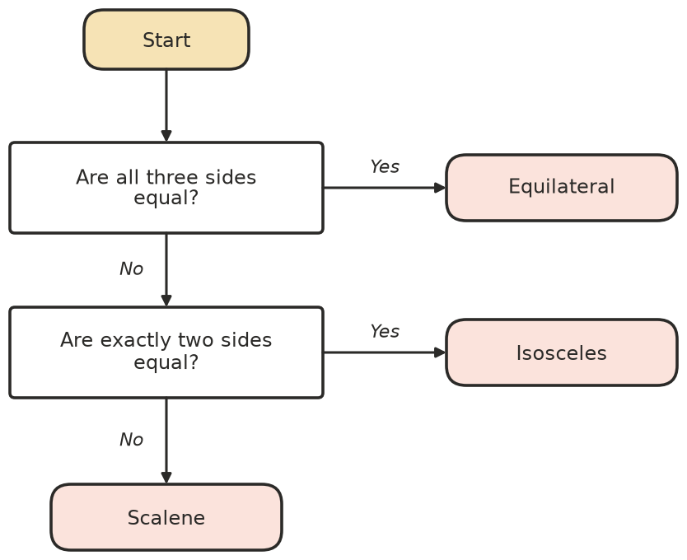
- Use the flowchart to sort each triangle. Write the result and the number of questions you had to answer.
Side lengths (cm) | Result | Number of questions
5, 5, 5
4, 7, 9
6, 6, 10
8, 3, 8
12, 13, 5

- The second question asks about exactly two equal sides. Suppose the two questions were swapped, and the first question became “Are at least two sides equal?” with Yes leading to Isosceles. What would go wrong? Explain.

Part B: Finish an algorithm
This flowchart sorts quadrilaterals. Two questions and three results are missing (the dashed boxes).
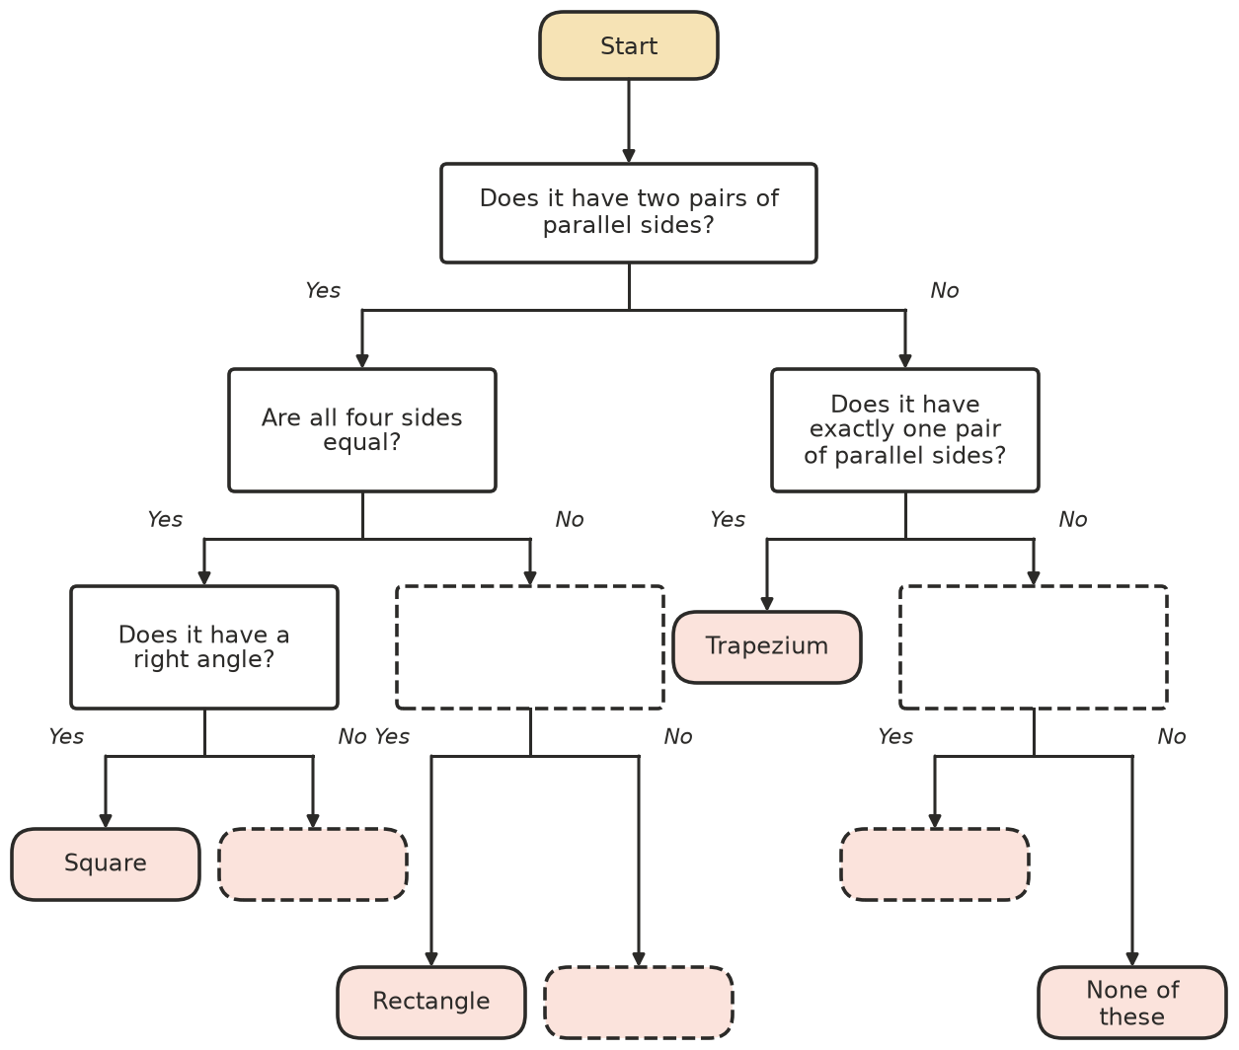
- Fill in the dashed boxes on the flowchart. Use the properties you learned in Lesson 11.04.
- Test your finished flowchart on these shapes. For each shape, write the answers you gave in order (for example: Yes, No, Yes) and the result.
- 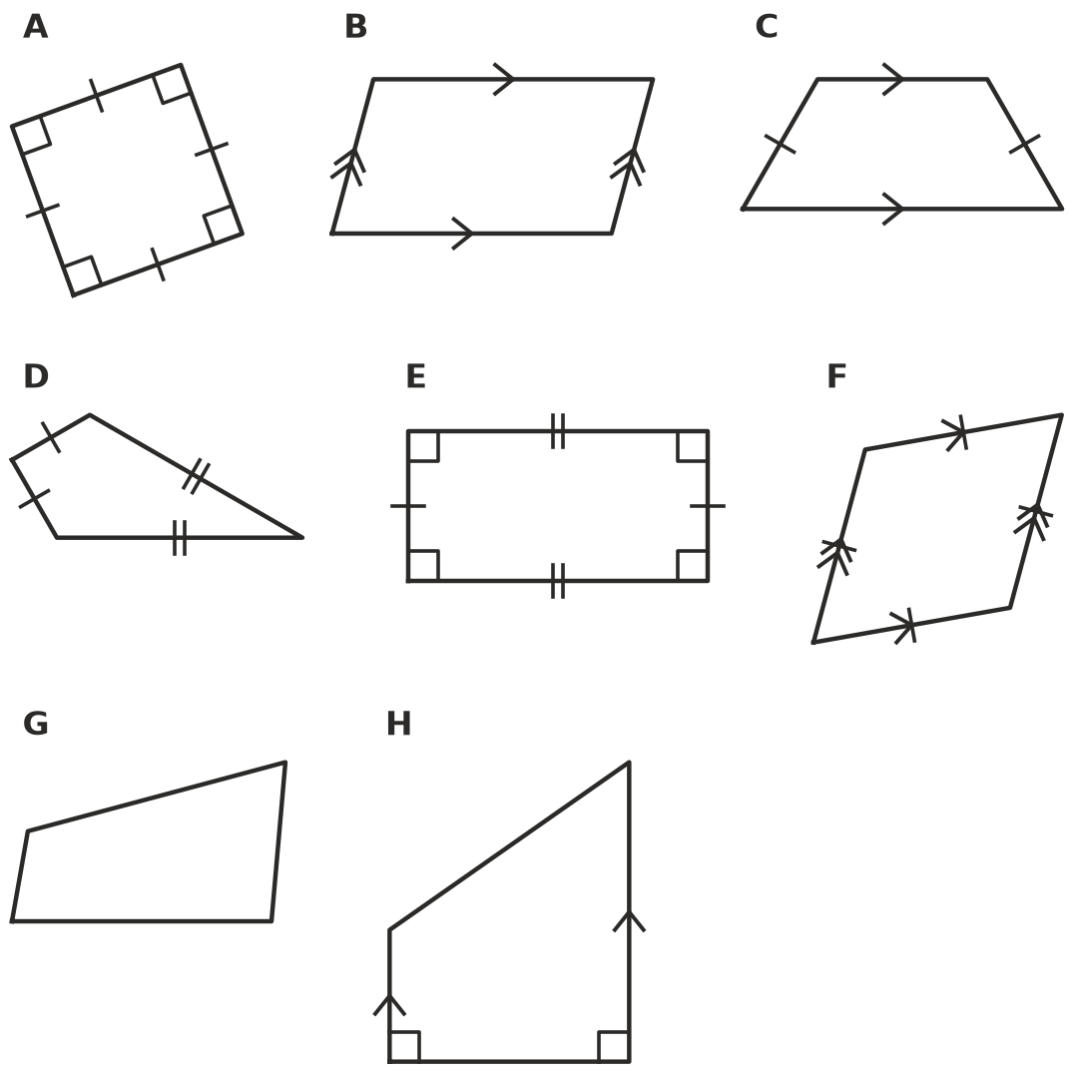
Shape | My answers, in order | Result
A
B
C
D
E
F
G
H

- Every square is also a rhombus, a rectangle and a parallelogram. Explain why the flowchart always gives a square the name “Square”, and never one of the other names.

Part C: Design your own algorithm
- Design a flowchart that sorts triangles by their angles into acute-angled, right-angled and obtuse-angled triangles. Use yes or no questions about the angles. Draw it in the box.

- Test your flowchart on these triangles. Write the result for each.
Angles of the triangle | Result
40°, 60°, 80°
30°, 60°, 90°
20°, 30°, 130°
45°, 45°, 90°
100°, 40°, 40°

- Write your algorithm from Question 6 as numbered steps, using the words IF, THEN and OTHERWISE. For example: “Step 1: IF all three sides are equal, THEN the triangle is equilateral. OTHERWISE go to Step 2.”

 Challenge: Your turn
- Design a flowchart that gives every triangle a two-part name, using both its sides and its angles (for example “right-angled isosceles” or “acute-angled scalene”). Draw it in the box.

- Swap flowcharts with a partner. Test each other’s flowchart on three different triangles.
  - Did your partner’s flowchart always give the right name? If not, which triangle went wrong, and why? ______________
  - What is the largest number of questions anyone has to answer in your flowchart? Could you change the order of the questions to make it smaller? ______________
  - Describe in one or two sentences how your algorithm works. ______________

