11.03 Triangles
Year 7 Maths · Worksheet · Level 3 · Challenge
Name: ____________________ Date: ______________
This worksheet practises reasoning about triangles: classifying them from clues, multi-step angle problems, and explaining why the angle facts are true. Tip: an exterior angle of a triangle equals the sum of the two inside angles that are not next to it. It can save you a step.

 Understanding
- Use the clues to find the angles of each triangle. Then name it by its sides and by its angles.
  - The angles are 2$x$°, 3$x$° and 4$x$°. ______________
  - The angles are $x$°, $x$° and 2$x$°. ______________
  - One angle is equal to the sum of the other two. (Find just the largest angle.) ______________
  - Its angles are three even numbers in a row, such as 20, 22, 24. ______________
- Explain why a triangle can never have more than one obtuse angle, and why its largest angle can never be less than 60°.

 Fluency
- Find the value of each pronumeral. Give reasons.
- 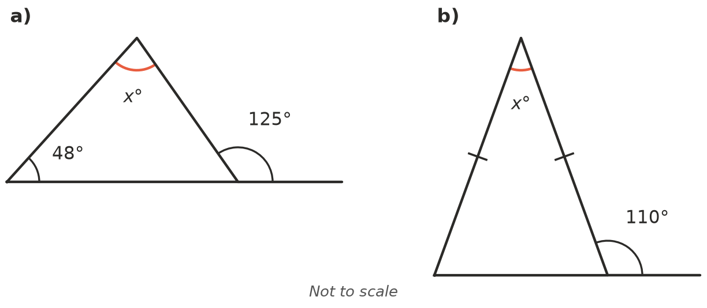
  - $x$ = ______________
  - $x$ = ______________
- 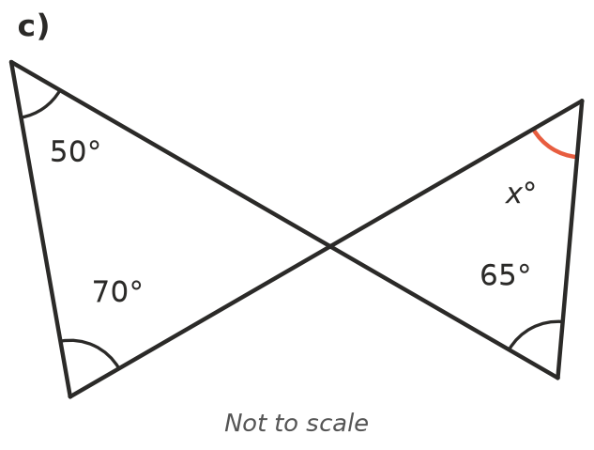
  - $x$ = ______________
- 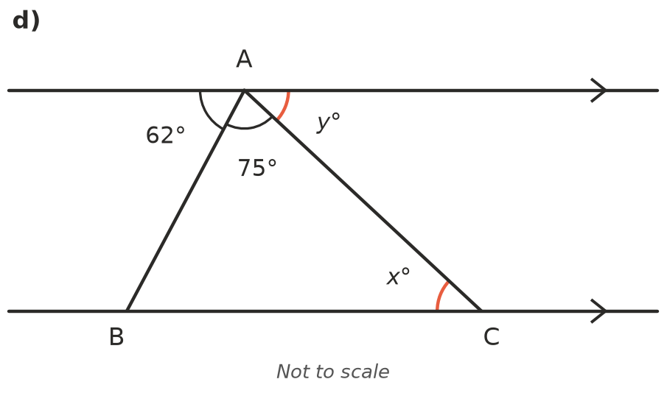
  - $x$ = ______________ $y$ = ______________
- Write an equation and solve it to find $x$. Then write the three angles.
  - A triangle has angles $x$°, 2$x$° and 3$x$°. ______________
  - A triangle has angles ($x$ + 10)°, 2$x$° and ($x$ + 30)°. ______________
  - An isosceles triangle has a top angle of $x$° and base angles of 2$x$° each. ______________

 Reasoning
- A triangle has inside angles $a$°, $b$° and $c$°. The side next to angle $c$ is extended to make an exterior angle $d$°. Prove that $d$ = $a$ + $b$. Draw a labelled sketch.

- At each corner of a triangle, extend one side to make an exterior angle (going around the triangle in the same direction). Show that the three exterior angles add to 360°. Hint: each exterior angle is 180° minus an inside angle.

- Look at Question 3c. Explain why, in any shape like this one (two triangles meeting at a point where two straight lines cross), the two marked angles in one triangle add to the same total as the two marked angles in the other triangle.

 Problem solving
- An isosceles triangle has whole-number angles, and its two base angles are a multiple of 10°.
  - How many different triangles like this are there? List their angles. ______________

  - How many of them are acute-angled? ______________
- The largest angle of a triangle is three times the smallest angle. The middle angle is 20° more than the smallest. Find all three angles and name the triangle by its sides and its angles.

- One exterior angle of an isosceles triangle is 100°. Find the two possible sets of inside angles.

- Liam says, “If I make each angle of a triangle twice as big, I get a triangle twice the size.” Explain why Liam is wrong.

- In triangle ABC, AB = AC and ∠A is twice as big as ∠B. Find all three angles. What special type of triangle is it?

