11.03 Triangles
Year 7 Maths · Worksheet · Level 2 · Core
Name: ____________________ Date: ______________
This worksheet practises classifying triangles, showing why the angles of a triangle add to 180°, and using that fact to find unknown angles. Tip: in an isosceles triangle, the two angles opposite the equal sides are equal. Look for the tick marks.

 Understanding
- Name each triangle by its sides and by its angles.
- 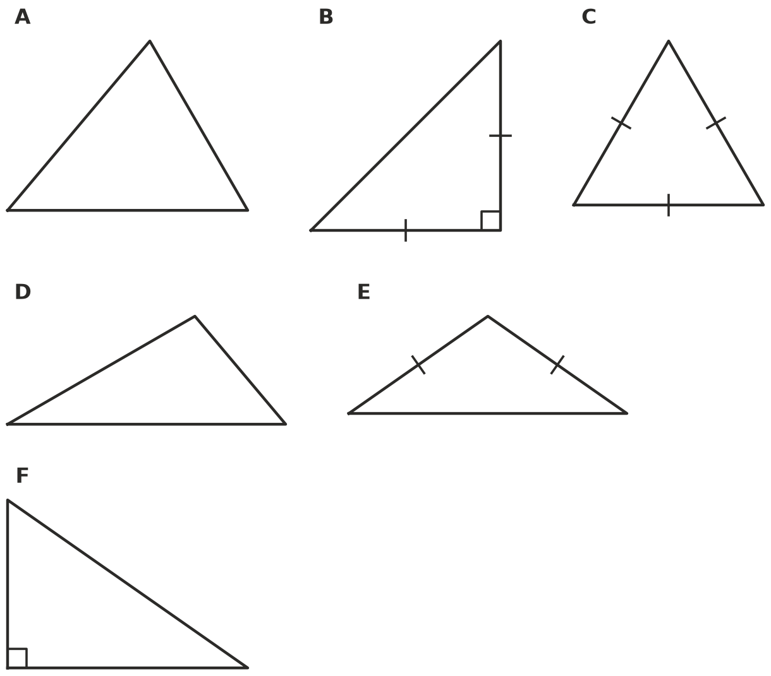
Triangle | Name by sides | Name by angles
A
B
C
D
E
F

- Is each triangle possible? Write Yes or No. If it is impossible, give a reason.
Triangle | Possible? | Reason if impossible
a right-angled equilateral triangle
an obtuse-angled isosceles triangle
a right-angled scalene triangle
an obtuse-angled equilateral triangle
a triangle with two obtuse angles

- This diagram shows why the angles of any triangle add to 180°. The line DE is drawn through A, parallel to BC.
- 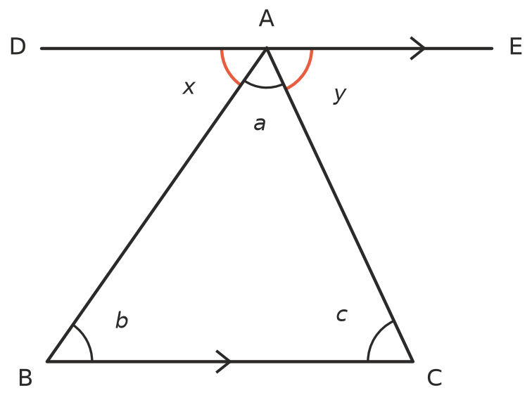
  - $x$ = $b$ because they are ______________ angles on parallel lines.
  - $y$ = $c$ because they are ______________ angles on parallel lines.
  - $x$ + $a$ + $y$ = ______________ because they make a straight angle.
  - So $b$ + $a$ + $c$ = ______________

 Fluency
- Find the value of $x$.
- 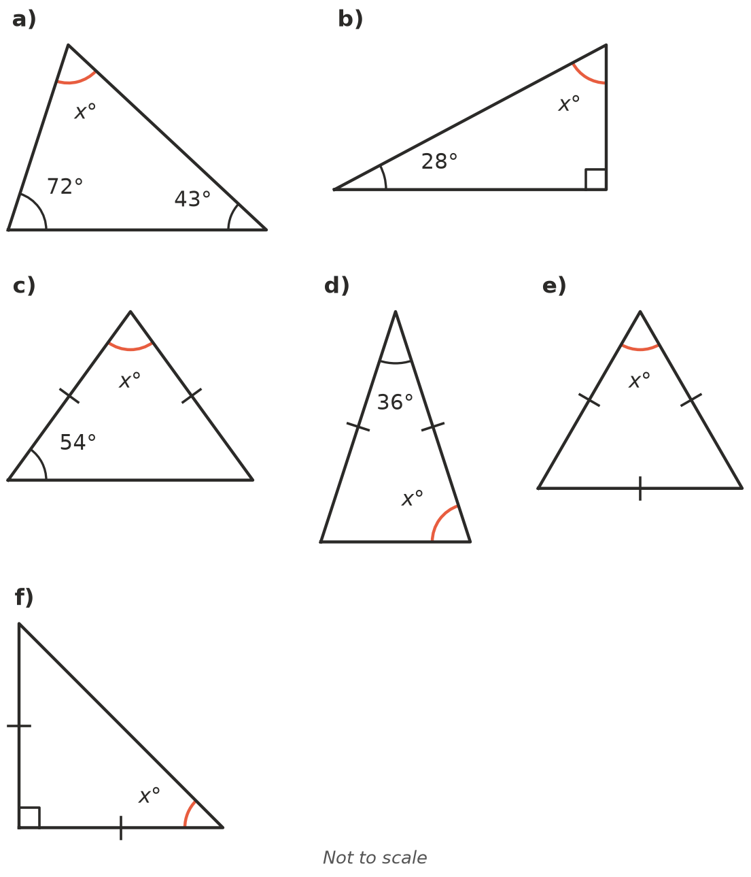
  - $x$ = ______________ b) $x$ = ______________ c) $x$ = ______________
  - $x$ = ______________ e) $x$ = ______________ f) $x$ = ______________
- One side of each triangle has been extended. Find $x$.
- 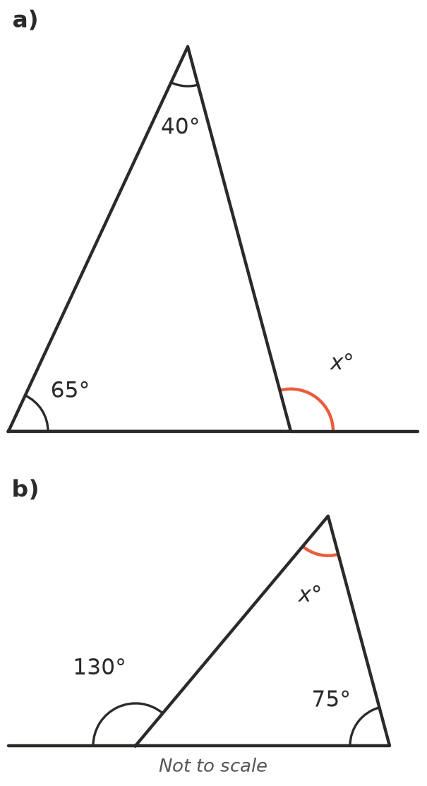
  - $x$ = ______________
  - $x$ = ______________
- Two angles of a triangle are given. Find the third angle and name the triangle by its angles.
  - 47° and 38° ______________
  - 90° and 27° ______________
  - 60° and 60° ______________
  - 25° and 25° ______________

 Reasoning
- Explain why every angle in an equilateral triangle must be 60°.

- The angle at the top of an isosceles triangle is 50°. Noah says each base angle is 130°, because 180 − 50 = 130. Explain his mistake and find the correct answer.

- In Question 5, the angle made by extending a side is called an exterior angle. Look at your answers. How is each exterior angle related to the two inside angles that are not next to it? Explain why this always works.

 Problem solving
- One angle of an isosceles triangle is 50°. There are two different triangles this could be. Find the angles of both.

- The legs of an A-frame sign are the same length. The angle between the legs at the top is 38°. Find $x$, the angle each leg makes with the ground.
- 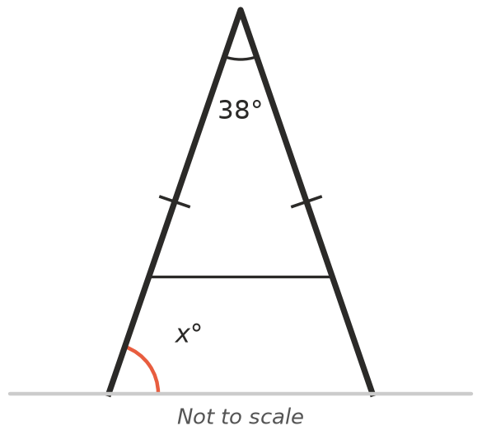
- $x$ = ______________
- The shape ABCD is made of two triangles. Find $x$ and $y$.
- 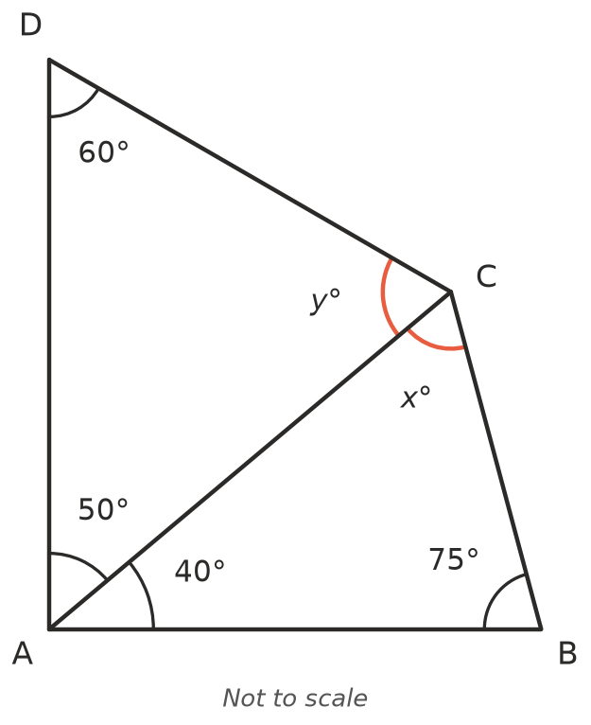
- $x$ = ______________ $y$ = ______________
- What is the size of ∠BCD in Question 12? ______________

