11.03 Triangles
Year 7 Maths · Worksheet · Level 1 · Warm-up
Name: ____________________ Date: ______________
This worksheet practises naming triangles by their sides and angles, and using the fact that the angles in a triangle add to 180°. Tip: matching tick marks show sides of equal length, and a small square shows a right angle.

 Understanding
- Write the name of each type of triangle: equilateral, isosceles or scalene.
Description | Name
All three sides are the same length.
Exactly two sides are the same length.
No two sides are the same length.

- Write the name of each type of triangle: acute-angled, right-angled or obtuse-angled.
Description | Name
One angle is exactly 90°.
One angle is more than 90°.
All three angles are less than 90°.

- Name each triangle by its sides and by its angles.
- 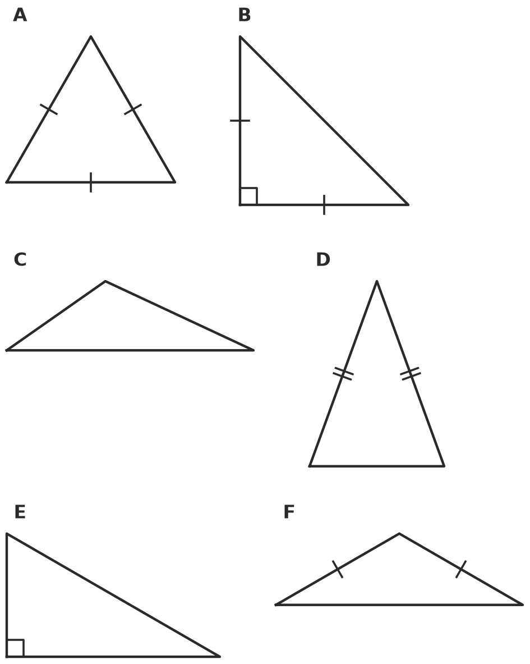
Triangle | Name by sides | Name by angles
A
B
C
D
E
F

- Ava drew a triangle and coloured its three angles. She tore off the three corners and placed them side by side, with their points touching.
- 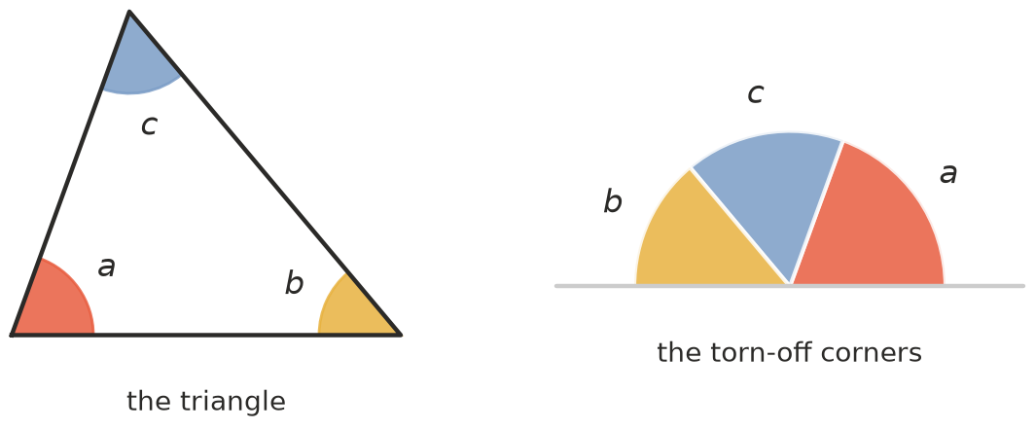
  - What do the three torn corners make together? ______________
  - So what do the three angles of a triangle add to? ______________
  - Try it yourself with a paper triangle. Did you get the same result? ______________

 Fluency
- Find the value of $x$ in each triangle.
- 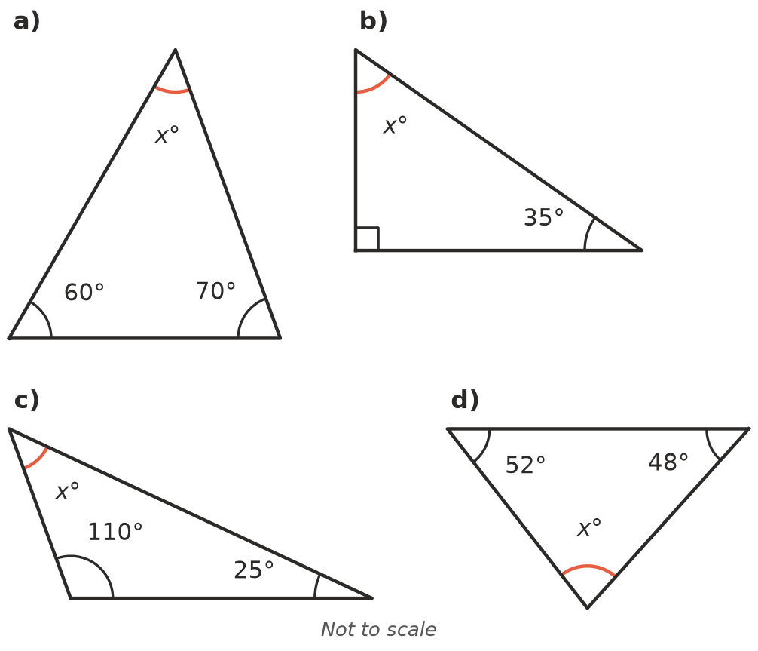
  - $x$ = ______________
  - $x$ = ______________
  - $x$ = ______________
  - $x$ = ______________
- In an isosceles triangle, the two angles opposite the equal sides are equal. Find $x$.
- 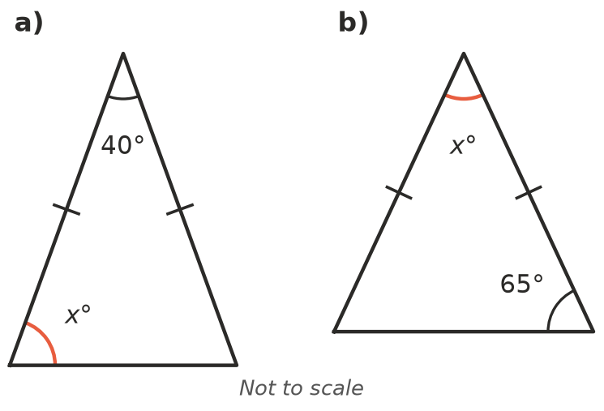
  - $x$ = ______________
  - $x$ = ______________
- All three angles of an equilateral triangle are equal. How big is each angle? Show how you know.

 Reasoning
- Can a triangle have two right angles? Explain.

- Ella says she drew a triangle with angles of 50°, 60° and 80°. Explain why she must have measured wrongly.

- Is each statement true or false? Write True or False in each empty box.
Statement | True or false
An equilateral triangle is also an acute-angled triangle.
A right-angled triangle can also be isosceles.
A triangle can have two obtuse angles.
The angles of a scalene triangle are all different.

 Problem solving
- The end of a shed roof is an isosceles triangle. The angle at the top is 100°. Find $x$, the angle at each end of the base.
- 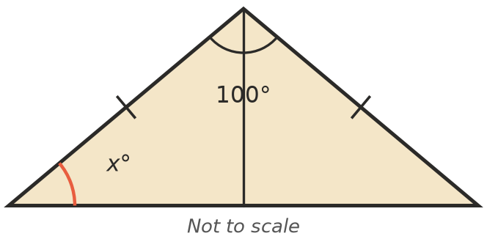
- $x$ = ______________
- A set square is a triangle with a 90° angle and a 45° angle.
  - What is its third angle? ______________
  - Name the set square by its sides and by its angles. ______________

